PSEA Network Awareness Video: Guidance for sharing on social media

The Myanmar PSEA Network has created a short PSEA awareness video for community members, which includes the inter-agency reporting phone number.

The English version of the video can be accessed using the following link.
English version of video
https://vimeo.com/417169261/707d9d488c

We welcome all UN agencies, PSEA Network members and others to upload the video on their agency’s Facebook page which is regularly monitored by communications or other relevant staff.

Step 1
Please download the media from the following link.
Burmese version of video
https://vimeo.com/423533217/d10dc597ff

Please upload on your social media page with the following tag line, both in English and Burmese. The hash tags are very important for monitoring the social media posts.

Burmese Tagline with hashtag
#လိင်ပိုင်းဆိုင်ရာခေါင်းပုံဖြတ်မှု ဆိုတာဘာလဲ သင်သိပြီးပြီလား
သင့်အနေနဲ့ ဘယ်လို ကာကွယ်နိုင်လဲ​
For UN : ကုလနှင့် မိတ်ဖက်အဖွဲ့အစည်းများက ကျူးလွန်သူကို #လုံးဝခွင့်မလွှတ် တဲ့ မူဝါဒကို ကျင့်သုံးနေပါတယ်။
သို့မဟုတ်
For non-UN : အကူအညီပေးရေး အဖွဲ့များအနေဖြင့် လိင်ပိုင်းဆိုင်ရာ ခေါင်းပုံဖြတ်အမြတ်ထုတ်မှု အလွဲသုံစားမှုများကို #လုံးဝခွင့်မလွှတ်တဲ့ မူဝါဒ ကျင့်သုံးနေပါသည်။

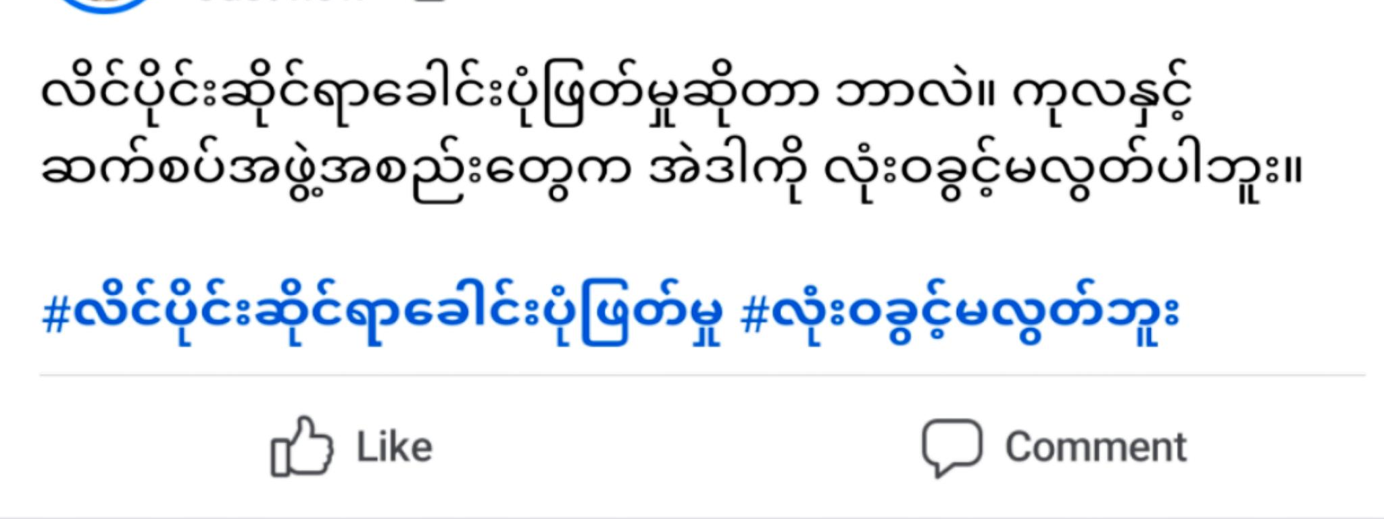

English tagline with hashtag
Do you know what is #sexualexploitation
Do you know how you can prevent it?
For UN posts: The UN and its partners have #zerotolerance policy for sexual exploitation and sexual abuse.
For non-UN posts: All aid organizations in Myanmar have #zerotolerance policy for sexual exploitation and sexual abuse.
#myanmarpsea network

Step 2
Share the social media link to mmrpsea@unfpa.org

Community and staff awareness posters
English and Burmese community and staff awareness posters are also available for download from the PSEA MIMU website (‘PSEA Network Resources & Tools’ => ‘IEC Materials’ => ‘PSEA posters for staff – MYA’/’PSEA posters for community – MYA’). These posters have a blank space where you can write your organization’s complaints details, or the inter-agency PSEA helpline.

Click to expand

Click to expand for more resources
Insert your organization’s preferred complaints contact details here (e.g. PSEA Focal Point number, central reporting number, or inter-agency PSEA reporting number)

