**STANDARD DESLUDGING PROCEDURE**

|  |
| --- |
| Produced by: WASH Cluster  Specific Support: Oxfam GB and Solidarites International  Type organization: UNICEF  Subject: Sanitation- Desludging  Created: 2013  Updated : June 2014  Resource: http://www.themimu.info/emergencies/wash-cluster |

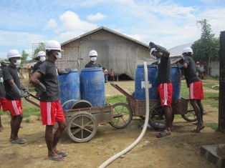



Background

The objective of this document is to capitalize how the desludging processes are being managed by the WASH agencies at the field. The detail of the technology of the desludging options is beyond the scope of this document. Due to the protractile nature of the conflict, many WASH agencies face the problem with emptying the sludge. In addition, the lack of infra-structures in the locations of the IDP camps drives the WASH actors to act on this challenging issue. Massive amount of efforts has been put by WASH agencies to establish the projects related to the desludging. 2 international WASH agencies are leading the project and the project is now operational at the field level.

This document is subjected to change based on the regular review and inputs from the field situation based on lesson learn. *(Preferably every 12 months)*

Outline of the desludging process

The process is apparently divided into three main parts in which several activities are included in each part.

|  |  |  |
| --- | --- | --- |
| Key part | Key component | Key Activities |
| Part 1 | Desludging | 1. Desludging equipment 2. Desludging teams 3. Desludging procedures & on-site sludge transport 4. Safety & hygiene measures |
| Part 2 | On-site Sludge Treatment | 1. Construction of on-site sludge treatment areas 2. Operation of on-site sludge treatment areas |
| Part 3 | Off-site Sludge Transport | 1. Operation of central sludge treatment site |
| Part 4 | Data Recording | 1. Record keeping (at all steps) |
| Appendix | Specific SOP for Sittwe Township |  |

Key Activities in Desludging Process

### Desludging Equipment

The list of equipment is based on the local context and field situation in Rakhine and it can be used as a reference.

|  |  |  |
| --- | --- | --- |
| No. | Items | Explanation |
| 1 | Desludging pump | Diaphragm pump/Manual pump/Motor pump - all pumps are suitable for desludging and all pumps need to be fitted with hose and strainer/foot valve. |
| 2 | Sludge transportation tanks | Plastic 40 gallon tank with sealed lid - these sludge tanks have the storage capacity of 40 gallons which is not too heavy and more portable. The sealed lid prevents the spillages while transporting the sludge. |
| 3 | Water storage tanks & buckets | Plastic water bucket of any storage capacity - water buckets are for the cleaning equipment, hand washing after using chemical. The buckets need to be filled with water |
| 4 | Sludge transport method | Push carts - are to be used in on-site sludge transport and can carry 2 sludge storage tanks/barrels. For off-site, the sludge storage tanks are loaded on the push cart and transported to the side of the road for the tractor.  Tractors - are to be used in off-site sludge transport sytem and it can carry up to 10 sludge storage tanks/barrels per trip. |
| 5 | Safety clothing | *Gloves and Boots* - should be worn by anybody handling sludge or chemicals. Remove and wash gloves and boots after working.  *Overalls or work clothing* - If labourers do not want to wear overalls, instead work clothing should be provided (eg vest & shorts). Work clothing should be removed after work is finished and washed; workers should not return home in their work clothing as it may contaminate their home.  *Masks* - are not compulsory for safety, but may be worn by workers to reduce the unpleasant smell of sludge.  *Safety glasses* - Safety glasses are not needed for all workers, but should be worn by workers who are handling chemicals (lime or chlorine). |
| 6 | Chlorine sprayer | 1 chlorine sprayer is needed per desludging team |
| 7 | Chlorine | 1% chloring solution is used for the following steps. [If Bleaching Powder – 35% is used, 30g or 2 tablespoons per litre of water is used to make 1% solution. If HTH – 65-70% strength is used, 15-14 g or 1 tablespoon per litre of water is used to make 1% solution.] No Metal bucket should be used in making. No direct sunlight should be exposed to the solution. The solution should be sealed tightly.   * Disinfecting around the latrine after desludging (but not inside the pit) * Disinfecting equipment and barrels after use * Hand washing by all workers after leaving the activity and at the end of the day |
| 8 | Lime | Hydrated lime can be used to treat accidental spillage of sludge near the pit. Or The accidental spillage should be covered with a layer of soil – about 2 inches thickness.  Lime is also used to cover the ground around the latrine after desludging has been completed.  Lime is caustic and can cause chemical burns. Care should be taken by workers who are handling lime. |
| 9 | Tools for removing and re-fixing latrine cover (if necessary) | Some latrines have a hatch in the top which can be removed. If this is not present then the latrine cover must be removed completely for desludging. (However, it may also be possible to remove the ventilation pipe and insert the desludging hose into the latrine through the ventilation pipe hole, if the strainer is not too large.)  If the entire cover is removed, then mortar (cement & sand) is needed to refix the cover after desludging. |

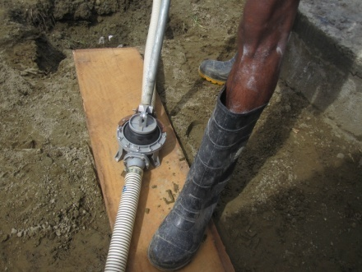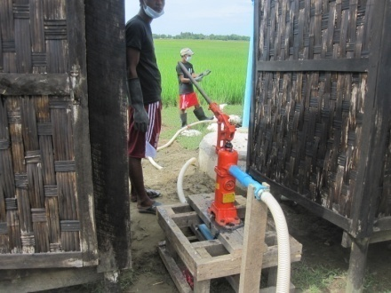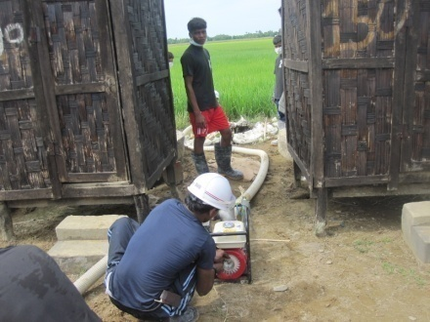

Figure Manual Diaphragm Pump Figure Typical Hand pump Figure Centrifugal Water Pump (Gasoline Engine)

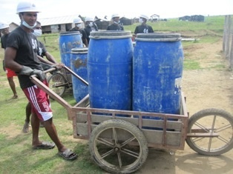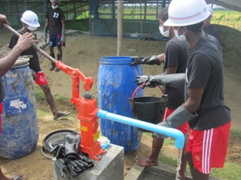

Figure Push cart for desludging Figure 5 Handling sludge barrels at Off-site treatment area

### Desludging Teams

Workers are required for the following tasks: Pump operator, Chlorine sprayer, Handling barrels, Pushing push-carts, Carrying water to the desludging site and Laundry for work clothes. There is no definite number of people per 1 desludging team. It will depend on the distance that the sludge must be transported by the push cart. For an operation involving 1 desludging pump and 2 push carts, Oxfam recommends 10 workers.

The following equipment is for 1 desludging team with 10 workers.

Equipment for 1 desludging team:

* 1 manual diaphragm desludging pumps with hose, foot valve and strainer
* 1 chlorine sprayer
* 10 barrels with lid (40 gallon each)
* 2 push carts
* 10 pairs boots
* 10 overalls or set of safety clothing
* 10 pairs heavy duty rubber gloves
* 10 pairs safety glasses
* 2 hard hats
* 1 disposable mask per 1 person per 1 activity (Eg. 100 disposable masks/month)
* 1 shovel
* 1 plastic bucket (15 litre)

Labour (per pump):

* 1 pump operator
* 2 labourers for handling the pump and hose
* 1 operator for the chlorine sprayers
* 6 operators for handling the barrels and the push carts (3 per cart)

### Desludging procedures & on-site sludge transport

The training on the desludging procedures should be provided to the desludging teams as well as the people who are involved in the desludging process such as staff from INGOs. The overall procedures are as follows;

* If there is no access hatch in the cover to allow access for the desludging pump, the cover of the latrine pit is removed by breaking the mortar seal.
* The end of the hose for the desludging pump with the strainer is placed inside the pit.
* Priming of the pump may be required
* Water can be added to the pit if necessary to increase the liquidity of the sludge for easy pumping.
* 2 barrels are placed inside the push cart and the end of the hose from the pump is placed in the first barrel.
* Pump operator pumps manually until the first barrel is full; the lid is fixed securely on the barrel after the hose is moved immediately to the second barrel and pumping continues.
* A second push cart, loaded with barrels, should to be ready to be used so that there no interruption in pumping whilst the full barrels are being transported.
* Once the barrels are full, they are transported in the push cart to either the on-site sludge treatment area, if one is available, or to the roadside where they will be collected for off-site disposal.
* If an on-site sludge disposal area is available, the barrels are rolled off the push cart to the edge of the treatment pit, and emptied manually into the treatment pit. (Separate guidelines are available for the operation of the on-site treatment pit.) The barrels are then loaded back onto the carts and returned to the latrine area.
* Latrines will be desludged until ¼ of the contents are remaining. The final ¼ of the latrine contents will be left in the latrine, since this part of the sludge contains bacteria which are active in digesting and decomposing the sludge. These bacteria should not be removed so that the sludge digestion process can continue as the latrine use continues.
* No chlorine or lime should be added to the contents remaining inside the pit, in order not to kill the active bacteria.
* If the cover of the pit has been removed, it should be replaced and sealed with plaster. If desludging has been carried out through a desludging hatch, the cover of the hatch should be replaced and sealed with plaster. If ventilation pipe has been removed it should also be fixed and sealed, with fly screen at the top of the pipe.
* After re-fixing of the cover, lime is added around the latrine pit over any area where sludge has spilled into the ground.
* The top of the cover and the area around the latrine pit is sprayed with 1 % chlorine solution.
* At the end of the day, the barrels and the push carts are thoroughly cleaned with water and 1 % chlorine solution.

1. **Safety & hygiene measures**

The safety and hygiene measures should be applied at all steps of the desludging process. Extra-care should be placed when there is a risk of outbreak of acute watery diarrhoea (AWD).

* Every person working on desludging should receive training on hygiene and on standard operating procedures for desludging. This should cover the principles of transmission and prevention of faecal-related diseases.
* Two sets of working clothes will be provided for each worker, which should be dedicated to be used only during the desludging process. Clothes worn during the desludging process should be removed before the workers return home.
* Clothes used during desludging should be soaked for 10 minutes in 0.05% chlorine solution [[If Bleaching Powder – 35% is used, 16g or 1 tablespoons per 100 litre of water is used to make 0.05% solution. If HTH – 65-70% strength is used, 7g or 1/2 tablespoon per 100 litre of water is used to make 0.05% solution.], before being washed with water and laundry soap. A proper location at each camp and at the on-site sludge treatement area should be defined by the desludging supervisor.
* After removing their clothing, workers must take a shower before putting on their home clothes.
* Workers should wash their hands with 0.05% chlorine solution before eating.
* All direct contact with sludge must be avoided unless the worker is wearing gloves.

All workers will be provided with:

* 1 bar body soap per month
* 1 bar laundry soap per month
* 5 sachet ORS per month (optional)
* 1 bottle household bleach (if available)

### Construction of on-site sludge treatment area

There are many different methods of sludge treatment and WASH agencies are encouraged to share their experiences with each other. This section covers the method piloted by Oxfam in Sittwe camps, but other methods are also applicable. If the land is available, site selection should be done according to the following criteria;

1. Depth to water table

* Base of the sludge treatment pit should be minimum 1ft above the water table
* Infiltration area should be minimum 3ft above the water table

1. Topography

* Land should be level to facilitate construction

1. Soil conditions

* Sandy soil is preferable to enhance infiltration

1. Proximity to households

* The distance to the households should be maximised; however, given the crowded nature of the sites and the urgency of the desludging process, it may be necessary to construct the sludge treatment area relatively close to the residential area. The following steps will be taken to minimise public health risk to the residential areas:
* On-site desludging pit will only be used in camps where there is no outbreak of diarrhoeal disease. In case of diarrhoeal disease risk, sludge will be transported off-site.
* Lime will be mixed with sludge each day so that pH of sludge in the pit remains high (i.e. pH >12) which inhibits biological processes to ensure stabilisation of sludge and reduction of smell. The amount of lime may vary from 2% to 60% of the total weight of the sludge.
* Volume of sludge in the treatment area will be small (maximum 36 m3) so no over-powering concentration of sludge occurs.
* Fly screen is constructed around the sludge disposal site to ensure that flies cannot transmit public health risks from the sludge, nor use it as a breeding area.
* So long as these factors are respected, the minimum distance to the residential areas is considered to be 100 m (300 feet).

The on-site sludge treatment area consists of 3 parts:

|  |  |  |
| --- | --- | --- |
| No. | On-site sludge treatment area | General Dimensions and minimum volume |
| 1 | Pit for lime stabilisation and settlement of sludge | Approximate general dimensions: Overall volume of one pit is around *30-36 m3*.  *Length (internal): 5-6 m (15-20ft)*  *Width (internal): 3-4.5m (10-15 ft)*  *Overall Height/Depth: 1.5-2m (5-6ft)*  The pit is partially excavated up to a depth which is at least 1 foot above the water table. (In normal conditions in the Sittwe camps this allows excavation of 2-3 feet depending on the depth to the water table at a particular site.) Following excavation, the overall height of the pit is raised to 5-6 feet through construction of embankment walls.  Embankment walls have a slope of 1:2 (27°) in sandy soil, although the slope can be steeper if the soil has higher clay content.  The embankment is constructed of soil which will be compacted every 6”.  The pit is lined with tarpaulin to prevent infiltration of untreated sludge into the ground.  A roof is constructed over the top of the pit to keep sludge dry during the treatment process.  Fly mesh is fixed around the walls to stop fly access to the sludge in the pit. |
| 2 | Planted infiltration / evapotranspiration area for dewatering of lime-stabilised sludge | Approximate general dimensions:  *Area: Minimum area 25 m2 (270 sq ft), (eg. 5m x 5m; 15 ft x 18 ft)*  *Depth: 1 ft*  Banana plants are planted at *5 ft* intervals (16 banana plants for a *270 sqft* site) |
| 3 | Secondary solar sludge drying area for additional drying of dewatered stabilised sludge | Approximate general dimensions: Overall volume 2.5 m3  *Length: 10 ft (3m)*  *Width: 5 ft (1.5 m)*  *Height: 2-3 ft (0.6-1.0 m)* |

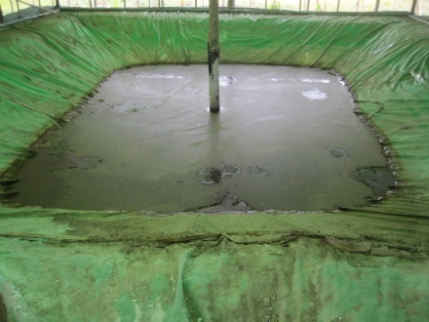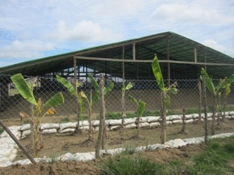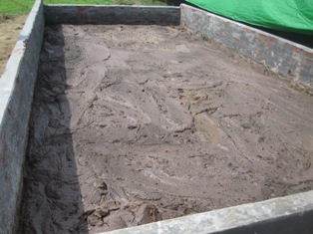

**Figure 7 On-site sludge treatment areas (Lime stabilisation and settlement of sludge, plant infiltration/evapotranspiration and solar sludge drying area)**

### Operation of on-site desludging area

Sludge is transported from the latrines to the lime stabilisation pit in 40-gallon barrels. The sludge is poured into the pit. At the end of the day, lime is added gradually, and the contents of the pit are stirred then the pH is measured. Another option could be that the desludging team adds lime to individual barrel and stir it and then pour it into the pit. The quantity of lime is adjusted gradually until a pH of 12 is reached. The contents are then stirred for another 30 minutes. The fly screen of the pit is closed and the contents of are left for 48 to 72 hours whilst the pH reduces and the solids separate from the liquid and settle to the base of the pit.

After the pH reaches 9, the liquid is siphoned off from the top of the solids and pumped into the infiltration / evapotranspiration area. Depending on the infiltration capacity of the soil in the infiltration, the dewatering process may need to be spread over 2 days. The solids from the sludge are left in the treatment pit for further drying for a minimum of 2 days. After 2 days the partially-dried solid sludge is manually transported to the secondary solar sludge drying area for further drying for *15 days*.

In the solar drying area, the sludge is mixed with ash to absorb moisture and aid composting. The sludge should be turned over every 2-3 days to aid aeration. After 15 days the solid sludge can be used for land application on crops.

The following equipment & materials are needed:

|  |  |  |
| --- | --- | --- |
| No. | Items | Purposes |
| 1 | 2” dewatering pump | To pump in and out of the sludge |
| 2 | Lime | Quantity of lime varies depending on the sludge consistency, but may be 100-200 bags (50 kg/bag) per operational rotation |
| 3 | Long bamboo stirring rod | For mixing sludge contents of the pit after adding lime |
| 4 | Shovels | For mixing sludge contents of the pit after adding lime |
| 5 | Mattocks | For picking up solid sludge to move from the pit to the solar drying area |
| 6 | Buckets | For picking up solid sludge to move from the pit to the solar drying area |
| 7 | Soap | For picking up solid sludge to move from the pit to the solar drying area |
| 8 | pH meter or pH paper | To check that the sludge has reached an appropriate pH after adding lime |

Labour needed for the on-site desludging area:

* 2 person to add and mix lime in the pit
* 1 person to operate dewatering pump
* 4 people to manually transport partially dried sludge to secondary solar drying area

Records should be kept for the following data:

* pH of the sludge which has been left overnight in the pit, to be measured at the start of the day
* number of barrels sludge added during the day
* number of kilogram of lime added during the day
* Consistency of the sludge
* pH at the end of the day
* Date of emptying liquid
* Date of emptying solid

### Off-site sludge transport

* If no on-site sludge treatment system is available, sludge will be transported to the central sludge treatment site (STS). This will be done by mini-tractor.
* Sludge waiting for collection is the responsibility of the WASH actor operating in the camp, or the camp manager, until it is collected by the mini-tractor.
* The camp manager should alert transport system (Oxfam) in advance of the start of desludging, to ensure that transport will be available and minimise the time that sludge is waiting in barrels before collection. The camp manager needs to give the following information:
  + Date and time of desludging
  + Location where the barrels need to be collected from
  + Number of barrels which will be produced during the day
* Sludge barrels waiting for collection should be *kept out of the sunlight* to minimise biological reaction which will produce methane gas inside the barrels in which the methane gas could become explosive or poisonous to the person who later opens the barrel.
* If there is a delay in collection of the sludge or no shade available in the camp, then lime may be added to the barrel to raise the pH and stop the biological activity (which will stop the production of methane inside the barrel). If lime has been added, the transport system operators must be informed.
* Tractors will carry drums of sludge from each camp to the central sludge treatment site (STS), where they will be offloaded by the STS operators.
* The tractor will be sprayed at the STS with 1% chlorine so that all elements which may have been in contact with sludge are correctly disinfected.
* After cleaning, the mini-tractor will be loaded with clean barrels.
* The driver will not directly handle the barrels or the sludge himself, except in the event of an accidental spillage (see below).

The drivers should be provided with clear instructions on the following measures;

1. Accidental spillage:

In case of accidental spillage, the tractor should carry the following:

* + 2 bags (25kg/bag) of lime
  + 1 shovel

If a spillage occurs, driver should pour lime over the spilled excreta.

If practical, the driver should attempt to recover the spilled excreta and return it to the barrel;

If not practical or attempts to recover the excreta are likely to increase the public health risk, then the driver should cover the spilled excreta with a 2 inch layer of soil.

The driver should call Oxfam sludge transport management team [phone number] with the following information.

* + Date, time & location of spillage
  + Quantity of sludge spilled
  + Mitigating action already taken

1. Cleanliness & hygiene for drivers:

All drivers will receive training on hygiene and on standard operating procedures for desludging. This should cover the principles of transmission and prevention of faecal-related diseases.

Drivers will receive training in action to be taken in case of spillage.

All drivers will be provided with:

* 1 bar body soap per month
* 1 bar laundry soap per month
* 5 sachet ORS per month (optional)
* 1 bottle household bleach (if available)

### Record Keeping

WASH actor or camp manager should keep records and should share with Oxfam sludge management team.

* Records of which latrines have been emptied and the date
* Number of barrels filled
* Number of barrels emptied into on-site sludge disposal area

Oxfam sludge transportation team will maintain the following records

* Departure time of mini-tractor from the camp
* Number of barrels carried
* Arrival time of mini-tractor at the STS
* Number of empty barrels returned to the camp

## Main Findings & Lesson Learned

To be documented in the next review after 6 months.

# Appendix – SOP for desludging & sludge transport for Sittwe Township

Background

*This SOP is for partners wishing to understand the procedure for transportation of desludged waste from latrines in Sittwe Township IDP camps, and utilize the available transportation service, presently provided by Oxfam GB. This SOP defines the key roles of the WASH partners, and of Oxfam, and should be read together with the STANDARD DESLUDGING PROCEDURE for a better understanding of the desludging process that exists for Sittwe Township IDP camps. This SOP mentions the key reporting requirements expected of WASH partners seeking transportation assistance, provides a reporting methodology, and offers helpful tips to maximize the volume collection and efficiency of the transportation service delivery. Importantly, this SOP highlights the standardized training and equipment which Oxfam provides to WASH partners. This SOP is periodically updated, and WASH partners can find the updated version in MIMU.*

Outline of the desludging process

Key Roles of WASH agency focal point of the IDP cap wishing to utilize OXFAM transportation

1. monitor all of their own desludging needs and their own volumes of septic tanks
2. mobilize their own desludging team to start activities according to needs (*based on factors including latrine ratio defined by usable latrines/population, overflowing latrines, routine desludging activities*)..
3. give 7 days notice where possible to OXFAM the start date of planned desludging and number of full latrines expected. (use the communication tree in below. For telephone numbers please enquire directly at Oxfam). Avoid expectations of a next-day pick-up delivery service.
4. provide to Oxfam a designated focal person (camp based) and contact details of each active desludging team.

Key Roles of Oxfam:

1. Provide a Focal point for centralised desludging information
2. Respond to all WASH partners needs by transporting desludged waste from the camp to the waste treatment station.
3. Develop a schedule according to Oxfam’s current fleet capacity and identified priority of desludging needs.
4. Plan and communicate the weekly tractor schedule to all WASH partners, and designated focal persons on a bi-lateral basis.
5. attempt to provide a minimum of 1-2 tractors to assist each WASH partner desludging team.
6. provide spare barrels to compliment planned activities and improve desludging teams efficiency
7. remove filled barrels from camps to the sludge treatment site (STS).
8. monitor and optimise the desludging transport procedure.
9. Monitor health and safety for transportation and desludging teams.

Minimum Key reporting from the WASH partners to Oxfam

1. ***Maintain daily verbal contact*** *between WASH partners and Oxfam Focal point.*
2. ***Maintain weekly update reports i****ndicating desludging needs* *directly to Oxfam Focal point.*

|  |  |  |
| --- | --- | --- |
| Frequency | Information Flow | Content |
| Daily | Oxfam Desludging Teams | Number of latrines desludged  Numbers latrines still full |
| Daily | Oxfam Desludging Teams | Daily Tractor Schedule |
| Weekly | Oxfam WASH actors | Planned desludging activities/camp |
|  | Oxfam WASH actors | Weekly Tractor Schedule according to requested needs |

Communication tree

Oxfam

Desludging

Assistant:

Khaing

Zin

PHEO

WinHlaing

CDN Camp Supervisors

OGB Camp Supervisors

Malteser

Camp Supervisors

SI Camp Supervisors

S/C Camp supervisors

Fleet

Manager



Tractors



Tractors



Tractors



OGB weekly update:

**Desludging**

**matrix**

**and tractor planning**

**Weekly**

tractor

schedule

produced

**INPUTS: Total number full latrines/**

**desludging**

**needs per camp**

**Daily**

tractor

movements

updates

**OUTPUTS: Latrines**

**desludged**

**/week/camp**



**Deployed to camp**

**Deployed to camp**



Figure 1: Communication tree to coordinate tractor schedule according to desludging needs of WASH actors in Sittwe camps.

Helpful hints to maximize volume collection (m3/day) and efficiency.

1. Prepare a sludge storage site for the barrels in the camp, with Oxfam design assistance.
2. Timing of desludging and filling of barrels is key for the desludging teams to combine with the Oxfam transportation system, as tractors will collect filled barrels on a rota system, which is determined by Oxfam.
3. Use the standardised weekly format to update desludging needs and priorities.
4. Use the provided Oxfam Poo tubes for latrine sludge monitoring and request Oxfam standardised latrine sludge monitoring format, training and equipment.