POND CLEANING AFTER FLOOD EVENT
Produced by: WASH Cluster, Myanmar
Updated: September 2015
Resource: http://www.themimu.info/emergencies/wash-cluster
  - I. BACKGROUND
In Rakhine, community ponds are one the major water sources in the rural areas. The communities rely on these water sources throughout the dry season. Although the pond water cannot provide safe drinking water, these community ponds are often the only available water reachable with local technology for villages where there is complex ground water access.
During floods, many ponds become filled with contaminated surface water, debris, deposits and animal bodies.
Risk and pond cleaning:
Pond cleaning for emergency flooding response should only be undertaken after consideration of the following risks:
- Have the village members and/or DRD requested that the pond be cleaned? Pond cleaning must not be undertaken if not requested and agreed upon by village members and DRD.
- Has any other agency/authority already cleaned a pond in the village in response to the latest flood? Confirm the status of this pond, and if it’s an acceptable drinking water source, no further ponds should be cleaned.
- Are there alternative sources of drinking water for the village for the period of pond cleaning? Only one pond for “drinking water” should be cleaned per village to ensure there is sufficient drinking water while the targeted pond is cleaned;
- Will the pond be able to be re-filled by rain before the end of the wet season? Emptying of ponds must be completed by 15 September to allow the ponds to be refilled by the end of the wet season, to maximize water storage for the next dry season.
Pond classification and treatment:
Due to the variation in the level of damage, ponds are categorized into 4 types: types 1, 2, 3 can be cleaned for emergency response, however type 4 ponds should not be cleaned this wet season.

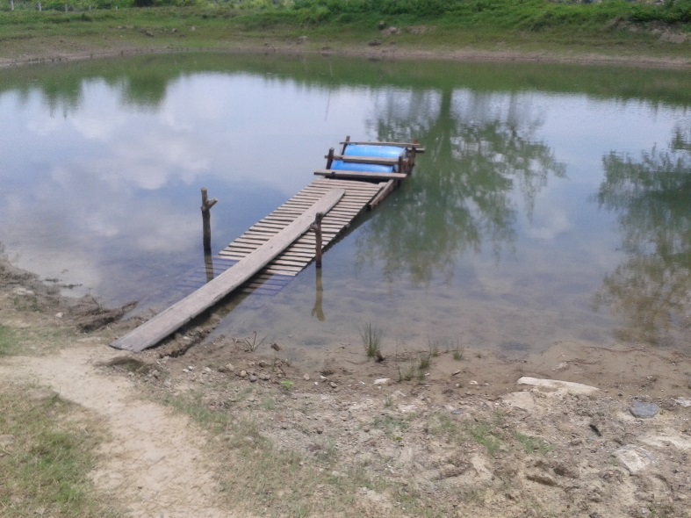
Type 1:
Condition:
- Turbidity level less than 50 NTU (see simplified turbidity test document to measure the level)
- Embankment still intact, higher than flood level in the area
- Situated in higher area of the village
- Not affected by the flood

Treatment:
- Pond cleaning is not required
- Water at household level: e.g. Aqua tabs, boiling, ceramic water filters
Figure 1 Type 1 Pond
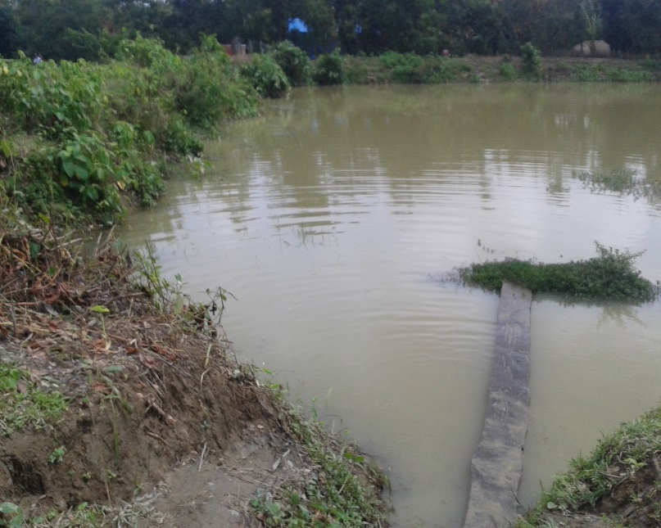
Type 2:
Condition:
- Embankment still intact or only with partial damage
- Some debris, mostly leaves and tree branches
- Debris easily to removed manually
- Turbidity level between 20 – 500 NTU
- Pathway still accessible by community

Treatment:
- Pond cleaning not required, unless contaminated with saline water.
- Water treatment at least at household level: PUR/ P&G water sachets; cloth filter/ sedimentation prior to Aqua tabs/chlorination; ceramic water filters
Figure 2 Type 2 pond

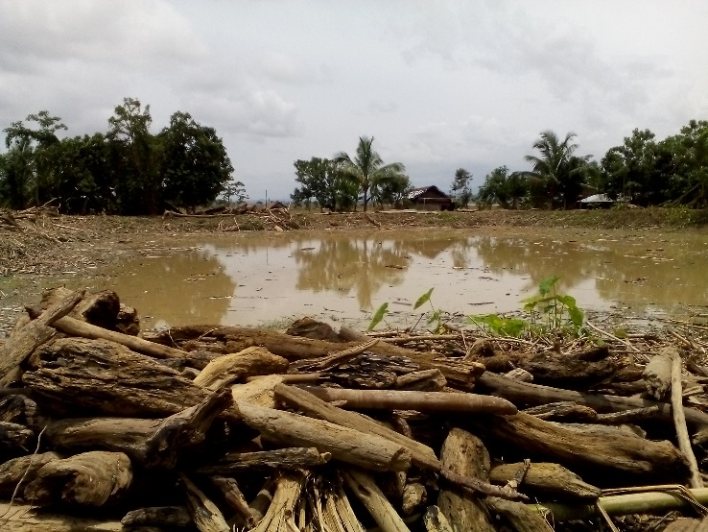
Type 3:
Figure 3 Type 3 pond, quick clean up been implemented to put big logs on the shore but some leaves and branch are still there
Condition:
- Dead animals found in the embankment
- Debris from tree logs
- Partially damaged embankment
- Water could be overflowing
- Turbidity level up to 2,000 NTU
- Access to pond is challenging but still possible with small pathway

Treatment:
- Remove dead animals immediately and bury.
- Remove debris with manpower and simple pushcart
- Apply pond cleaning (see methods below)
- Water treatment at community (such as diversion of a small volume to a separate pond or tank for settlement) and household level (such as PUR; household coagulation-flocculation with alum (jar test to define the right dose) and then chlorination).
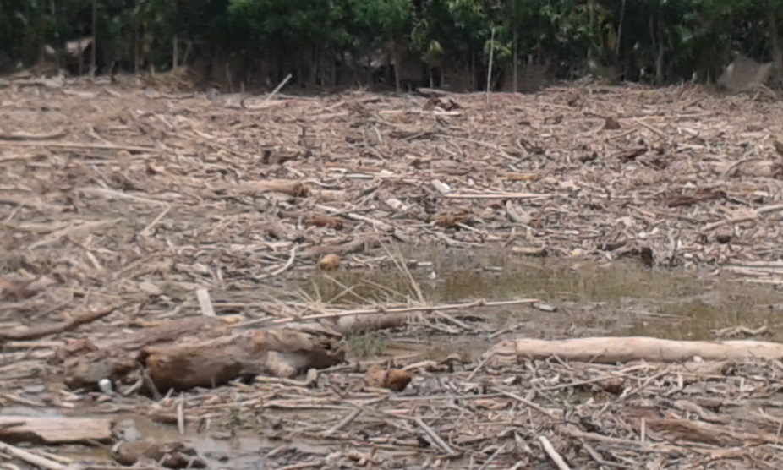
Type 4: As this pond is severely damaged, machinery and advanced treatment is required. As such, cleaning this pond for the first emergency phase should not be the priority. Alternative pond/water source should be identified and used.
Condition:
- Dead animals found in the pond area
- Debris from structures, logs, etc
- Embankment destroyed – no longer existed
- Water overflowing
Figure 4 Type 4 pond with dead animal, debris and destroyed embankment
- High turbidity, could be more than 2000 NTU
- Highly contaminated
- Access to pond blocked with debris/logs
Treatment:
- Remove dead animals immediately and bury
- Remove debris with machineries
- Create pathway for access
- Apply pond cleaning (see methods below)
- Water treatment: Coagulation-flocculation with alum (needs jar test to define the right dose), filtration, chlorination/disinfection advance water treatment system
  - II. METHODOLOGIES – only if there is an alternative pond/water source
Step 1:
Flush water out all of the water by pumping. Avoid breaking the embankment wall, as rapid reconstruction methods are unlikely to produce similar standards of construction. Ensure that water drained is safely diverted to existing drainage ditches or watercourses in order to avoid flooding or mudslides affecting the nearby infrastructures or agricultural lands. When the water is crucial (e.g. low rain intensity), water should be channelled into temporary storage (e.g. tarpaulin tank) and treated for further use by community.
Two types of pumps can be used: 1) Suction pump and engine, recommended for static lifts that greater than 1.6 m. 2) Axial flow pump, for static lifts that less than 1.5 m.

Step 2:
Remove sediment/contaminated layer manually by using bamboo, timber, shovels, etc. All debris and organic matter should be removed from the pond after drainage and disposed of away from watercourses. Careful not to disturb the clay-sand layer at the bottom of the pond. Avoid excessive scraping in areas with high water table because it could cause seepage and further saltwater intrusion.
Note: Soil removed from the pond bottom should not be used to raise the embankment height, due to risk of further contamination.
The following additional steps may be undertaken in a “building back better” development approach, post-emergency phase, and only if alternative drinking water sources are available.

Step 3:
After all the contaminated sediments are removed, expose drained bottom layer with sunlight to oxidise and disinfect it. UV radiation in the sunlight will assist to destroy pathogens in the bottom layer. The time required to dry a bottom soil depends upon air temperature and weather. For Rakhine, three sunny days is estimated to be efficient to drying the bottom layer and double when it’s cloudy.

If needed, relining the bottom with clay can be added for protection from leakage and salt water intrusion. However, additional time is required to stabilize the new layer.

Step 4:
Lime (CaO) can be added for pond cleaning. Liming pond is best done after the pond has been drained, organic material and the top layer of saline saturated soil from the bottom of the pond has been removed by scraping and dried by the sunlight.
Spreading lime over ponds that are partly filled with water is not particularly effective. Adding lime increases pond water alkalinity for more rapid decomposition of organic matter that falls into the pond after it has been cleaned.
  - III. MITIGATION MEASURES FOR WATER SCARCITY
Prior to pond cleaning, mitigation measures should be applied to ensure that affected population has access to drinking water during the cleaning process and for the next dry season, including the following:
- Installation of temporary rain water harvesting system with tarpaulin and bamboo
- Distribution of water purification agent (P&G sachet, aqua tabs, ceramic water filters) at household level to treat turbid water
- Temporary collection and treatment of pond water with flocculation-coagulation at community level

