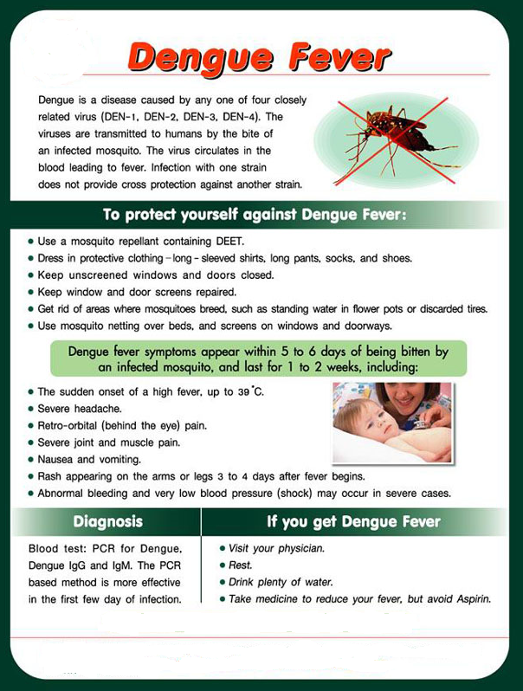
Currently one dengue vaccine has been registered in several countries (CYD-TDV or Denvaxia); this is a live-attenuated vaccine, available in Thailand.
The vaccine is given as a three-dose series on a 0/6/12month schedule.

Individuals nine (9) to 45 years of age living in dengue endemic areas should get vaccinated.

Full immunity is achieved after completing the full three-dose course of the vaccine.

