KACHIN and NORTHERN SHAN
Monthly report
April 2015

Produced by: Kachin & North Shan Wash Sub Cluster team
Organization: UNICEF
Location: Myitkyina
Month: April 2015
Resources: http://www.themimu.info/emergencies/wash-cluster

Overall Humanitarian WASH situation and WASH actor’s mobilization
No specific clashes required the mobilization of WASH cluster members in April. However, approximately 270 people were displaced in Tanai Township due to fighting which ceased on 22 April. These IDPs stay at the Baptist and RC churches in Tanai. The GAD has reportedly provided some assistance. Since the situation could be temporary, the churches have not appealed for assistance. 300 migrant workers have been also reported to be unable to move from the area due to the fighting. Travel authorizations are needed for international staff and agencies to access to this area.

Cross line missions
Cross line mission have resumed in Kachin following a 6 months break due to the overall humanitarian situation.
Laiza area that includes notably two highly populated IDP camps (11722 IDPs ie about 15% of total IDPs camps population) and where there are current WASH projects was not part of these cross line missions and has been not accessible by international Humanitarian agencies for 8 months.
The WASH cluster team has been participated to the following cross line missions:

Mai Ja Yang | 31st March – 5th April 15
Lana Zup Ja and Bum Tsit Pa | 25 to 29 April 2015
Chipwi & Pan War | 22 -26 April 2015
Border Post 8 and Post 6 Camps | 27th -30th April 15

Operation and maintenance activities of existing WASH facilities as well as capacity development activities have been the main needs identified through these cross line missions along with a need to upgrade and in some locations complete the WASH facilities. The findings of these cross line missions have been shared with the WASH cluster.
These cross line missions have been also the opportunity for UNICEF to distribute 427 basic Hygiene kits and 1263 refill kits to 2736 IDPs living in five IDPs locations where WASH NFI gaps have been identified by the WASH focal agencies and where humanitarian assistance is very challenging from June to September due to rainy season.

WASH assessment
Joint WASH assessment in Hpakant
A joint WASH assessment including DRD township authorities, Shalom and WASH cluster teams has been carried out in Hpakant area from first to seventh April. This assessment targeted 20 camps out of a total of 22 IDPs camps in Hpakant area and host 3442 IDPs.
The purpose of this joint assessment was to assess the impact of 392 additional IDPs in six existing IDPs camps on the WASH facilities. This assessment aimed also at monitoring the overall WASH situation in these locations where there is no WASH actor since the end of December 2014 due to funding gap. Besides, this assessment has been also an opportunity to strengthen the capacity of WASH cluster members in terms of assessment methodology.
The WASH cluster team will look at solutions with the members to address the WASH needs that have been identified through this WASH assessment have

4W highlight
WASH actors’ presence
Based on the 4W for April, 55 camps out of a total of 155 (35%) are not currently targeted by the WASH Focal agencies. These 55 not targeted IDPs camps host 18090 IDPs out of a total of 74001 IDPs (24%). More than half of the non-WASH targeted IDPs camps are located in Hpakant area. In case of no new additional funding for the coming months, the number of not targeted camps will raise to 73 in May and 119 in June.

The ongoing development proposal from WASH agencies should however enable to maintain and even increase the WASH actors’ presence for the following months.

IDPs camps size and WASH coverage
Based on the April 4W, there are 71 IDPs camps out of a total of 153 (46%) in Kachin and NSS with less than 50 Households. These 71 camps host 7987 IDPs that means “only” 10% of the total IDPs in Kachin and NSS. The quasi totality of these camps are located in GCAs
The WASH coverage in these camps in April 2015 are provided below.

Looking at both water, latrines and bathroom coverage, the small IDPs camps appear to be the ones with the best coverage of WASH facilities. The small size of these IDPs camps contributes to facilitate the proper coverage of WASH facilities. Given this high WASH facilities coverage, it is crucial at this stage to empower these small scale IDP communities with WASH issues in order to increase their self-reliance and to concentrate Humanitarian efforts on remaining needs in bigger IDPs camps.

Basic HKs coverage
The below graphs provides the situation in terms of HK coverage in Kachin and NSS. The overall coverage of HKs in April was 67%. The main gaps are located in North Shan and North Kachin. Some of the gaps highlighted in this graph will be addressed in May and following months.

Semi-permanent latrines needs

The graph below provides the semi permanents latrines needs (source 4W) over the last years.

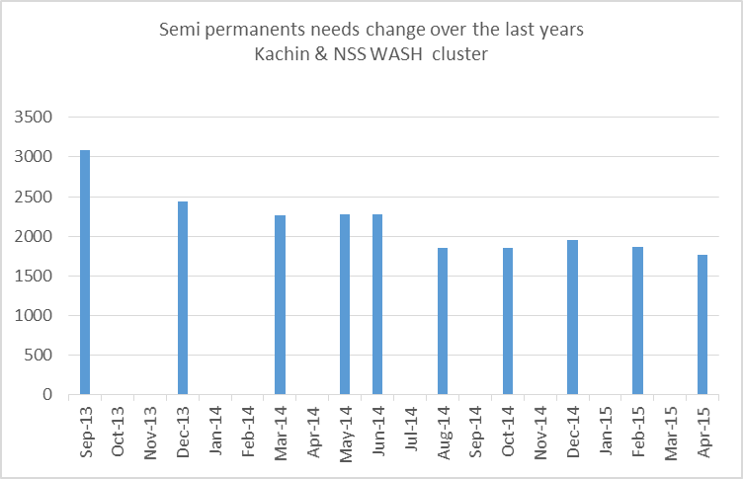

Significant progress in the semi-permanent latrines coverage has to be done since September 2013, and the number of semi-permanent latrines needed dropped from 3085 in September 2013 to 1761 in April 2015. New mall scale emergencies and their related construction of emergencies facilities contributed to increase the number of semi-permanent latrine needs. This graph shows a clear slowdown of the progress over the last months and reveals the limits of semi permanents latrine construction. The graph below provides the theoretical remaining needs of semi permanent latrines per township (Source 4W)

The main townships where needs for semi permanents latrines remain are Mansi, Momauk and Waingmaw. These needs are estimated based on humanitarian standards of one latrine seat for 20 people. According to field monitoring carried out by the WASH cluster team in GCA, the real needs for semi permanents latrines construction appears to be lesser. In Mansi and Momauk townships, management issues, land availability, and IDPs data issues needs to be taken into account beyond quantitative needs to estimate the real needs.

In NGCA Waingmaw township, discussions with WASH focal agencies enabled to highlight challenging soil conditions, high prices of construction material, land availability issues and the absence of desludging solutions. Due to this combination of factors, humanitarian actors in NGCA don’t promote the construction of semi-permanent latrines construction.

The total need of semi-permanents latrines calculated in the 4w Matrix of April is 1761 in the documented IDPs camps of Kachin and NSS. Based on all constraints preventing the construction of semi-permanent latrines, the real needs can be estimated to around 300 latrines for Kachin and NSS cluster.

Other events
Capacity development
- A 3 days training in Myitkyina on “Water Supply & Sanitation in Emergency “ has been organized by Oxfam with Emergency Respond Fund from 6th to 8th April 2015. 17 participants from 9 Agencies attended to this training.
Emergency Response
- Through ERF mechanisms and with SI support, KBC has prepared the distribution of 91 HKs for 91 HHs recently displaced in Lung Sut camp at Puta O town.

Main Priorities for next month
- Prepare next round of Cross line missions
- Strengthen capacity development activities with the arrival of new Capacity development officer within the WASH cluster
- Finalize monitoring framework for the WASH cluster in Kachin
- Keep monitoring the WASH situation in IDPs camps
- Support the WASH cluster members for WASH situation analysis

Produced by the WASH members
- Hpakant WASH joint assessment report
- Cross lime mission assessment report
- WASH cluster minutes
- Join field visit with local authorities to address desludging issues

