KACHIN and NORTHERN SHAN
Monthly report
July and August 2015

Produced by: Kachin & North Shan Wash Sub Cluster team
Organization: UNICEF
Location: Myitkyina
Month: July & August 2015
Resources: http://www.themimu.info/emergencies/wash-cluster

- Main events in July and August

WASH cluster meetings / workshops
- Meeting between WASH cluster team and WASH agencies involved in long term durable WASH projects (outside emergency settings) in Kachin state. A note will be produced summarizing the WASH projects and plans of these organizations,
- Conducted two WASH cluster coordination meetings one in Bhamo and one in Myitkyina,
- Meetings of the WASH cluster team with Kachin state municipal affairs (TDA) to enquire about their on-going activities and capacity to undertaken urban WASH actvities

Small scale emergencies: Floods

- Floods occurred in four township of Kachin Mohnyin, Mogaung, Tanai, and Hpakant
- According to governmental source, 7454 people have been affected by floods
- Bhamo township has been also concerned by floods but to a less extend,
- 8 actors including Red cross Movement, SI, KMSS, RRD, KBC, UNICEF, State Health department have participated to the response

WASH response included:
- WASH NFI and aquatab distribution,
- WASH assessments,
- Water point cleaning and chlorination,
- Setting up of temporary emergency water supply (SI) in Mogaung through ERF mechanisms,
- UNICEF supported 5 drums (50 kg each) of bleaching powders and 150 toilet pans & pipe sets to State DoH to use in Mogaung emergency flood response.
- Three members from Kachin WASH sub cluster coordination team have been deployed to support flooded areas of Chin Magwe and Kale region and state.
WASH situation monitoring
- The water quality of 346 water points has been tested and data has been collected by the WASH cluster
- WASH Monitoring to 84 camps in July and 16 camps in August has been completed by the WASH cluster coordination team accompanied when available by WASH focal agencies and governmental authorities staff
- Join WASH-Shelter site planning in Sar Maw Village of Mogaung Township for the setting up of new camp sheltering IDPs coming from other temporary location

- August 4W

WASH actors presence

- 120 IDPs camps out of a total of 152 (78%) are targeted with a WASH project until at least the end of 2015,
- 32 WASH projects to be stopped at the end of August 2015 due to funding availability
- Starting of new WASH project implemented through a partnership between UNICEF and Shalom Foundation from 28 July 2015

Community management of WASH facilities

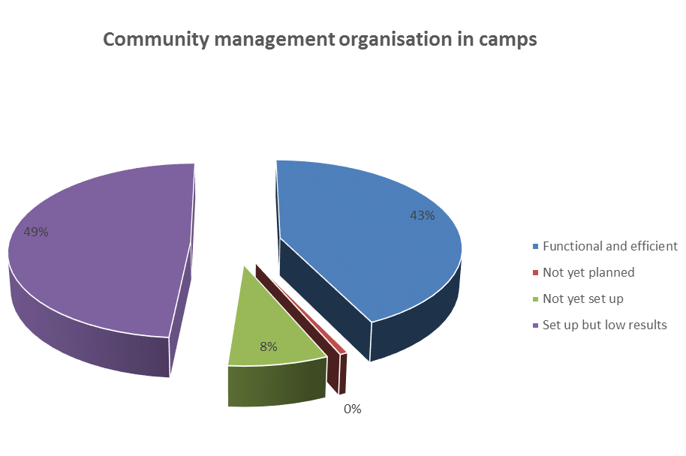
The graph above shows that almost half of the WASH facilities management structures that have been set show low result of achievements. The needs to reinforce the capacity and autonomy of camp management committee is therefore crucial and WASH projects should emphasize on this activity.
- Update on WASH cluster initiatives about sanitation

With a total of about 3200 semi-permanent latrines in 170 IDPs locations, the issue of desludging has been and is still one of the main challenges of the WASH cluster in Kachin and NSS.
The lack of sanitation master plans, the absence of formal private sector and of waste water treatment sites, the limited capacity of municipalities, the land availability issues are amongst the factors that reduce the desludging options in Kachin state.

To address this sanitation issues, a number of initiatives have been taken by the WASH cluster since his activation:

- In year 2013 the WASH cluster identified a need to investigate alternative sanitation options and feasibility of DEWATs (Decentralised Waste Water Treatment Systems) in IDPs camps and schools in Kachin and northern Shan state. A quick survey showed the potentiality and relevance for introducing DEWATs within the protracted crisis of Kachin, for the collective and institutional settings and building such schools, health centers and protracted IDPs camps,
- In 2014, the WASH cluster strategy recommended to shift from emergency latrines construction to semi-permanent ones with increased pit lifespan enabling desludging,
- In June 2014, creation by OXFAM of a Technical Working Group in Myitkyina on desludging issues that carried out a desludging assessment in 18 IDPs camps and led to a project of excreta site disposal in the north of Mytkyina. The physical construction of the site is on-going and should be operational in October 2015
- In 2015 a sanitation survey has been carried out by SI and included stakeholders analysis and review of desludging practices in South Kachin. This survey highlighted the needs to reinforce local capacity for desludging activities. A more exhaustive survey should be carried out by SI before the end of the year to better analyze the possible options for sustainable sanitations solutions in South Kachin
- In August and September 2015, the WASH cluster has been coordinating closely with UNOPS over the last month to promote the development of DEWATS solutions in South Kachin

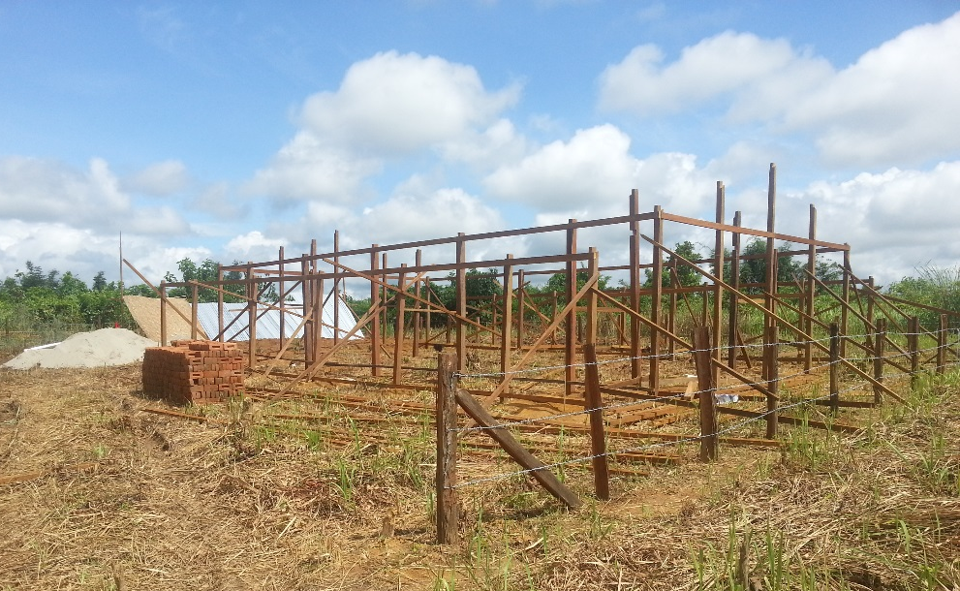
On-going construction of excreta disposal (KBC / OXFAM) about 15 Km from Myitkyina
11st September 2015

Capacity development

- Training by UNICEF of 28 WASH cluster members on “Orientation on CSO Guideline” in Myitkyina on 21st July 2015.
- Organized and facilitated orientation WASH situation monitoring and KAP analysis with WASH monitoring Consultants and WASH Cluster support Officer on 02 July, 2015.
- Support to WASH focal agencies and DRD staff for the use of WASH monitoring templates in 2 IDP camps of south Kachin,
- 3 days training on “Gravity Flow water supply system designing” in Bhamo 22-24 July 2015, (Total participants 13 from SI, CESVI, METTA, KMSS and DRD)
- 1 day training on “Data Management” by National WASH cluster team in Bhamo on 23rd July 2015 and in Lashio on 28th July 2015. (total participants 13 from CESVI, Metta, KBC, KMSS and SI)

Main Priorities for next months

- Improve collection and consolidation of water quality data from WASH cluster members,
- Monitoring of WASH situation in schools, health centers and Host families concerned by the IDPs presence
- Follow up with WASH focal agencies critical WASH issues identified during last monitoring round
- Support to WASH members for capitalization of lesson learned
- Attempt to monitor the WASH situation in NGCAs
- Follow up situation of Sumprabum situation, North Kachin, through inter cluster meetings,
- Join WAH & Shelter cluster meetings in Bhamo,
- Follow up the WASH needs for new eventual temporary locations to be created (Lwegel, Nay Win NI, Man wing Gyi (?), Sar Maw)
- Strengthen WASH focal agency approach in NSS

Produced by the WASH members
- 4w matrix (WASH cluster)
- Pre-KAP data survey and analysis conducted by Shalom for Hpakan Camps. The data includes 17 camps and 407 respondents from all camps. As reported by Shalom the survey was conducted for around 15% of total families. Based on the final analysis, Shalom will prepare a narrative of Pre-KAP survey and submit on 17th September
- WASH monitoring report including water quality data
- Situation reports in Chin, Magway and Sagaing
- Minutes of WASH cluster meetings
- 3W for affected areas in Kachin,
- WASH assessment report in Sagaing (SI)

