**COORDINATION PRINCIPLE FOR WASH IN SCHOOLS**

|  |
| --- |
| Produced by: WASH Cluster and Education sectors  Specific Support: **Education in Emergency, Save the Children**  Subject: Wash in Schools  Created: May 2015  Updated: -  Resources: [*http://www.themimu.info/emergencies/wash-cluster*](http://www.themimu.info/emergencies/wash-cluster) |

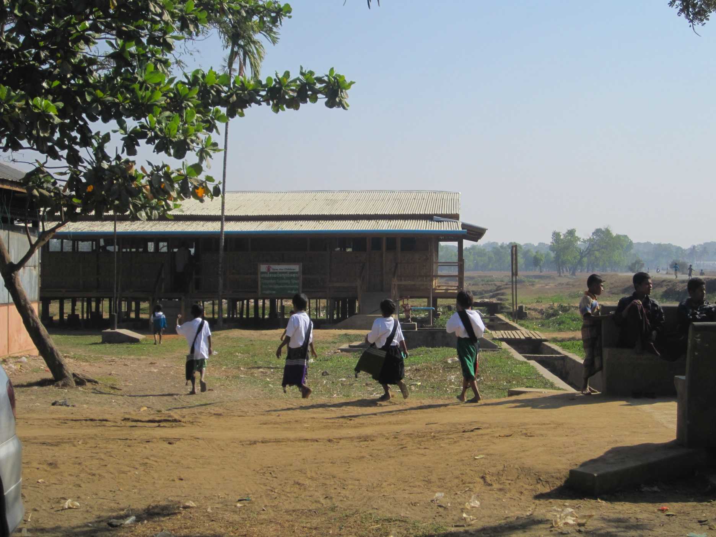

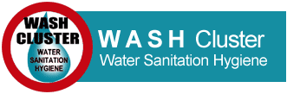 

# Context & Subject Scope

The following guidance note formalizes the roles and responsibilities for implementing, in the best coordinated manner, WASH emergency activity in educational structures, either Temporary Learning Spaces (TLS) in camp setting or Village or a permanent school structures’ so that all children benefit from a protective learning environment.

As validated in the WASH Cluster Strategy and Education Sector Strategy since 2013, one WASH focal agency and one EiE focal agency is in charge per location (camp or village) avoiding any overlapping in response. The WASH and EiE focal points in the location hold the responsibility to develop a full package covering on all sub- thematic issues, aiming to fully cover sector objectives outlined for beneficiaries. For the WASH Cluster partners this includes, the WASH needs of education structures.

However, the WASH sector’s approach has been more defined to target camp settings in which 100% of WASH needs are supported, including educational structures. In villages the definition is less systematic, where the Wash cluster has intervened in different type of villages with different targets: Affected villages, villages with IDP and surrounding villages. In consequence, in villages the Wash interventions in schools has not been systematic, despite being a recommended priority approach in both the WASH cluster and EiE strategies. In addition the lack of joint planning between WASH and EiE agencies has led to an insufficient and non-systematic response in education structures in both camps and villages. This has mainly been due to funding limitations and lack of coordination between sectors. While WASH may face difficulty in funding WASH in Schools.

Thus, based on lessons learned, this guidance note modifies the definition of roles and responsibilities, enabling strengthened coordination and ensuring direct WASH technical support to establish quality WASH in Schools interventions. .

# Roles and responsibilities

## Overall principle:

It is essential all actors recognize the focal WASH agency per location as the key actor in any and all WASH interventions. This understanding will ensure, quality, technical delivery of WASH interventions, no on-going project is negatively impacted and the designated WASH agency can maintain a holistic community approach. This will additionally ensure sensitivity of the following actions is taken into consideration: procurement modality, contracting approach, communication with community, casual labor payment rate.

This note does not aim to establish a siloed approach by separating responsibility, but rather clarify each sectors technical roles to ease synergy between the actors at field and cluster level and ensure all children are provided access to a protective learning environments.

## Coordination between Sectors:

The wash cluster being responsible and accountable to the Wash situation in any structure, including School and TLS, in the Humanitarian Response plan (HRP) scope, Wash situation in School/TLS should be adequately transmitted to Wash cluster. To ensure coherent inter-sectorial coordination mechanism, the Education and WASH Cluster coordinators will regularly consolidate sector challenges and issues.

Joint field visits and monitoring should be organized based on specific situation/concerns.

All needs assessments concerning WASH in schools or broader WASH issues will be approached in a coordinated manner between sector coordinators. The Wash Cluster should regularly inform the Education sectors about need analysis done through its monitoring tools, including properly School infrastructures.

The tools to support this coordination planning include the WASH and Education 4W (Who-what-Where-When), WASH and Education Contact lists updated and shared on a monthly basis and the WASH and Education strategies and corresponding work plan.

## Coordination at site level:

Despite above definition of Sector role and responsibility, it is essential that successful coordination is developed at field level between involved actors, especially considering that each location has specific dynamics in a heterogeneous overall context.

EiE and WASH actors must collaborate to determine practical plans and solutions specific for each location. Situation, availability of services and therefore arrangements are different from camps to villages.

The main responsibility for both WASH and Education agencies is to ensure a joint and coordinated planning on each site in line with WASH and Education strategies. Planning involves program managers of both domains to agree on the details and specificities of each context and community.

Any community problems faced by an actors should be shared with the other one. A joint approach to community participation and communication should be developed, establishing a clear vision and approach to beneficiaries and re-enforcing join leverage to community when necessary.

In camp setting, the participation to CCCM meeting should be considered as a key coordination mechanism.

In villages or host communities in which there is no WASH agency working, EiE agencies should refer to the WASH Cluster for guidance on the existing relevant standards who should also offer support to liaise with the local authorities directly TEO, TDE or DRD.

# Intervention modalities

## Construction of WASH Facilities in Education Structures

**EiE Agency Responsibility**

Contract and construction payment: EiE agency is responsible for initiating the planning process for construction contracts for latrines, hand washing stations and/or water points. This should include in all cases a WASH Focal agency representative with decision making power (manager, coordinator). All technical designs are to be provided by the WASH Cluster and/or agency.

Construction management and contractor mediation: EiE agency is responsible to manage the construction process and address any issues which may arise. WASH Focal agencies should provide technical support and monitoring at the request of the EiE agency. One option can be proposed by the EiE agency for construction management is to establish two payment installments only after approval by the WASH agency representative.

**WASH Agency Responsibility**

Technical monitoring: EiE agency should request technical monitoring support from WASH agency to ensure quality design and construction.

Contract issuing and construction guidance: As individual agencies have different procedures for contracting, tendering and construction management, an open discussion on the best way to proceed in construction is necessary between agencies at the initial planning meeting. If and when applicable, WASH agencies should provide EiE agencies guidance on tendering procedures and key contracting stakeholders. The contracting process should take strongly in consideration the local micro-dynamics, especially in camps, following a joint strategy with the WASH focal agency to avoid any negative impact or future constraint.

## WASH FACILITIES OPERATION AND MAINTENANCE IN EDUCATION STRUCTURES

**EiE Agency Responsibility**

General maintenance: EiE agency/ learning space is responsible for latrine cleaning, transporting water where/when necessary, making small repairs such as broken locks and purchasing all cleaning supplies. The WASH sector can provide recommendations where needed.

Operation of WASH facilities: EIE agency/PTA must ensure that all children have access to the WASH facilities at any time during the school operation hours: latrines are not locked, soap and water are available.

Social organization: Organization of the management of facilities is defined in the EiE project approach and should be ensured among PTA members in link with TEO and local authorities by the EiE agency.

**WASH Agency Responsibility**

Desludging: WASH agencies provide desludging services within camps upon request by the EiE agency/learning center. The EiE agency/PTA to inquire about the desludging service available in the camp and adapt to it (frequency, schedule…). In villages, WASH agencies are not required to desludge.

Solid waste management: WASH agencies provide solid waste management services within camps upon request by the EiE agency/learning center. The EiE agency/PTA to inquire about the waste management process working in the camp and adapt to it (frequency of collection, collection points…). In villages, WASH agencies are not required to manage waste.

Training and hygiene messaging: Close coordination between EiE and WASH partners should aim at ensuring inclusion of WASH in education programs (teachers training, child health clubs…). EiE agency should request training and/or key messaging from WASH agency for the learning centers. Trainings can include but are not limited to; safe water handling, use of ceramic filters, solid waste management, determining when desludging is needed, cleaning of latrines, hand washing and hygiene messaging. WASH Cluster will share IEC material templates and the EIE Agency is financially responsible for procurement and distribution. It is to be noted that specific WASH in schools IEC material are available at the WASH Cluster.