Joint WASH field visit monitoring trip

Hpakant

WASH cluster / Shalom / DRD

1st-7th April 2015

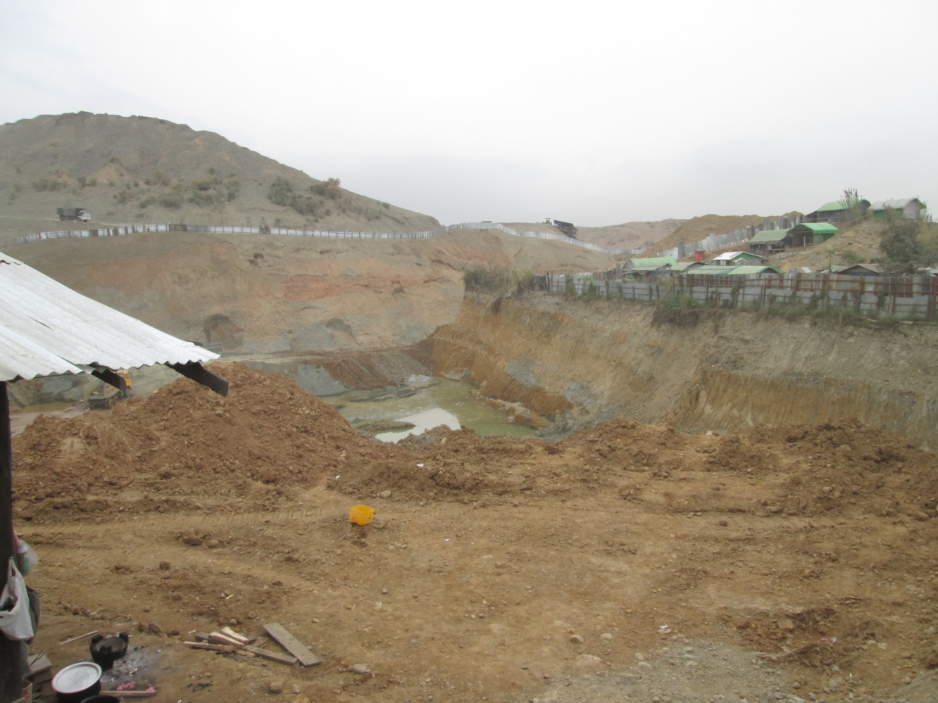
Jade Mining site near AG Maw Si Sar Camp

Table of Contents
1 Background 4
1.1 Rationale 4
1.2 Timeframe 4
1.3 Objectives 4
1.4 Participants 4
1.5 Methodology 4
1.6 Scope 5
2 Main findings on WASH situation 6
2.1 Impact of population increase on existing WASH infrastructures 6
2.2 Water shortage issues 9
2.3 Needed interventions for water access 9
2.4 Needed interventions for sanitation 11
2.4.1 Latrines 11
2.4.2 Desludging Issue in Hpakant Area 12
2.4.3 Solid waste management 12
2.4.4 Bathing Spaces 12
2.4.5 Hand Washing Stations 14
2.5 Needed interventions for Hygiene 15
2.5.1 Hygiene promotion 15
2.5.2 WASH NFI 16
2.6 Operation and maintenance 18

Annex 1: Agenda 19
Annex 2: Detail of WASH situation per IDP camp 20
Annex 3: Pictures 42

Background

Rationale
On 14 January, fighting broke out in the Hpakan area of Kachin State between the Government of Myanmar Army and the Kachin Independence Army (KIA). This fighting led to the arrival of about 660 individuals in four existing IDPs camps and one new camp.
An inter UN agency scoping mission including WASH staff has been deployed from 22 – 24 January to conduct a quick overview of needs and the humanitarian situation.
On 30 January, local NGOs could distribute - through ERF mechanism support (consortium of three INGOs) - 200 HKs to IDPs affected by the conflict. Training of WASH NGOs staff on emergency WASH assessment has also been carried on through this ERF mechanisms.
The limited operational capacity of WASH focal agencies in Hpakant prevented from carrying out a robust WASH assessment at a later stage to assess the eventual impact of new IDPs on existing WASH facilities. Besides, the chronic water shortage issue in Hpakant area requires to follow up closely the situation in this area.

Time Frame
The field visit monitoring trip has been carried out from 1st to 7th April 2015
See agenda in Annex I

Objectives
This joint field trip monitoring trip aimed at :
- Assessing the impact on existing WASH infrastructures following the recent arrival of new IDPs in the existing IDPs camps of Hapakant
- Following up chronic water shortage issue in Hpakant
- Monitoring overall WASH situation & Update WASH data (4W) in existing IDPs locations of Hpakant
- Assessing WASH NFI situation
- Better understanding desludging issues in Hpakant area

Participants
- 2 WASH monitors form the WASH Cluster Kachin and NSS
- 1 staff from Nyein (Shalom) Foundation
- Up to two Hpakant Township DRD staff

Methodology
- Preparation of Field monitoring trip with Hpakant Township DRD authorities who liaise with GAD.
- Focus groups discussion with IDPs community
- Meeting with Camp committee leaders
- Field observations
- Township DRD will inform to the Local Administration Committee of IDP camp area
- Two staffs from Township DRD will accompany in this joint Assessment
- In addition, Township DRD will assist to meet with local authority of Seik Mu village to inquiry about the impact of land slide
- Township DRD will help in WASH in school activities that will implement from ADRA

Scope
- This assessment has been carried out in 20 camps of Hpakant area. KMMS is the WASH focal agency in 2 camps while Shalom is the WASH focal agency in the other 18 camps. Due to funding gaps there is currently no WASH project in these 20 camps. There is a total of 22 IDPs camps in Hpakant area. The two camps that were not visited were located in remote area not accessible within the frame of this assessment.
- The 20 assessed camps host a total of 3442 IDP camp of Hpakant area
- 18 FGD (Focus Groups Discussion) about WASH NFI and Hygiene were held during the assessment in 18 camps. There was no FGD in the new open camp named Baptist Church Gaday village

Main findings on WASH situation

Impact of population increase on existing WASH infrastructures
The table blow shows the impact of new IDPs arrival on the population of 6 existing IDPs camps of Hpakant area.
Camp Name | Household  (Dec 2014) | Population (Dec 2014) | New IDPs  (HHs) | New IDPs  (Individual) | Total current IDPs  (HHs) | Total current IDPs  (Individual) | % of increase
Hpakant Baptist Church Nant Ma Hpit | 65 | 297 | 57 | 228 | 122 | 525 | 177%
5 Ward RC Church (Lon Khin) | 59 | 321 | 24 | 104 | 83 | 425 | 132%
Nant Ma Hpit Catholic Church | 53 | 261 | 2 | 11 | 55 | 272 | 104%
Hmaw Wan Anglican | 10 | 57 | 3 | 18 | 13 | 75 | 132%
Ward 2 Sai Tawng Baptist Church Seik Mu | 32 | 173 | 6 | 17 | 38 | 190 | 110%
Yu Mar Baptist Church | 12 | 66 | 10 | 14 | 22 | 80 | 121%
Total | 231 | 1175 | 102 | 392 | 333 | 1567 | 133%

The table provides the WASH needs coverage in these 6 IDPs locations and is extracted from the WASH 4W matrix updated from the assessment carried out in Hpakant:
Extract 4W March 2015 for these IDP locations
Site | Nb of affected household | IDPs Pop | Focal point Agency | Ending date funds/project coverage | Water coverage | % Latrine needs coverage | # Semi permanent latrines missing | Coverage Bathing % | Nb of missing bathing space | Coverage hand wash station % | Nb of missing hand washing station | HKs  Next distribution to be done | Ratio between population and nb of community HP | Community management organise and efficient in camps
Hpakant Baptist Church, Nam Ma Hpit | 118 | 519 | Shalom | Gap | 100% | 62% | 10 | 58% | 2 | 58% | 2 | To be realized | Excellent coverage | Functional and efficient
5 Ward RC Church(lon Khin) | 83 | 425 | KMSS | Gap | 100% | 89% | 2 | 47% | 2 | 47% | 2 | 27-Jun-15 | No coverage | Set up but low results
Nant Ma Hpit Catholic Church | 55 | 272 | KMSS | Gap | 100% | 74% | 4 | 74% | 1 | 100% | 0 | 27-Jun-15 | No coverage | Set up but low results
Hmaw Wan, Anglican | 13 | 75 | Shalom | Gap | 100% | 100% | 0 | 100% | 0 | 100% | 0 | To be realized | Excellent coverage | Functional and efficient
Ward 2 Sai Taung Baptist Church, Seik Mu | 40 | 190 | Shalom | Gap | 100% | 95% | 6 | 100% | 0 | 100% | 0 | To be realized | Excellent coverage | Functional and efficient
Yumar Baptist Church | 22 | 80 | Shalom | Gap | 100% | 100% | 3 | 100% | 0 | 100% | 0 | To be realized | Excellent coverage | Functional and efficient
Total | 331 | 1561 |  |  |  |  | 25 |  | 5 |  | 4

Water Needs within these 6 locations

No | Camp Name | Water Coverage (Dec 2014) | Water Coverage (Present) | Encounter Problem | Needed Actions
1 | Hpakant Baptist Church, Nam Ma Hpit | 100% | 80% | Due to increased population , current water pipe line size is not enough to provide the needed yield | To set up with 2’’pipe size in current GFS
2 | 5 Ward RC Church(lon Khin) | 100% | 100% | Seasonal Water Shortage | Emergency Water trucking
3 | Nant Ma Hpit Catholic Church | 100% | 100% | NO | NO
4 | Hmaw Wan, Anglican | 100% | 100% | Seasonal water shortage | Water distribution from municipal pipe line
5 | Ward 2 Sai Taung Baptist Church, Seik Mu | 100% | 100% | Although adjacent Mining company shared the water, as they don’t have water storage tank, they are facing with trouble in storing water for daily usage | No
6 | Yumar Baptist Church | 100% | 100% | Can’t store water for daily water usage | - to set up with water storage tank

During seasonal water shortage time IDPs go to the nearest neighbor houses to fetch drinking water and domestic usage. Some adult people go to the stream to take a bath.

Latrines Needs within these 6 locations
No | Camp Name | Latrine Coverage (Dec 2014) | Latrine Coverage (Present) | Missing SP Latrines | Encounter Problem | Needed Actions  Comments
1 | Hpakant Baptist Church, Nam Ma Hpit | 98% | 61% | 10 |  | Need to build up 10 more Semi permanent latrines
2 | 5 Ward RC Church(lon Khin) | 81% | 89% | 2 | Not have land space but Church committee let IDPs to use 6 Church owned Latrines | NO
3 | Nant Ma Hpit Catholic Church | 87% | 74% | 4 |  | Need to build 4 more semi permanent latrines
4 | Hmaw Wan, Anglican | 71% | 100% | 0 | s | Church committee let them to use Church owned 2 Latrine
5 | Ward 2 Sai Taung Baptist Church, Seik Mu | 94% | 95% | 6 |  | Church constructed 5 emergency latrines for IDP use
6 | Yumar Baptist Church | 100% | 100% | 3 | Church committee don’t let to use to construct more latrines

Bathing Spaces Needs within these 6 locations
No | Camp Name | Bathing Coverage (Dec 2015) | Bathing Coverage (Present) | Missing Bathing Spaces | Encounter Problem | Needed Actions
1 | Hpakant Baptist Church, Nam Ma Hpit | 62% | 58% | 1 |  | Need to build up 1 bathing space
2 | 5 Ward RC Church(lon Khin) | 62% | 47% | 2 |  | Need to build up 2 bathing spaces
3 | Nant Ma Hpit Catholic Church | 87% | 74% | 1 |  | Need to build up 1 bathing space
4 | Hmaw Wan, Anglican | 100% | 100% | 0
5 | Ward 2 Sai Taung Baptist Church, Seik Mu | 100% | 100% | 0 |  | Current bathing spaces need to renovate for privacy
6 | Yumar Baptist Church | 100% | 100% | 0 |  | Current bathing space need to renovate

Hand Washing Stations within these 6 locations
No | Camp Name | Bathing Coverage (Dec 2015) | Bathing Coverage (Present) | Missing Bathing Spaces | Encounter Problem | Needed Actions
1 | Hpakant Baptist Church, Nam Ma Hpit | 100% | 57% | 2 |  | Need to build up 2 hand washing stations
2 | 5 Ward RC Church(lon Khin) | 62% | 47% | 2 |  | Need to build up 2 hand washing stations
3 | Nant Ma Hpit Catholic Church | 100% | 74% | 1 |  | Need to build up 1 hand washing station
4 | Hmaw Wan, Anglican | 100% | 100% | 0
5 | Ward 2 Sai Taung Baptist Church, Seik Mu | 100% | 100% | 0
6 | Yumar Baptist Church | 100% | 100% | 0

New IDP camp
1 new camp was opened in Gaday village in January 2015 because of intense fighting at their village. WASH facilities existing in this camp and needed action are mentioned are as followed.
Camp Name | HH | Pop | Water supply | Needed Actions | Latrines | Needed Actions | BS | Needed Actions | Hand Washing Stations | Needed Actions
Baptist Church Gaday village | 58 | 244 | GFS (shared by village water supply line) and 1 emergency water storage tank | - 1 water storage tank  (minimum 750 Gallon) to cover for all 1 day usage | 6 | 7 semi permanent latrines need to build | 1 (temporary Bathing space with tarpaulin sheet) | 2 bathing spaces need to set up | 0 (now they wash their hand with the water from the tank attached in the latrines) | 3 hand washing station need to set up)
Hygiene Promotion and WASH NFI for increased population and new camp
- There was no any hygiene promotion session for these new IDP people in these camps after they arrived to these camps. Sanitation facilities are used (using latrines, disposing solid waste, water usage, etc.,) based on the camp management advise to the new IDPs.
- The camp management committee request the hygiene promotion like last year because the latrines were blocked with sanitary pads and some open defecation occurs near latrines following new IDPs arrival
- WASH NFI is also needed for new IDPs. There is no enough water storage and carrying buckets. The IDP people complaint that although they bought the required WASH items at the start camp arriving, it is start to lack of money that was brought from their home. In Baptist Church Gaday village, soap was received by the donation of particular donation from the Church

Water shortage issues
Seasonal water shortage has been identified in 5 IDPs camps:
- AG Church Maw Si Sar
- Maw Wan Anglican
- 5 Ward Baptist Church Lon Khin
- 5 Ward RC Church Lon Khin and
- Rawan Baptist Churh Maw Shan village Seik Mu
The main water facilities prone to seasonal water shortage are hand dug wells

Needed interventions for water access in 20 camps
No | Camp Name | Water Source | Encounter Problem | Priority to Repair | Needed Actions
1 | Baptist Church Sai Ra village | 1 HDW
2 | 5 Ward RC Church Lon Khin | 1 HDW | Shortage | 1 | - need temporary water storage tarpaulin tank  - need emergency water distribution
3 | 5 Ward Baptist Church Lon Khin | 2 HDW | Shortage | 1 | - need temporary water storage tarpaulin tank  - need emergency water distribution
4 | Baptist Church Maw Si Sar (Lon Khin) | 2 HDW | Loose cooperation for operating the water supply system | 2 | - Need Coordination among CCCM, IDP and Church to maintain the water supply system
5 | DhamaRakhitaNyein Chan TharYar Ward (Lon Khin) | 1 HDW | Frequently damage pumping machine. Sometime camp running cost is not cover to repair it. | 2 | - Need Coordination among CCCM, IDP and Church to maintain the water supply system
6 | Baptist Church Gaday villages | 1 HDW+1GFS
7 | Sai Nai Baptist Church Maw Shan village, Seik Mu | 1 HDW | Temporary water storage tank tear | 2 | HDW is owned by Company, even if they pump up, they get water.  Need tarpaulin sheet to repair temporary storage tank
8 | Lisu Baptist Church Maw Shan village, Seik Mu | 1 HDW+1GFS |  |  | Now they are repairing pump motor by themselves
9 | Rawan Baptist Church, Maw Shan village, Seik Mu | 1 GFS | Shortage | 1 | - need temporary water storage tarpaulin tank  - need emergency water distribution
10 | Chin Church Seik Mu | 1 HDW | High Price for water | 2 | - Need Coordination among CCCM, IDP and Church
11 | Ward 2, Sai Tawng Baptist Church, Seik Mu | 1 GFS
12 | Yumar Baptist Church | 1 HDW | No storage tank | 1 | - Need water storage tank (but need to discuss with land owner Church committee before build up)
13 | Maw Wan Mu Yin Baptist Church | 1 HDW + 1 GFS
14 | AG Church Maw Si Sar | 1 HDW | Shortage | 1 | - need temporary water storage tarpaulin tank  - need emergency water distribution
15 | Lisu Baptist Church Maw Wan Ward | 1 HDW | design of HDW | 2 | But need to add parapet and lining in the hand dug well
16 | Hpakant Baptist Church Nant Ma Hpit | 1 GFS | Design of GFS | 2 | - Need to change from 1 inch pipe line to 1.5 inches or 2 inches pipe line
17 | Nant Ma Hpit COC | 1 HDW + 1 GFS
18 | AG Church Maw Wan | 1 HDW | Storage tank | 2 | - Need IDP use engine and dynamo to pump up the water
19 | Nant Ma Hpit Catholic Church | 1 HDW
20 | Hmaw Wan Anglican | 1 HDW | Shortage | 1 | - need emergency water distribution (can get water from company pipe line)
*HDW = Hand Dug Well, GFS= Gravity flow System
*For Priority 1 = require immediate or urgent action, 2= require short term action

Encounter Problems in Water Supply System of Hpakant Area

In 20 camps opened in Hpakant township area, 13 camps (65%) get water mainly from Hand Dug Well, 5 camps (25%) from Gravity flow system and 2 camps get from both hand dug well and gravity flow system. Among them, 4 camps used water from hand dug well faced with water shortage problem during in summer season and 1 camp from gravity flow system.

Needed interventions for sanitation

Latrines

No | Camp Name | Population | Functioning Latrine | Missing Semi permanent latrine | Available land space | Remarks
1 | Baptist Church Sai Ra village | 4 | 3 | 0
2 | 5 Ward RC Church Lon Khin | 425 | 19 | 3 | No | Church committee feel that current latrine amount is enough
3 | 5 Ward Baptist Church Lon Khin | 360 | 5 | 13 | No | Church committee feel that current latrine amount is enough
4 | Baptist Church Maw Si Sar (Lon Khin) | 113 | 10 | 0
5 | DhamaRakhitaNyein Chan TharYar Ward (Lon Khin) | 335 | 17 | 0
6 | Baptist Church Gaday villages | 244 | 6 | 7 | Yes | New opened camp in Jan 2015
7 | Sai Nai Baptist Church Maw Shan village, Seik Mu | 43 | 8 | 0
8 | Lisu Baptist Church Maw Shan village, Seik Mu | 137 | 8 | 0
9 | Rawan Baptist Church, Maw Shan village, Seik Mu | 43 | 4 | 0
10 | Chin Church Seik Mu | 25 | 2 | 0
11 | Ward 2, Sai Tawng Baptist Church, SeikMu | 190 | 9 | 1 | Yes | According to the increased population
12 | Yumar Baptist Church | 80 | 3 | 1 | No | 1 frame already existed only need to dig up the pit
13 | Maw Wan Mu Yin Baptist Church | 25 | 3 | 0
14 | AG Church Maw Si Sar | 338 | 15 | 2 | Yes
15 | Lisu Baptist Church Maw Wan Ward | 71 | 4 | 0
16 | Hpakant Baptist Church Nant Ma Hpit | 519 | 18 | 8 | Yes | According to the increased population
17 | Nant Ma Hpit COC | 63 | 5 | 0
18 | AG Church Maw Wan | 80 | 4 | 0
19 | Nant Ma Hpit Catholic Church | 272 | 10 | 4 | Yes | According to increased population
20 | Hmaw Wan Anglican | 75 | 5 | 0

Desludging Issue in Hpakant Area
In Hpakant area, generally, the most of camps are opened on the filling land. This land can absorb the liquid easily. So, desludging is not the main problem in this area. During observing to 20 camps, only two latrines in one camp, Nant Ma Hpit Catholic Church were full at the time of assessment.
There is no desluding experience in IDP camps in the past. DRD and 1 camp committee share the information that there was 1 desludging truck in Township Municipal (Township Development Committee). Desludging price is50000 kyats for 1 pit.

Solid waste management
For solid waste disposal, they collect solid wastes by buckets and plastic bags at the household level. In all camps garbage collecting plastic bucket was supported by focal agencies. There are 3 types of disposing solid waste in the camps after collecting in the plastic buckets. They are 1. Dumping near the camp and burning 2. Disposing to the stream bank and 3. Disposing to the municipal dumping sites.

Dumping near the camp before burning can affect their health status because of no fencing that can be entered by the animals. And there is no specific place to dispose for female sanitary pad in this site (female sanitary pad burning place). And disposing to the stream bank is also a problem for the environmental sanitation. Operating on Solid Waste Management by disposing on the Municipal recommended places was done in 9 camps.

Bathing Spaces
Bathing Spaces Situation in Hpakant Area

No | Camp Name | Population | Bathing Spaces | Missing Bathing Spaces | Available land space | Remarks
1 | Baptist Church Sai Ra village | 4 | 1 | 0
2 | 5 Ward RC Church Lon Khin | 425 | 2 | 2 | Yes | Need to renovate to the current Bathing spaces and need 2 more Bathing spaces to cover for all
3 | 5 Ward Baptist Church Lon Khin | 360 | 2 | 2 | No | Most of them bath near Hand Dug well and in their house
4 | Baptist Church Maw Si Sar (Lon Khin) | 113 | 2 | 0
5 | DhamaRakhitaNyein Chan TharYar Ward (Lon Khin) | 335 | 3 | 0
6 | Baptist Church Gaday villages | 244 | 1 | 2 | Yes | Need to renovate to the current temporary Bathing spaces and need 2 more Bathing spaces to cover for all
7 | Sai Nai Baptist Church Maw Shan village, Seik Mu | 43 | 2 | 0
8 | Lisu Baptist Church Maw Shan village, Seik Mu | 137 | 2 | 0
9 | Rawan Baptist Church, Maw Shan village, Seik Mu | 43 | 2 | 0
10 | Chin Church Seik Mu | 25 | 1 | 0
11 | Ward 2, Sai Tawng Baptist Church, Seik Mu | 190 | 3 | 0 | Yes | Need to renovate to the existing bathing spaces (no privacy for girl)
12 | Yumar Baptist Church | 80 | 2 | 0 | No | Already set with Permanent Bathing spaces, now use in Temporary Bathing spaces
13 | Maw Wan Mu Yin Baptist Church | 25 | 2 | 0
14 | AG Church Maw Si Sar | 338 | 2 | 1 | No | They have a plan to move current Bathing Space bcoz of raising surrounded lands
15 | Lisu Baptist Church Maw Wan Ward | 71 | 2 | 0
16 | Hpakant Baptist Church Nant Ma Hpit | 519 | 3 | 2 | Yes | According to increased population
17 | Nant Ma Hpit COC | 63 | 2 | 0
18 | AG Church Maw Wan | 80 | 2 | 0
19 | Nant Ma Hpit Catholic Church | 272 | 2 | 1 | Yes | Need to renovate to the current temporary Bathing spaces and need 1 more Bathing space to cover for all
20 | Hmaw Wan Anglican | 75 | 1 | 0

Hand Washing Stations
16 camps have already full coverage for Hand Washing Stations. Only 2 camps need to build hand washing stations for the new arrived IDP peoples.
No | Camp Name | Population | Hand Washing Stations | Missing Hand Washing Stations | Available land space | Remarks
1 | Baptist Church Sai Ra village | 4 | 3 | 0
2 | 5 Ward RC Church Lon Khin | 425 | 2 | 2 | No | They wash in the nearest bathing space
3 | 5 Ward Baptist Church Lon Khin | 360 | 6 | 0
4 | Baptist Church Maw Si Sar (Lon Khin) | 113 | 4 | 0
5 | DhamaRakhitaNyein Chan TharYar Ward (Lon Khin) | 335 | 4 | 0
6 | Baptist Church Gaday villages | 244 | 3 | 3 | Yes | New camp
7 | Sai Nai Baptist Church Maw Shan village, Seik Mu | 43 | 2 | 0
8 | Lisu Baptist Church Maw Shan village, Seik Mu | 137 | 2 | 0
9 | Rawan Baptist Church, Maw Shan village, Seik Mu | 43 | 6 | 0
10 | Chin Church Seik Mu | 25 | 3 | 0
11 | Ward 2, Sai Tawng Baptist Church, Seik Mu | 190 | 3 | 0
12 | Yumar Baptist Church | 80 | 2 | 0
13 | Maw Wan Mu Yin Baptist Church | 25 | 2 | 0
14 | AG Church Maw Si Sar | 338 | 4 | 0
15 | Lisu Baptist Church Maw Wan Ward | 71 | 3 | 0
16 | Hpakant Baptist Church Nant Ma Hpit | 519 | 3 | 2 | Yes | According to the increased Population
17 | Nant Ma Hpit COC | 63 | 3 | 0
18 | AG Church Maw Wan | 80 | 3 | 0
19 | Nant Ma Hpit Catholic Church | 272 | 2 | 1 | Yes | Only Need if new latrines build
20 | Hmaw Wan Anglican | 75 | 1 | 0

Overall Needed WASH Facilities in Hpakant area
The cost mentioned below are purely estimated and are given for information only. A more robust cost estimation is needed and is not part of this assessment.
Component | Activities | No of Camp | Needed Actions | Estimated budget (USD)
Water Supply | Emergency Water supply during water shortage | 5 | 1241 people x15 liter= 18615 Lit/day X30 days (water trucking) for May 2015 | 3000
 | Deepening of hand dug Well | 1 | 15 ft deepening in the current hand dug well | 1000
 | Upgrading the current GFS | 1 | To get water from spring source 6000’ with 2’’ pipe size (1 geophysic surveyX1000+1water point upgrading) | 1300
 | Water Storage tank construction | 3 | 3 ground water storage tankX300 | 900
Sanitation | Semi Permanent Latrine | 5 | 22 semi permanent latrineX350 | 7700
 | Bathing Space | 5 | 7 Bathing need to build upX400 | 2800
 | Renovation of Bathing Sapce | 4 | 8 Bathing space need to renovate (now not privacy)X400 | 3200
 | Hand Washing Stations | 3 | 6 hand washing stationsX100 | 600
 | Desludging | 1 | 2 latrines need to desludgeX50 | 100
Hygiene | Full Hygiene Kit | 20 | 734HHX35 | 25690
 | Refill Hygiene items | 20 | 734 HHX12monthX5 | 44040
 | Hygiene Promotion | 20 | 1241beneficiariesX25 | 31025
Community Mobilization | WASH committee set up | 20 | 20campX150 | 3000
 | Maintenance Kit | 20 | 20campX150 | 3000
 | Training for committee | 20 | 60sessionsX150 | 9000
Total Estimated Budget |  |  |  | 136355

Needed interventions for Hygiene

Hygiene promotion
In IDPs camps where Shalom is the WASH focal agency, Hygiene Promotion is carried out by hygiene promoters volunteers. They have to do in the dissemination of hygiene education, distribution of hygiene Kits, mobilizing IDPs for cleaning campaigns, and monitoring in every month.
For IDP camps with smaller population (<10 Households) one hygiene volunteers were assigned; whereas, for IDP camps with larger population (>10 Households), two volunteers are assigned. Hygiene volunteers were first trained on Hygiene promotion: F-diagram, 4 clean techniques, how to use ORS, WASH related diseases and how to promote the environmental sanitation of the camps. Refresher training was also provided to the volunteers after two months of the 1st training. Hygiene volunteers mobilize IDPs every month to attend Health Education sessions and Sanitation campaign. Poster, demonstration, arts, role play, singing and drama competition held during the project period.
Shalom hygiene promotion staff monitors regularly the activities of the volunteers. Monthly meeting is organized by Shalom Hygiene promotion staff whereby all volunteers share information, challenges, lesson learned and constraints. Exchange visit was arranged between different camps to increase learning between volunteers.
In KMSS focal camps, Hygiene Promotion activities were done by Project staffs directly. Project staffs arrive to the focal camp approximately 1 time per 3 month. But this time is not defined as routinely. Daily supervision and mobilizing activities were mainly done by the Camp Management staffs who are assigned by the CCCM committee. They mobilize for sanitation campaign to conduct in every week and they assisted in Hygiene kits distribution and also in the other items such as food and NFI distribution process.
Following FGD, it appears that:
- Most of the IDPs mentioned having changed their behavior since they receive HP training and notably in terms of hand washing. IDPs in 5 camps said they shift from using sticks or paper after defecation to water cleansing method.
- Latrines surrounding are cleaner than before and no more cleansing material are visible (Toilet paper, Sticks..)
- Increased bath frequency.
- Use of soap for clothes washing unlike arriving to the camp
- Better disposal of solid waste management in one camp

Besides FGD, field observations highlighted:
- Feces near the latrines in 2 camps
- Solid waste was disposed in the stream bank near the camps in 6 camps
- No soap in the hand washing station in most of the camps. But they said that so as the soaps frequently lost in the hand washing station, in later, they do not put the soaps in washing stations. They wash in their home or by bringing and wash in the hand washing stations.

WASH NFI
Outputs from FGD were:

1. Current Situation of Hygiene Kits
Main issue is the refill items. Although some household still have in some items in low family members, some households start to buy the hygiene items (mainly on soaps and tooth paste). In 2 camps, they use body soap in washing because body soaps still have and washing soap is empty. For the new arrived IDPs, they have not received soaps from any agencies; soaps are donated only by Church. Now they are using cautiously soaps and tooth pastes.
2. What is the problem of Hygiene Kits?
Financial problem is the main challenges in their household (not have daily income), to get daily income to buy hygiene items daily is very difficult because Hpakant is a very risky area for life threaten in working in Mining sites. . In camps there are so many additionnal things with regard to their original village (for education of our children). Among the all hygiene items, washing soap is main problem than other items. They (in some camps) wash the clothes with only water and sand, while they arrive to the camps, the hygiene promoter promoted to use the soaps for washing, now they are in practices. At that time, if the agencies stop the distribution of soaps and tooth pastes; they will be stay back to the original states. It will effect to the personal hygiene of the camp people because of economical usage in hygiene items.
3. Can you buy it around your camps?
They can buy all hygiene items around their camps.
4. Can you afford to get it?
They faced with trouble while there is no casual jobs. And ther are so many risk to work in the mining area. (1 person from Sai Taung was died from hitting the large stones while working in the jade mine at Feb 2015). Some Mine Comapany don’t want to give the job, because they (some owner of jade mine)assume that the IDP are the unlucky men. Their works is based on fate. So, the unlucky fates will dissiminate to them if they give the job in their company for IDP. Sometiems they go to our plot field of our original village to get income. But one people (from Li Su Church Maw Wan) was demaged and cut the leb by mine. So, to go to the original place’ plot field is also danagerous.
5.Copying mechanisms
They solve the hygiene gap:
1. by borrowing money from Church
2. by borrow money from our relatives residing in the Hpakant
3. by selling the ration rice to buy the hygiene refill items
4. by reducing other expenses (eating eggs instead of eating meats)

Operation and maintenance
Operation and Maintenance on WASH facilities was mainly done by Camp Management Committee. Camp management committee was formed with the representatives of IDP and Church committee. Under the management of camp management committee, the sub-committee operated on their assigned works such as CCCM, Shelter, Solid Waste Disposal, food distribution, health. So, most of the decision to use the budget in O&M for WASH facilities came from the output of internal advocacy meeting of camp management committee.
To operate for water pumping up to the camp, camp management committee assigned one focal person or appointed one staffs from external by paying salary. If the machine was broken/damage, the mechanic outside the camps repaired it. There is no skillful person in the camps mostly. And the IDP people understand that the pumping or to get water in the camps is only responsible in the camp management committee.
In Chin Church Seik Mu, water supply system is set up with metering system. And the IDP people need to pay for the charges according to their usage. The camp management committee assigned 1 staff for pumping up the water from the source to the using point.
Latrines were defined with household numbers to clean and for maintenance. Small scale repairing in latrine was responsible to these assigned households. Solid waste management was supervised by the camp management committee. To dig up the burying pit and hire the vehicle to dispose the solid waste is taken by Camp Management Committee.

Annex 1: Agenda
 | Activities | Comment
1st April | Trip Myitkyina / Hpakant from 9h00 to 15h00  Meeting with Deputy Director of Township Department of Rural Development and Shalom Hpakant team to prepare the joint field assessment | - implement in the budget year 2015-2016 in Hpakant concerned with building with latrine
2nd April | WASH field assessment in  Baptist Church Sai Ra village  5 Ward RC Church Lon Khin  5 Ward Baptist Church Lon Khin  DhamaRakhitaNyein Chan TharYar Ward (Lon Khin)  Baptist Church Maw Si Sar (Lon Khin)  WASH Emergency Assessment in  Gaday Baptist Church
3rd April | Sai Nai Baptist Church Maw Shan village, Seik Mu  Lisu Baptist Church Maw Shan village, Seik Mu  Rawan Baptist Church, Maw Shan village, Seik Mu  Chin Church Seik Mu  Ward 2, Sai Tawng Baptist Church, Seik Mu  Yumar Baptist Church  Sai Wan Baptist Church (Branch of Nant Ma Hpit Baptist Church)
4th April | Maw Wan Mu Yin Baptist Church  AG Church Maw Si Sar  Lisu Baptist Church Maw Wan Ward  HpakantBaptist Church Nant Ma Hpit  Nant Ma Hpit COC  AG Church Maw Wan
5th April | Data Entry and Report Writing (not taken field visit to the camps because of religious day
6th April | Nant Ma Hpit Catholic Church  Hmaw Wan Anglican | went to the Seik Mu village Administrator to discussed with Village administrator about the last even of land slide occurred in Seik Mu village Mining site
7th April | - Return back from Hpakant to Myitkyina, departed from Hpakant at 9:00 am and arrived to Myitkyina 15:00

Annex 2: Detail of WASH situation per IDP camp
Baptist Church Sai Ra village

Site | Nb of affected household | IDPs Pop | Focal point Agency | Ending date funds/project coverage | Water coverage | % Latrine needs coverage | # Semi permanent latrines missing | Coverage Bathing % | Nb of missing bathing space | Coverage hand wash station % | Nb of missing hand washing station | Next distribution to be done | Ratio between population and nb of community HP | Community management organise and efficient in camps
Baptist Church, Sai Ra village | 1 | 4 | Shalom | Gap | 100% | 100% | 0 | 100% | 0 | 100% | 0 | To be realized | No coverage | Not yet set up

Finding
- Only 1 Household 4 people live in this camp. They don’t want to move to another camp. They want to live in this church compound because of many reasons. One of all is there is no water shortage in this camp. They can get the water throughout the whole year while the most of Hpakant area faced with water shortage. Another reason is personal good relationship with the Church religious leaders. And as one family member is suffering from chronic disease, they don’t want to live as IDP compound.
- 1 Protective Hand Dug Well, 1 Bathing Spaces and 3 emergency exist in this camp
- For hand washing after defecation, they go to the bathing spaces and sometime wash in the camp
- They disposed the garbages to the nearest tunnel by collecting with the plastic bucket first
- Hygiene items can be afforded to buy by themselves mostly. But it was very difficult to buy in the rainy seasons because of lack of the manual works
Recommendation
- No need to implement in WASH infrastructure such as Water supply, Building up bathing spaces, latrines and hand washing stations
- Need to think about the refill items to distribute or by creating job opportunity to get throughout the whole year

5 Ward RC Church Lon Khin

Site | Nb of affected household | IDPs Pop | Focal point Agency | Ending date funds/project coverage | Water coverage | % Latrine needs coverage | # Semi permanent latrines missing | Coverage Bathing % | Nb of missing bathing space | Coverage hand wash station % | Nb of missing hand washing station | Next distribution to be done | Ratio between population and nb of community HP | Community management organise and efficient in camps
5 Ward RC Church(lon Khin) | 83 | 425 | KMSS | Gap | 100% | 89% | 2 | 47% | 2 | 47% | 2 | 27-Jun-15 | No coverage | Set up but low results

Findings
- As new IDP people (25HH and 105 populations) arrived to this camp at 14 Jan 2015 because of the increase tension of border area. So, update current Household is 82 and Population is 425.
- they have 2 HDW, 10 Permanent latrine, 9 Semi permanent latrines and 2 bathing spaces.
- There is not hand washing stations separately, they wash their hand in the bathing spaces or when they arrive to their house
- 2 HDW face with water shortage problem water shortage time is 3 month.
- Now, company support the water for domestic usage and get the water from one Hand Dug Well for drinking purpose
- Existing bathing tanks included in the bathing spaces is not enough to store for one day use for bathing
- The camp committee manager want to do gravity flow system from 4 miles water spring sources for sustainable water supply
- In the Hygiene refill items gap period, if it is needed while lack of manual job, they bought the soaps and other hygiene items by borrowing money from others. To get job daily is many difficult.
Recommendation
- No need to implement for constructing new water supply, latrines and hand washing stations
- Need to implement 2 bathing spaces to cover for all camp community and also for emergency water storage (for long term) to solve emergency water shortage problem (or)
- Need to arrange emergency temporary water storage tank with tarpaulin (required water will support by company)
- Need to think about the refill items to distribute or by creating job opportunity to get throughout the whole year

5 Ward Baptist Church Lon Khin

Site | Nb of affected household | IDPs Pop | Focal point Agency | Ending date funds/project coverage | Water coverage | % Latrine needs coverage | # Semi permanent latrines missing | Coverage Bathing % | Nb of missing bathing space | Coverage hand wash station % | Nb of missing hand washing station | Next distribution to be done | Ratio between population and nb of community HP | Community management organise and efficient in camps
5 Ward Baptist Church(lon Khin) | 77 | 360 | Shalom | Gap | 100% | 28% | 13 | 56% | 2 | 100% | 0 | To be realised | Excellent coverage | Functional and efficient

Findings
- They have 3 HDW and 2 bathing spaces
- 10 Permanent latrines are built as series but the camp committee opened only 5 latrines for them, if needed the camp committee will let them to use these latrines
- Current problem in the camp is water shortage problem as other most of the Hpakantaera
- Last year, they are not difficult for water in the water shortage period because Nyein (Shalom) Foundation distribute water by trucking to the temporary water storage tarpaulin tanks
- During water shortage time, they sometime to the stream to bath the water. It is far from camp about to walk about 25 minutes
- No water in Bathing spaces
- No space to construct more latrines
- They told about they are not difficult to buy hygiene refill items if they have daily manual work
Recommendation
- No need to do to dig up new water sources, bathing spaces and latrines
- Need to distribute to solve for emergency water shortage problem (they already exist temporary water storage tarpaulin tanks)
- Need to think about the refill items to distribute or by creating job opportunity to get throughout the whole year

DhammaRakhitaNyein Chan TharYar Ward Lon Khin

Site | Nb of affected household | IDPs Pop | Focal point Agency | Ending date funds/project coverage | Water coverage | % Latrine needs coverage | # Semi permanent latrines missing | Coverage Bathing % | Nb of missing bathing space | Coverage hand wash station % | Nb of missing hand washing station | Next distribution to be done | Ratio between population and nb of community HP | Community management organiseand efficient in camps
DhamaRakhita, Nyein Chan Tar Yar Ward(Lon Khin) | 65 | 335 | Shalom | Gap | 100% | 100% | 0 | 90% | 0 | 100% | 0 | To be realised | Excellent coverage | Functional and efficient

Findings
- The already hand dug well was demaged by the land filling of Mining company as compensation, The company re-build another hand dug well. But this well located near the static stagnant contaminated lake. It can be contaminated from this lake. They use the water from this well for domestic usage.
- They fetch the water from the near surrounding hand dug well for drinking purpose
- As pump to life the water from the hand dug well is now broken, there is no water in the hand washing station and bathing spaces.
- Some stool was found near the latrines because of open defecation by children (complaint by camp committee)
- When they are difficult to buy the hygiene refill items, and there is not job on these days, they sell rice got from ration to the nearest shop.
Recommendation
- Need to install water treatment system form domestic usage get from contaminated hand dug well
- Need to think about the refill items to distribute or by creating job opportunity to get throughout the whole year
Baptist Church Maw Si Sar Lon Khin

Site | Nb of affected household | IDPs Pop | Focal point Agency |  | Ending date funds/project coverage |  | Water coverage n |  | % Latrine needs coverage |  | # Semi permanent latrines missing |  | Coverage Bathing % |  | Nb of missing bathing space |  | Coverage hand wash station % |  | Nb of missing hand washing station |  | Next distribution to be done |  | Ratio between population and nb of community HP |  | Community management organise and efficient in camps
Baptist Church, Hmaw Si Sar(Lon Khin) | 35 | 218 |  | Shalom |  | Gap |  | 100% |  | 89% |  | 1 |  | 89% |  | 0 |  | 100% |  | 0 |  | To be realised |  | Excellent coverage |  | Functional and efficient

Findings
- They have 2 hand dug well, 1 water storage overhead tank, 2 bathing spaces and 10 permanent latrines and 3 hand washing concrect tanks and 1 basin
- But there is no water in bathing spaces, water storage tank, latrines and hand washing station because of lack of running cost to pump up the water to buy fuel
- There is no water shortage throughout the whole year
Recommendation
- Need to think about the O&M to function on the water supply system because if the water system was broken, other WASH facilities will also automatically be difficult to run.

Ku Day Maw KBC

Site | Nb of affected household | IDPs Pop | Focal point Agency | Ending date funds/project coverage | Water coverage n | % Latrine needs coverage | # Semi permanent latrines missing | Coverage Bathing % | Nb of missing bathing space | Coverage hand wash station % | Nb of missing hand washing station | Next distribution to be done | Ratio between population and nb of community HP | Community management organise and efficient in camps
Ku Day Maw KBC | 58 | 224 | None | Gap | 100% | 54% | 5 | 0% | 2 | 0% | 2 | To be realised | No coverage | Set up but low results

Findings
- Water source from GFS was shared by the village authority to the camp
- Church arrange for 6 Permanent latrines, 2 temporary bathing spaces for them
- They start arrive to this place at 14 Jan 2015. Now HH is 58 and Pop is 224.
- There is no any supportive for Hygiene Kit form organization. Soaps are sometime received by private donor
- The camp committee want to do GFS to get water for long term use by own line (now water is shared by village pipe line). Spring source is far from Camp about 4000 feet.
Recommendation
- Need 5 more latrines, 2 bathing spaces and 3 hand washing station to build up
- Need to distribute full Hygiene Kit as emergency
- Need to give hygiene promotion session to the IDP people
Sai Nai Baptist Church Maw Shan Village, Seik Mu

Site | Nb of affected household | IDPs Pop | Focal point Agency | Ending date funds/project coverage | Water coverage | % Latrine needs coverage | # Semi permanent latrines missing | Coverage Bathing % | Nb of missing bathing space | Coverage hand wash station % | Nb of missing hand washing station | Next distribution to be done | Ratio between population and nb of community HP | Community management organise and efficient in camps
Sai NaiBaptish Church, Maw Shan Vil., Seki Mu | 8 | 40 | Shalom | Gap | 100% | 100% | 0 | 100% | 0 | 100% | 0 | To be realised | Excellent coverage | Functional and efficient

Findings
- They get the water from the hand dug well that is owned by the mining company
- They felt that this water is not good to use for drinking because this dug well is located beside the stream (stream is contaminated by mining works)
- Some people suffered irritation and skin diseases if they take a bath with this water
- In the camps water is stored by temporary Tarpaulin tank but now this tarpaulin is start to tear
- Although overhead water storage tank is existed in the camp, there is no water in the tank
- Bathing spaces, Latrine and hand washing stations are enough to use by all
Recommendation
- Need to take water treatment system in the camp to use for domestic use
- Need to change the tarpaulin sheet that is used in the temporary emergency water storage tank

Lisu Baptist Church Maw Shan village, Seik Mu

Site | Nb of affected household | IDPs Pop | Focal point Agency | Ending date funds/project coverage | Water coverage | % Latrine needs coverage | # Semi permanent latrines missing | Coverage Bathing % | Nb of missing bathing space | Coverage hand wash station % | Nb of missing hand washing station | Next distribution to be done | Ratio between population and nb of community HP | Community management organise and efficient in camps
Lisu Baptist Church, Maw Shan Vil,.Seik Mu | 26 | 137 | Shalom | Gap | 100% | 100% | 1 | 100% | 0 | 100% | 0 | To be realised | Excellent coverage | Functional and efficient

Findings
- They have 1 Hand Dug Well and 1 main reservoir get water from Gravity Flow system
- Gravity flow system was instralled from 2 different spring sources (1 from original one and 1 set up by Nyein (Shalom) Foundation
- The water don not flow from GFS installed by Nyein (Shalom) foundation because the company digging the land of this pipe line way (Company temporarily removed pipe while digging the land not to demage)
- So, camp do not get enough water during this time hand
- They now trying to set up Hand pump in the existing hand dug well
- According to focus group discussion with IDP people, they are difficult to get daily income, searching the jade is not familiar with some of them. (Feb 2015, one IDP died from hit of large stones while searching jade in the land mine
- If they are in empty of soap on the meanwhile they are in lack of money, they borrow from the relatives to buy soaps
- They recognized themselves about their changes in hand washing practices
Recommendation
- Need more coherence between camp management committee and the IDP people, need to function CCCM meeting and sharing information session among them
- Need to think about the refill items to distribute or by creating job opportunity to get throughout the whole year

Rawan Baptist Church Maw Shan village Seik Mu

Site | Nb of affected household | IDPs Pop | Focal point Agency | Ending date funds/project coverage | Water coverage | % Latrine needs coverage | # Semi permanent latrines missing | Coverage Bathing % | Nb of missing bathing space | Coverage hand wash station % | Nb of missing hand washing station | Next distribution to be done | Ratio between population and nb of community HP | Community management organise and efficient in camps
Rawan Baptist Church, Maw Shan Vil., Seik Mu | 11 | 42 | Shalom | Gap | 100% | 100% | 0 | 100% | 0 | 100% | 0 | To be realised | Excellent coverage | Functional and efficient

Findings
- They are now facing with water shortage problem in the camp
- The existing water source of spring is already out, they will get water from this source only in June (start of rainy season)
- Now they go to the near houses to fetch the water, sometimes they pump up from the hand dug well apart from camp about 500 near contaminated stream
- Latrines, Bathing spaces and hand washing stations covered to all population
Recommendation
- Need to search for possible water source to solve for the long term use
- Need to arrange for emergency water trucking or supporting in the water pump up by coordination from adjacent environment houses’ protected wells

Chin Church Seik Mu

Site | Nb of affected household | IDPs Pop | Focal point Agency | Ending date funds/project coverage | Water coverage | % Latrine needs coverage | # Semi permanent latrines missing | Coverage Bathing % | Nb of missing bathing space | Coverage hand wash station % | Nb of missing hand washing station | Next distribution to be done | Ratio between population and nb of community HP | Community management organise and efficient in camps
Chin Church, Seik Mu | 6 | 25 | Shalom | Gap | 100% | 100% | 0 | 100% | 0 | 100% | 0 | To be realised | Excellent coverage | Functional and efficient

Findings
- The Church committee arranged to get water by pumping up Water from the foot of the their hills, so the church committee collect money for water usage 1 unit (220Gallon) for 1500Kyats
- So, they have to pay round about 20000Kyats per month that is massive amount for them
- Current this water includes enormous number of iron (can see yellow color storage tank)
- There is no difficulties in Bathing spaces, latrines, hand washing station and solid waste management
Recommendation
- Need more coherence and clear among camp management committee, church and IDP people about the management of operating WASH facilities (difference unit prize for water between Camp committee and IDP people)
- Need to arrange for household level water treatment system

Ward 2 Sai Tawng Baptist Church Seik Mu

Site | Nb of affected household | IDPs Pop | Focal point Agency | Ending date funds/project coverage | Water coverage | % Latrine needs coverage | # Semi permanent latrines missing | Coverage Bathing % | Nb of missing bathing space | Coverage hand wash station % | Nb of missing hand washing station | Next distribution to be done | Ratio between population and nb of community HP | Community management organise and efficient in camps
Ward 2 Sai Taung Baptist Church, Seik Mu | 40 | 190 | Shalom | Gap | 100% | 95% | 6 | 100% | 0 | 100% | 0 | To be realised | Excellent coverage | Functional and efficient

Findings
- They get water mainly from Gravity flow system that was managed by Church
- All of the WASH facilities were built up by camp management committee that was organized by Church
- Bathing spaces for female is in no privacy condition because of absent of side wall
- 6 HH of 17 population arrived to this camp after the intense tension in fighting at Jan 2015
- For these added households, Church constructed 1 latrine and 1 bathing space but they have not received any WASH NFI from any organizations
Recommendations
- Need to distribute full hygiene kit for the new arrived IDP people
- Need to renovate to the bathing spaces to be privacy
- Need to think about the refill items to distribute or by creating job opportunity to get throughout the whole year

Yumar Baptist Church

Site | Nb of affected household | IDPs Pop | Focal point Agency | Ending date funds/project coverage | Water coverage | % Latrine needs coverage | # Semi permanent latrines missing | Coverage Bathing % | Nb of missing bathing space | Coverage hand wash station % | Nb of missing hand washing station | Next distribution to be done | Ratio between population and nb of community HP | Community management organise and efficient in camps
Yumar Baptist Church | 22 | 80 | Shalom | Gap | 100% | 100% | 3 | 100% | 0 | 100% | 0 | To be realised | Excellent coverage | Functional and efficient

Findings
- 8 HH of 14 population arrived to this camp after increase tension in January 2015
- Although 4 semi permanent latrines constructed by Shalom, it has damaged by the land filling
- Now 3 latrines' infrastructures used by attaching with emergency pit, 1 latrine sill left to use
- Bathing spaces also damaged by this land filling, so, now they go to the temporary bathing spaces cover by tarpaulin sheet
- Land spaces is limited to construct more latrines (need good coordination with land owner, Church committee)
- They get water from company water source of Hand dug well dug near the stream
- There is no enough storage water tank in the camp

Recommendation
- Need one storage tank to store water
- Need more positive coordination between camp management committee, Church committee and IDP people
- Need to distribute full hygiene kit for the new arrived IDP people

Sai Wan Baptist Church (Branch of Nant Ma Hpit Baptist Church)

Findings
- They have a plan to move to the Nant Ma Hpit Baptist Church if that camp constructed shelter
- So, permanent structures such as bathing spaces, semi permanent latrines and well were not constructed by Shalom from the previous project
- They are now using the water from hand dug well but now this water source is in shortage situation
- Church committee arranged to use in 2 latrines for them
Recommendation
- Need to arrange for water trucking or water distribution by coordination with water distribution companies
- Need to think about the refill items to distribute or by creating job opportunity to get throughout the whole year

Maw Wan Mu Yin Baptist Church

Site | Nb of affected household | IDPs Pop | Focal point Agency | Ending date funds/project coverage | Water coverage | % Latrine needs coverage | # Semi permanent latrines missing | Coverage Bathing % | Nb of missing bathing space | Coverage hand wash station % | Nb of missing hand washing station | Next distribution to be done | Ratio between population and nb of community HP | Community management organise and efficient in camps
Maw Wan, Mu-yin Baptist Church | 5 | 25 | Shalom | Gap | 100% | 100% | 0 | 100% | 0 | 100% | 0 | To be realised | Excellent coverage | Functional and efficient

Findings
- This camp is managed by the Church by forming Camp Management committee
- They use water from 1 Hand Dug Well mainly, but if they have special event at Church, they get the water from Municipal Pipe Line, so, water are available all time
- They use in 2 emergency latrines and 1 semi permanent latrine, 2 bathing spaces and 3 hand washing buckets
- Their hygiene practices is sharply changed start arriving time to the camp and current time (they said in FGD)
Recommendation
- Need to think about the refill items to distribute or by creating job opportunity to get throughout the whole year

AG Church Maw Si Sar

Site | Nb of affected household | IDPs Pop | Focal point Agency | Ending date funds/project coverage | Water coverage | % Latrine needs coverage | # Semi permanent latrines missing | Coverage Bathing % | Nb of missing bathing space | Coverage hand wash station % | Nb of missing hand washing station | Next distribution to be done | Ratio between population and nb of community HP | Community management organise and efficient in camps
AG Church, Hmaw Si Sa | 67 | 338 | Shalom | Gap | 100% | 89% | 2 | 59% | 1 | 89% | 0 | To be realised | Excellent coverage | Functional and efficient

Findings
- 1 Hand Dug Well is start to be water shortage problem because of nearest mining site dug the soil to the deeper hole. So, the underground stream to this well can be interfere by this deepening mining session.
- They dispose the garbages to the river sides directly
- As the refill items gap in these 3 months, most of the IDP claims to support to the camp management committee. Now, Church leader arranged to get Soaps and hygiene items by cheap prices
- There are some feces around latrines (still have open defecation from the child)
Recommendations
- Need to take deepening of the Hand Dug Well (It is possible to get water by discussing with the camp management committee)
- Still need to take Hygiene Promotion not to have open defecation and to care sanitation practices by community mobilization approach

- Need to think about the refill items to distribute or by creating job opportunity to get throughout the whole year

Li su Baptist Church Maw Wan Ward

Site | Nb of affected household | IDPs Pop | Focal point Agency | Ending date funds/project coverage | Water coverage | % Latrine needs coverage | # Semi permanent latrines missing | Coverage Bathing % | Nb of missing bathing space | Coverage hand wash station % | Nb of missing hand washing station | Next distribution to be done | Ratio between population and nb of community HP | Community management organise and efficient in camps
Lisu Baptist Church, Maw Wan Ward | 15 | 71 | Shalom | Gap | 100% | 100% | 0 | 100% | 0 | 100% | 0 | To be realised | Excellent coverage | Functional and efficient

Findings
- They get water from 1 un-protected hand dug well, (There is no lining, parapet, and roof)
- 2 Bathing spaces, 4 semipermanent latrines and 3 hand washing buckets are operating very well under the management of Camp Management committee
- As there is a limited spaces in the original place, they move to the current site
Recommendation
- Need to change GPS location in the 4W because of changing location
- Need to repair/renovate the existing Hand Dug Well
- Need to think about the refill items to distribute or by creating job opportunity to get throughout the whole year

Hpakant Baptist Church Nant Ma Hpit

Site | Nb of affected household | IDPs Pop | Focal point Agency | Ending date funds/project coverage | Water coverage | % Latrine needs coverage | # Semi permanent latrines missing | Coverage Bathing % | Nb of missing bathing space | Coverage hand wash station % | Nb of missing hand washing station | Next distribution to be done | Ratio between population and nb of community HP | Community management organise and efficient in camps
Hpakant Baptist Church, Nam Ma Hpit | 118 | 519 | Shalom | Gap | 100% | 62% | 10 | 58% | 2 | 58% | 2 | To be realised | Excellent coverage | Functional and efficient

Findings
- They get water mainly from 2 source: 1 from near village hand dug well by pumping 2 from gravity flow
- As there is increasing the population from Jan 2015 tension, existing pipe line is not enough to cover for all
- Increasing household is 57 and population is 219 so, current Household is 122 and population is 481
- 1 health center and 1 TLS are opened, 1 staff in Health center and 59 students in TLS
- Some latrines are blocked by the sanitary pad and also current latrine amount can’t cover for all
- 3 Bathing spaces and 3 hand washing tanks are running but not cover to all because of increased household

Recommendations
- Need to set up GF system with the large size pipe line to have sufficient water
- Need to build up 8 semi permanent latrines, 1 bathing space and 1 hand washing station for IDP people and 2 latrines for Health and TLS need to install
- Need to give full hygiene kit for new arrived IDPs and Need to think about the refill items to distribute or by creating job opportunity to get throughout the whole year

Nant Ma Hpit COC

Site | Nb of affected household | IDPs Pop | Focal point Agency | Ending date funds/project coverage | Water coverage | % Latrine needs coverage | # Semi permanent latrines missing | Coverage Bathing % | Nb of missing bathing space | Coverage hand wash station % | Nb of missing hand washing station | Next distribution to be done | Ratio between population and nb of community HP | Community management organise and efficient in camps
Nam Ma Phyit, COC | 17 | 63 | Shalom | Gap | 100% | 100% | 0 | 100% | 0 | 100% | 0 | To be realised | Excellent coverage | Functional and efficient

Findings
- They have 1 overhead water storage tank, 2 bathing spaces, 3 semi permanent latrines and 2 emergency latrines and they operate them very well
- There is no water shortage problem in this camp
Recommendation
- Need to think about the refill items to distribute or by creating job opportunity to get throughout the whole year

AG Church Maw Wan

Site | Nb of affected household | IDPs Pop | Focal point Agency | Ending date funds/project coverage | Water coverage | % Latrine needs coverage | # Semi permanent latrines missing | Coverage Bathing % | Nb of missing bathing space | Coverage hand wash station % | Nb of missing hand washing station | Next distribution to be done | Ratio between population and nb of community HP | Community management organise and efficient in camps
AG Church, Maw Wan | 14 | 80 | Shalom | Gap | 100% | 100% | 0 | 100% | 0 | 100% | 0 | To be realised | Excellent coverage | Functional and efficient

Findings
- Water storage tank can store only 500 liter and they pump up water from the foot of the hill. Church committee manages to pump up the water. But there is only one dynamo and engine to all population (Church religious houses and IDP houses). They want to put the engine and dynamo separately from the Church house owned one to pump the water from the well
- Current Hand Dug well is also need to renovate in the parapet. Current Parapet is to low in height (can be dangerous for the child)
- Other WASH facilities are operating very well
Recommendation
- Need to put additional water storage tank to be more store
- Need to set up with engine and dynamo to pump the water from well to water storage tank
- Need to renovate the hand dug well by raising parapet

Nant Ma Hpit Catholic Church

Site | Nb of affected household | IDPs Pop | Focal point Agency | Ending date funds/project coverage | Water coverage | % Latrine needs coverage | # Semi permanent latrines missing | Coverage Bathing % | Nb of missing bathing space | Coverage hand wash station % | Nb of missing hand washing station | Next distribution to be done | Ratio between population and nb of community HP | Community management organise and efficient in camps
Nant Ma Hpit Catholic Church | 55 | 272 | KMSS | Gap | 100% | 74% | 4 | 74% | 1 | 100% | 0 | 27-Jun-15 | No coverage | Set up but low results

Findings
- They use the water from 1 Hand Dug Well by pumping up the water to the water storage tank and there is no water shortage in this dug well
- 2 Bathing spaces, 10 semipermanent latrines and 2 hand washing station are operating well
- 2 Household of 11 population arrived to this camp after Jan increased tension
- 2 Bathing spaces side wall are torn so it is not convenient for privacy
- 5 latrines start to block because of sanitary pad or pit full, They will desludge if it is sure that the latrine pit is full of feces by municipal desludging vehicle
- They dispose garbage to the stream side by collection with bag
Recommendation
- Need to build up 2 latrines to cover current population
- Need to renovate in bathing spaces to be privacy
- Need to conduct Hygiene promotion session to have sanitized solid waste disposing methods
- Need regular hygiene promotion session to all IDP people

Hmaw Wan Anglican

Site | Nb of affected household | IDPs Pop | Focal point Agency | Ending date funds/project coverage | Water coverage | % Latrine needs coverage | # Semi permanent latrines missing | Coverage Bathing % | Nb of missing bathing space | Coverage hand wash station % | Nb of missing hand washing station | Next distribution to be done | Ratio between population and nb of community HP | Community management organise and efficient in camps
Hmaw Wan, Anglican | 13 | 75 | Shalom | Gap | 100% | 100% | 0 | 100% | 0 | 100% | 0 | To be realised | Excellent coverage | Functional and efficient

Findings
- They are now facing with water shortage problem (1 Hand Dug Well)
- Other WASH facilities are operating very well and sufficient
Recommendation
- Need to arrange for water trucking or water distribution by coordination with water distribution companies

Ga Day

Site | Nb of affected household | IDPs Pop | Focal point Agency | Ending date funds/project coverage | Water coverage | % Latrine needs coverage | # Semi permanent latrines missing | Coverage Bathing % | Nb of missing bathing space | Coverage hand wash station % | Nb of missing hand washing station | Next distribution to be done | Ratio between population and nb of community HP | Community management organise and efficient in camps
Ga Day | 58 | 244 | None |  | 100% | 50% | 7 | 41% | 2 | 0% | 3 | To be realised | 0 | Not set up yet

Findings

or these new households, WASH full Hygiene kits have not distributed yet. And WASH facilities still need to support for them.
Recommendation

Annex 3: Pictures
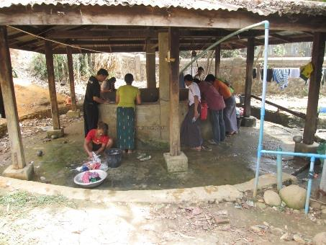
DRD, UNICEF, Focal Agency Nyein (Shalom) Foundation and Camp Management Committee joint Monitoring in Hand Dug Well at 5 Ward Baptist Church Lon Khin

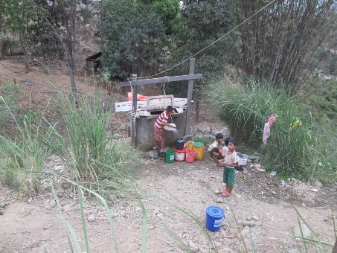
Stand by water buckets and fetching the water by children because of weakness in water supply system in Baptist Church Maw Si Sar

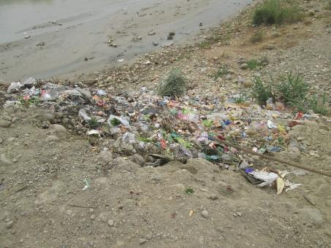
Disposing the garbages near the stream bank on AG Maw Si Sar

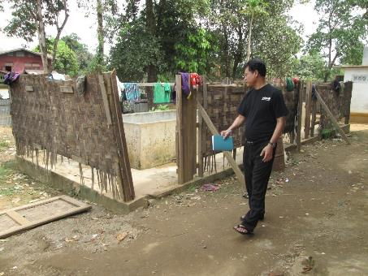
Damaged Bathing Space (No Privacy) in 5 Ward RC Church Lon Khin

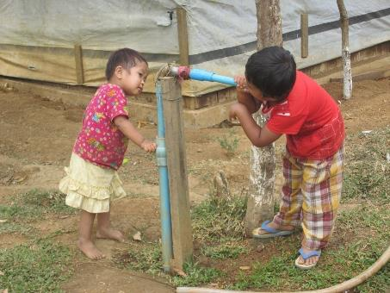
Trying to get water from unprotected tap stand by Children in 5 Ward RC Church Lon Khin

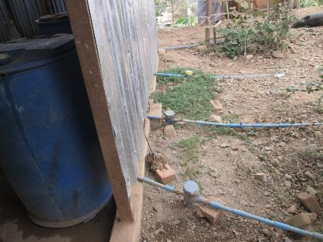
Bathing Space installed with water metering in Chin Church Seik Mu (they pay about 15000-20000 Kyats per month1 unit for 1500 kyats)

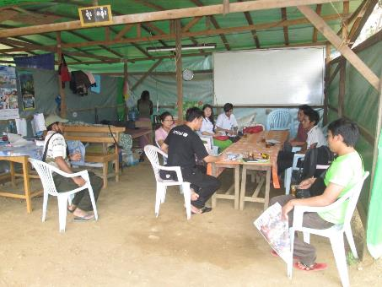
Emergency WASH Assessment in new opened camp Baptist Church Gaday village (with joint assessment team – DRD,UNICEF, Shalom and camp committee)

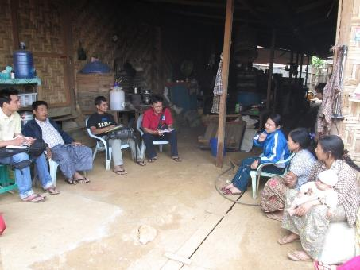
Focus Group Discussion with IDP people in Rawan Baptist Church Maw Shan village Seik Mu
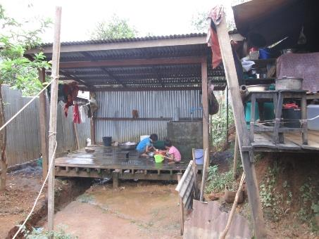
Bathing space for Female in Ward 2 Sai Tawng Baptist Church

