*PROPOSAL*

**The Future of International Strategic Partnerships 2019-2021 at the UT**

*Draft version**February 2019*

**List of Contents**

1. Introduction
2. Summary Key Proposal Future International Strategic Partnerships Approach
3. Looking back: what has been done and achieved
4. Main Purpose of International Strategic Partnerships
5. Our Future Partners: Main Selection Criteria Partner Universities:
6. Way forward: Proposed Decision-Making Process of New ISPs
7. How to Realize Our Ambitions: Financial scheme to support International Strategic Partnerships on the university level 2019-2021
8. Evaluation/monitoring

**Introduction**

The Internationalization Vision of the UT sets ambitious goals to increase the degree of internationalization of the university and provide the preconditions to help create the global citizens of tomorrow. Collaboration with partner universities generally takes place in research groups or within degree programmes which is strongly encouraged. In addition, the UT partners with a number of universities at the institutional level. University-wide International Strategic Partnerships & Networks are important means to realize wide-range strategic and operational goals of the UT. They are not the end-goals, but facilitate the foundation for success.

Since 2016, the UT has prioritized 6 partner universities of strategic importance with the aim to firstly ‘provide excellent teaching and research and keep access to first class research facilities’ and secondly ‘position the UT in the emerging global system of higher education’. In the internal policy document ‘International partnership strategy of University of Twente’, which was drafted in 2016, the main purposes of international partnerships have been described based on the following definition for strategic partnerships:

*‘A University level is a formal alliance between the UT and another university that share physical and/or intellectual resources in achievement of defined common objective that is of mutual benefit. Ideally, this means that both partners possess one or more assets that will help the other to make both institutions stronger in the long run, but that each respective other does not wish to develop internally’.*

This document will briefly describe the on strategic partnerships with other universities on the institutional level, the objectives of the UT and the resources available for this.

**Key Proposal Future International Strategic Partnerships Approach**

|  |
| --- |
| *Main rationale and brief description of proposal*  *Short list of ISPs to be included*  *4 main stages of Strategic Partnerships:*   1. ***Exploration Stage*** *(for International Partners, IPs):*   *Initial stage to explore opportunities for potential long-term and comprehensive partnerships through encouraging individual contacts between staff.*  *Instrument 1: flexible seedmoney for staff travel costs at any time of the year (Budget: 50k/year). Application nominated by Fainco’s and county coordinators*   1. ***Mutual Exchange Stage*** *(for International Partners, IPs):*   *Based on first contacts, formalize collaboration in student and staff exchange to build personal networks and a foundation for long-term partnership and joint projects in education and research.*  *Instrument 2: Existing UT scholarship and exchange programmes support (on central and faculty level)*   1. ***Consolidation Stage*** *(for International Strategic Partners, ISPs):*   *Consolidate collaboration based on gained trust and understanding through personal contacts and encourage individual staff to create more synergies and start joint education programmes and projects to reach strategic goals and aimed at collaboration with more than 1 faculty.*  *Instrument 3: Annual competitive ISP-calls implemented by S&P to allocate project funding based on quality, co-funding and reaching strategic goals*   1. ***Strategic Priority Initiatives Stage*** *(for selected International Strategic Partners, ISPs):*   *Based on mutual identification and investments of strategic flagship programmes/initiatives of high priority from ISP joint calls (stage 3) with explicit and concrete strategic objectives.*  *Only open to a small selection within top-rated ISP-partner universities*  *Instrument 4: Additional multi-annual funding of priority strategic initiatives based on a competitive calls for proposal*   1. ***Full Strategic Partnership Stage:***   *Integration of activities in different domains and integrated access to facilities, regional ecosystems and networks partners, and education/research agenda’s*  *Instrument 5: joint investments on request (CvB and external partners)* |

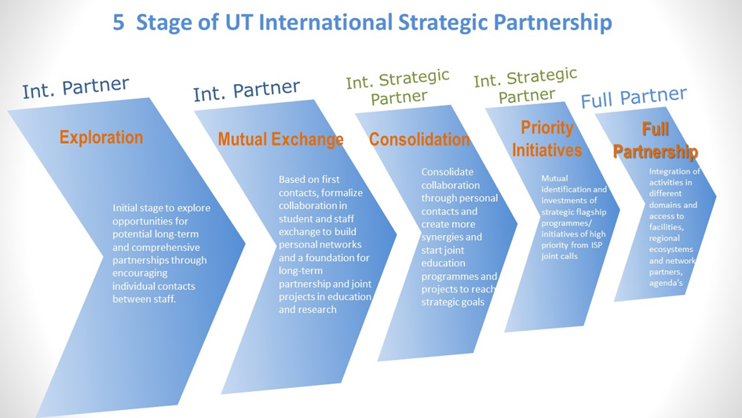

**Looking back: what has been done and achieved**

*ISPs from 2016-2018*

In 2013 the policy paper ‘Strategische internationale partners UT’ emphasized the importance of strategic partners to raise the international profile of the UT by reaching objectives related to education, research and knowledge transfer. In March 2016, the Executive Board and Deans (CvB-D) of the UT selected 6 partner universities in 5 target countries to develop International Strategic Partnerships (ISPs) with the same purpose of reaching strategic goals of the UT. The same year the instrument ‘Financial Support for cooperation with International Strategic Partners’ was launched to support collaboration projects with the 6 selected strategic partner universities on an annual and competitive basis. This has resulted in 40 funded projects over the past 3 years (see annex) after 3 annual calls for proposal with the following 6 international strategic partner universities.

1. Brazil: University of Sao Paulo (USP)

2. Brazil: Institut Technologico Aeronautica (ITA)

3. China: University of Science and Technology of China (USTC)

4. Germany: Westfalische Wilhelms Universitat Munster (WWU)

5. Indonesia: Institut Teknologi Bandung (ITB)

6. Mexico: Tecnologico de Monterrey (TecM)

*Main achievements*

From 2016 till 2018, the annual financial scheme to support “International Strategic Partnerships” was created to support partnerships with these partner universities. Three calls for proposals have been launched with an annual budget of €200,000. In the past 3 years €488,500 has been allocated to 46 projects with 6 partners in the past 3 years.

* 2016: €196,200 allocated to 18 projects with 6 partners
* 2017: €126,500 allocated to 17 projects with 6 partners
* 2018: €166,800 to be allocated to 11 projects (€120,000 to 6 projects to support Special Partnership with WWU Munster and €46,800 allocated to 5 projects with remaining 4 ISP partners)

In the latest 2018 call, more emphasis was put on quality and competition and commitment from the UT faculty and ISP partner (co-funding) to encourage more proposals for sustainable and strategic projects, parallel to a separate call with WWU Munster.

The main results was increased mobility and expansion of domains and involved parties in the collaboration. With the help of the UT country coordinators, who also acted as the ISP-contact person, the network of UT and ISP colleagues has been enlarged and more opportunities for collaboration with the ISP and through partner with the target country as a whole has been identified. In some cases, this has resulted in strategic activities to achieve strategic goals. Some examples:

* ITA/USP Brazil: Broaden and increased partnership with USP/ITA, possibility for regional education and research funding and plans to setup a joint research centre in Brazil with ISP partner and regional funding agency.
* USTC, China: attracting more master’s and PhD talents, joint research labs and plans to internationalize the curriculum at USTC and support the internationalization of startups through a partnership between USTC and NovelT
* WWU, Germany: broader collaboration in joint education and research, financial commitment for bilateral joint research projects based on strategic themes, more mobility and plans to support the regional agenda by setting up an entrepreneurship centre in Munster
* ITB, Indonesia: stronger government relations, improving double degree programmes with Indonesia and attracting more talented students
* TecM: Mexico: Financial commitment for joint research projects and start matching UT and TecM researchers for joint projects

**Main Purpose of International Strategic Partnerships**

The internal policy document ‘International partnership strategy of University of Twente’ from 2016 described set of key objectives of strategic partnerships and a set of criteria to select the limited number of strategic partner universities. Based on these strategic choices and discussion with the ad-hoc UT advisory group for strategic partners , the following objectives for new international strategic partners is proposed.

* Raise the profile and improve the international reputation of the UT and partners.
* Education (UT & partners):
  + strengthen the educational portfolio of UT by developing joint programmes and exchange facilities to increase the attractiveness for (inter)national students/faculty
  + provide access to first class talents and educational facilities to improve the UT’s teaching and education quality
* Research (UT & partners): provide access to talented PhD students/faculty, high-quality research facilities and additional funding to increase UT’s international research profile and research quality
* Knowledge transfer (UT & partners): provide access to new local eco systems of innovation (industry and government) in order to enhance social outreach and economic development

**Our Future Partners: Main Selection Criteria Partner Universities:**

In order to achieve above-mentioned objectives, it is essential to select the right partner university that will help create the right conditions to achieve concrete results for both parties. It is important to realize that by appointing a UT-wide strategic partner, does not imply that other faculty-level partner universities are not important and will continue to be encouraged by the UT. University-level ISP universities will receive more central support from the university.

The following conditions for future ISPs have been formulated based on the criteria used to select previous ISPs. A distinction has been made between primary and essential criteria en secondary ones that are not required but will also be taken into account.

*Primary:*

1. Reputation: should enjoy a strong reputation in research, and/or show a strong quality and innovative education strengths (in top 100 of world reputation rankings). Preferably higher ranked than the UT or shows the potential to reach this level in the near future
2. Quality: should possess a strong profile in 5 UT strategic themes for research and/or education or have the potential to reach equal standards (quality and excellence) in the near future
3. Mass: have at least 3 domains/faculties at UT committed and involved in the partnership
4. Talents: Should offer a pool of potential talents for master’s and PhD programmes and located in the A-list countries from M&C
5. Compatibility: Should have a policy in place to invest in partnership on an equal basis and the willingness to accept UT as an equal partner
6. UT Profile: will contribute substantially to UT’s core ambitions in education and research and UT’s internationalization vision

*Secondary:*

1. Geographical location: Should cover different global regions to ensure a fair geographical spread (incl. EU, Asia and America’s)
2. Financial support: Intention to co-fund joint initiatives to ensure self-sustaining and long term (> 5 years) cooperation models that will be able to operate financially independent
3. Organisational support: should have dedicated staff to coordinate the partnership and relevant faculty and staff on both sides that are available to implement the activities

**Way forward: Proposed Decision-Making Process of New ISPs**

In 2017, S&P collected nominations from faculties and institutes for new partner universities based on a set of key criteria’s which resulted in the following list.

|  |  |
| --- | --- |
| **Proposed additional partners from 2017** | **Faculty** |
| Stevens Institute of Technology, USA | BMS |
| Stanford, USA | TNW |
| University of Waterloo, Canada | BMS |
| Forschungszentrum Jülich, Germany | TNW |
| TUMunchen, Germany | BMS |
| EPFL, Switzerland | TechMed |
| Polytechnico Milano, Italy | ET |
| University of Melbourne, Australia | ET |
| KAIST, South Korea | ET / EWI |
| Northwestern Polytechnic University, China | EWI |
| SUTD, Singapore | EWI |
| Universitas Gadjah Mada, Indonesia | EWI / ITC |
| UNPAD, Indonesia | BMS |

Based on above-mentioned lists, a new list of ISPs for the coming 3 years needs to be decided based on nominations by faculties, which will be decided by the Executive Board will decide about the final choice of International Strategic Partners for 2019-2021 and about the internal support system to ensure sustainable and concrete results from investments in time and funding.

As discussed by the Executive Board in 2017, this decision will be based on nominations for potential ISP’s from the faculties and institutes and on the discussion and decision by the UT Executive Board and Deans (CvB-D). When the final decision has been made and the commitment from the potential Strategic Partner University has been verified, (joint) strategic agenda’s including a corresponding budget plans with each partner universities need to be developed by the responsible UT country coordinator who also acts as the UT contact person for the ISP.

The ISP strategic agenda and related strategic country plans need to be approved by the Executive Board, after consultations with the faculties, based on the following procedure.



**Life cycle ISP strategic agenda and country strategy at UT**



**How to Realize Our Ambitions: Financial scheme to support International Strategic Partnerships 2019-2021**

From 2016-2018, 3 annual ISP calls have been implemented to stimulate synergetic collaboration with the ISP partner universities. The main purpose of the ISP scheme was to support faculty (staff) that are already collaborating with colleagues at a ISP partner university in order to deepen and broaden the existing scale of collaboration by involving relevant (new) colleagues at UT. The funding was mainly intended as seed-funding to start new initiatives and obtain support and commitment from the ISP partner to reach strategic goals of the UT and ISP partners and build the foundation for large-scale collaboration actions that in the long run would create great strategic value for and help raise the global profile of both parties.

The annual calls did not distinguish the different stages of partnerships and did therefore not offer focused support to UT colleagues. In practice, the scheme mainly funded travel expenses to allow colleagues to meet each other. The administrative work load to implement the call and apply for the grants could also be diminished.

To tackle these issue, the scheme has been revised to cater to different needs in 4 different stages of the partnership supporting the development of international partners to international strategic partners. Obviously, there might be exceptions of partnerships that will not follow the mentioned stages.

**Main goals and proposed instruments for 4 different stages:**

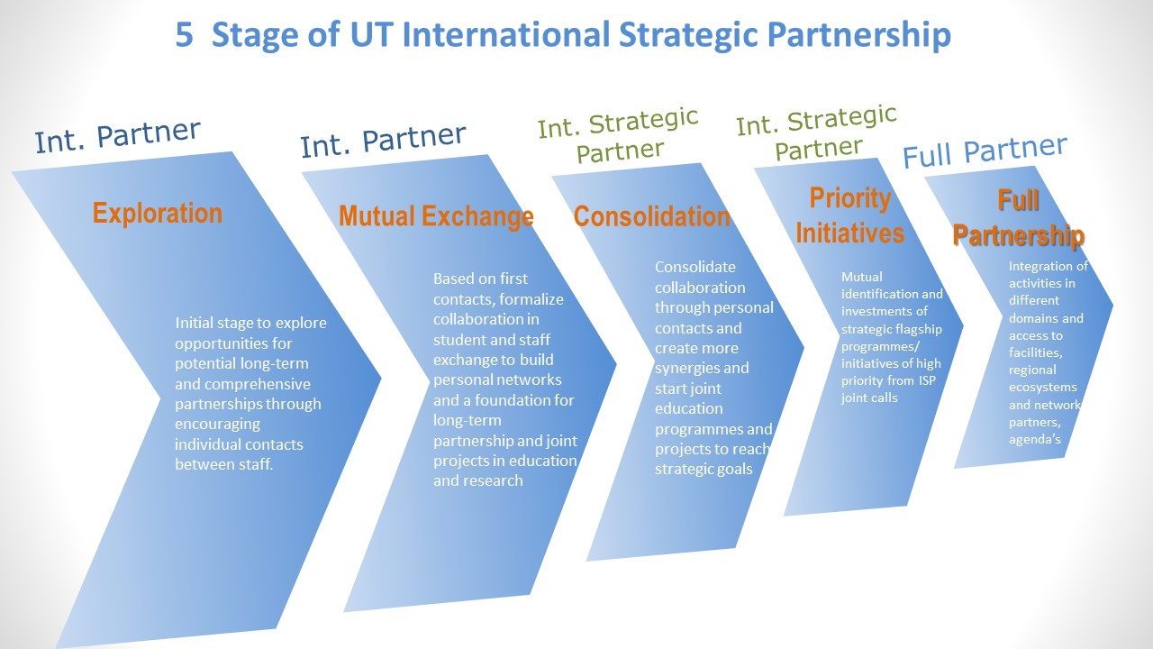

1. **Exploration Stage** (for International Partners, IPs):

Initial stage to explore opportunities for potential long-term and comprehensive partnerships through encouraging individual contacts between staff.

Aim: Identify strong international partners and invest in future international strategic partners (ISP), and explore synergies and possibilities for joint initiatives.

Open to: all international partner universities (IPs) in UT target countries (to be determined) on a faculty level. Not limited to ISP partners

* + *Instrument 1: flexible seedmoney for staff travel costs at any time of the year (Budget: 50k/year). Application nominated by Fainco’s and county coordinators*
  + *Service level: advice and matching with potential partners (country coordinators, CES and faculties), travel funds, support with exchange, agreements and incoming/outgoing visits (faculties)*

1. **Mutual Exchange Stage** (for International Partners, IPs):

Based on first contacts, formalize collaboration in student and staff exchange to build personal networks and a foundation for long-term partnership and joint projects in education and research.

Aim: Prepare joint commitment and co-funding of joint education and research by increasing the mass of collaborating students and staff

Open to: qualitative sound university-wide level exchange partner with high standards. Not limited to ISP partners

* 1. *Instrument 2: Existing UT scholarship and exchange programmes support (on central and faculty level)*
  2. *Service level:* *advice and matching with potential partners (country coordinators, CES), travel funds, support with UT-wide exchange (CES), agreements and incoming/outgoing delegations (CES)*

1. **Consolidation Stage** (for International Strategic Partners, ISPs):

Consolidate collaboration based on gained trust and understanding through personal contacts and encourage individual staff to create more synergies and start joint education programmes and projects to reach strategic goals and aimed at collaboration with more than 1 faculty.

Aims: Prioritize and jointly fund joint strategic actions (e.g. faculty&staff exchange, outreach to regional stakeholders, startups) with selected ISP universities

Only open to selected ISP-partner universities

* 1. *Instrument 3: Annual competitive ISP-calls implemented by S&P to allocate project funding based on quality, co-funding and reaching strategic goals (Budget: TBC, CvB/S&P)*
  2. *Service level:* *full support for advice and matching with potential programmes and researchers (ISP coordinators, S&P), funding joint projects, support with UT-wide exchange (CES), agreements and delegations (S&P), incoming/outgoing visits CvB (S&P), recruitment/promotion (M&C)*

1. **Strategic Priority Initiatives Stage** (for selected International Strategic Partners, ISPs):

Based on mutual identification and investments of strategic flagship programmes/initiatives of high priority from ISP joint calls (stage 3) with explicit and concrete strategic objectives.

Aim: Capitalize on partnership to access new networks and funding/facilities through ISP partner and to jointly fund and implement priority initiatives for long-term and strategic purposes

Only open to a small selection within top-rated ISP-partner universities

* *Instrument 4: Additional multi-annual funding of priority strategic initiatives based on a competitive calls for proposal (Budget: TBC, CvB)*
* *Service level: full support for advice and matching with potential programmes and researchers (ISP coordinators, S&P), funding joint projects, support with UT-wide exchange (CES), agreements and delegations (S&P), incoming/outgoing visits CvB (S&P), recruitment/promotion (M&C)*

1. **Full Strategic Partnership Stage:**

Integration of activities in different domains and integrated access to facilities, regional ecosystems and networks partners, and education/research agenda’s

* 1. *Instrument 5: joint investments on request (CvB and external partners)*

**Assessing ISPs: Evaluation/Monitoring**

**Procedure**

* Both the instruments and ISP partner universities will be assessed following a 3 year cycle. The evaluation will start in the 3rd year (early 2021) and result in a new proposal for improvement before Dec 2021.
* The relevant ISP coordinator will submit an assessment report for each ISP listing the key achievements and results.
* S&P will carry out the evaluation and draft the new recommendations with input from the UT country coordinators and ISP contact persons and the faculties/institutes
* The proposed decisions about revising the ISP-list and ISP programme instruments will be made in the Executive Board and Dean (CvB-D). The final decision will be made by the EB.
* The recommendations will be drafted based on the set criteria. Important criteria for discontinuing the strategic partnership is lack of substantial Strategic Priority Initiatives and lack of (financial) commitment and co-funding for joint projects from the partner university.