**Roles and Responsibilities of Community Volunteers (-) in the Containment of the Spread of AWD/Cholera**

Community volunteers are key players in mobilizing community in ensuring the community transmission of AWD/cholera is contained through promoting adoption of hygiene and sanitation practices, including proper storage and use of household water. This guide provides key actionable roles and responsibility of community volunteers as part of the community health team in responding to disease outbreaks.

Contents

**(1) Roles and responsibilities of community volunteers**

**(2) Six principles of effective interpersonal communication**

**(3) Key messages**

**(4) Ethical conduct for community volunteers**

**(5) Checklist for community volunteers to monitor the access and usage of water, sanitation and hygiene (WASH) supplies by households and vendors**

**(6) Weekly reporting template for community volunteers**

**(1) Roles and Responsibilities of Community Volunteers**

Community volunteers should support in the following activities:

1. **Community Mobilization, Awareness-raising and Education**

* **Awareness-raising:** Communicate families to provide information about AWD/cholera, its transmission, symptoms, and prevention strategies.
* **Promoting hygiene practices**: Explain/demonstrate to the family members how to use chlorine tablets, how to make oral rehydration solution (ORS), proper handwashing at critical times and food hygiene.
* Observe and assess hygiene practices of the family and help them to understand how AWD/Cholera is transmitted and to identify what kinds of awareness-raising and behavior change communication interventions are needed. The F-diagram can be used to explain the transmission routes.
* **Addressing existing rumors or misinformation:** Share factual information about the existing AWD/Cholera outbreak and address the rumors and misinformation spreading in the community.

1. **Awareness raising and education of households affected by cholera and their neighbors**

* Educate families members and their neighbors how to manage AWD/cholera patients at home to reduce the spread of infection among family members and improve patient's recovery.
* **Immediate rehydration through ORS is the key to recovery**: Start giving ORS and encourage the patient to take small sips of ORS. Even if the patient vomits or has diarrhea, some fluids will still be absorbed.
* **Monitor signs of dehydration**: If patient shows signs of dehydration which are dry mouth, sunken eyas, lethargy, continue ORS and seek medical help urgently.
* **Frequency of home visits to households –** make 2-3 more visits to the households with confirmed (and suspected) cholera cases and give support and advice for relevant behaviours they need to adopt and maintain, including keeping the environment clean and disinfection of utensils and surface area.

1. **Community-based surveillance and notification for AWD/cholera**

* **Case identification**: Monitor the signs of AWD/cholera in the ward/village you cover, record the name, age, contact phone number and address and notify the case to the health worker in the relevant ward/ village. (-)
* **Public announcements**: Make loudspeaker announcements on health education information two times a day, targeting hard-to-reach areas, and encourage community to share concerns/feedback related to the situation at their family level.

1. **Build relationships with key influencers in the communities to influence adoption of hygiene and sanitation practices among community members and manage rumors.**

* Engage with the key community influencers during community outreach to seek their support in ongoing advocacy, handling rumors and communication about AWD/cholera in communities.
* **Monitoring and tracking behaviours –** Monitor behaviour shifts in hygiene and sanitation practices, household water management, environmental cleanliness, food hygiene practices for food vendors/markets. Review the observation checklist to mark progress/bottlenecks on progress tracked in the list.
* Gather feedback from communities and reports to identify their needs and to improve the activities.
* Collect information about misconceptions, rumors and misbeliefs and report the information to take appropriate actions.

**(2) Six principles of effective interpersonal communication**

Use these principles during interactive discussions with the communities, individually or in small groups. The acronym, GATHER, will help you remember these 6 principles – **G**reet, **A**sk, **T**ell, **H**elp, **E**xplain and **R**eturn.

1. **Greet** the family or community you meet respectively, paying attention to the social hierarchy within the family.

2. **Ask** them about their well-being and living conditions as well as about the recent AWD/cholera outbreak. (-)

* What have they heard about AWD/cholera in their community?
* Is there anyone who suffers from AWD/cholera in the family/ in the community?
* Do you know ways AWD/cholera is transmitted, explaining key transmission routes?
* Do you know ways to prevent AWD/cholera, explaining key preventive practices?
* What are your concerns when it comes to AWD/cholera?

(-)

3. **Tell** them why you came to meet them and what they should do to protect themselves from getting AWD/cholera. (-)

4. **Help** them to understand the potential dangers they may face if they contract AWD/cholera. (-)

5. **Explain** to the family or the community the situation of AWD/cholera outbreaks, its transmission and trends and provide information and explanation about what they want to know more.

6. **Return** to the family or community to check whether they are actually following positive hygiene and sanitation practices to prevent AWD/cholera and if necessary engage them to improve the hygine and sanitation practices to minimize the risk of infection.

**(3) Key messages**

AWD/Cholera is transmitted through drinking of unsafe water or contaminated water, and eating food cooked with contaminiated water and not cooked well, or food exposed to flies.

* AWD/Cholera bacteria are present in the faeces from the people infected with AWD/cholera.
* AWD/Cholera can cause rapid depletion of water and electrolytes in the body, leading to dehydration.
* In severe cases, it can lead to death if left untreated in a timely manner.

**Modes of transmission:**

* Drinking unsafe water;
* No adequate fly-proof latrines and no proper use of them;
* Eating unsafe food such as food exposed to flies;
* Lack of or inadequate proper environmental sanitation;
* Not washing hands with soap after using toilet;
* Not washing hands with soap before eating;
* Lack of or inadequate proper personal hygiene;

**Symptoms**

* Loose watery diarrhea
* Nausea and vomiting
* Quick loss and depletion of water and electrolytes in the body, leading to fatigue
* muscle cramps, fainting and even death

**Prevention of AWD/cholera**

* Drink safe water disinfected by boiling or treating water with chlorination.
* Do not leave foods uncovered and make sure that all the foods you eat are served hot.
* Avoid eating moldy food, food exposed to flies and overripe fruit.
* Use clean fly-proof latrines.
* Wash hands properly with soap before eating and after using toilet.
* Avoid washing clothes of cholera patients near drinking water sources (wash clothes of hospital patients separately only at the hospital)
* Ensure safe disposal of child stools to avoid exposure to flies.
* Wash hands properly with soap before handling, preparing, eating food and after using toilet.
* Drink oral rehydration solution if you get severe AWD and go to the nearest health center to seek care if you do not get better.

If you have the following danger signs, go to the nearest health center immediately;

* Diarrhea lasting more than 2 days;
* Excessive thirst;
* Dry mouth and skin;
* Little or no urination or dark-coloured urine;
* Severe dizziness;
* Severe abdominal pain;

The following persons should go to the nearest health center to seek health care when they have diarrhea:

* malnourished children, pregnant women and breastfeeding mothers;
* people with pre-existing chronic diseases (including those living with HIV, Diabetes or other chronic diseases)

**How to treat acute watery diarrhea (AWD) at home**

If you suffer from AWD or vomiting, it is crucial to rehydrate your body very quickly. To rehydrate, you can drink oral rehydration solution (ORS).

**How to make ORS solution**

* Wash your hands with soap and water properly first.
* Check the expiry date on the packet. If it is expired, do not use it.
* Prepare ORS by putting one packet of ORS powder and one liter of boiled water or purified drinking water in a clean bottle or container and stirring the mixture.
* Once prepared, ORS should be used up within 24 hours and discard any unused solution after 24 hours.
* Do not add any extra sugar, salt or other liquid in preparing ORS.

**How to make home-made rehydration drinks**

If ORS is not available, you can make rehydration drinks at home by using sugar and salt as below:

* Before preparing it, wash your hands with soap and water properly first.
* Put 8 teaspoons of sugar and 1 teaspoon of salt into one liter of boiled water or purified drinking water and stir the mixture well.

**Steps to be taken for clean foods**

* Cook foods properly.
* Cleanse fruits and vegetables thoroughly with water.
* Keep foods covered not to be exposed to flies.
* Eat properly cooked/warm food.

**Critical times to wash hands**

1. Before and after eating food,
2. Before handling and preparing food,
3. After using toilets,
4. After contact with child faeces/ waste and garbage, hands need to be washed properly with soap and water.

**Steps to be taken for clean water**

Water can be disinfected by boiling or using chlorinating tablets. This water can be used for drinking and cooking. Disinfected water needs to be stored in safe cleaned bottles and containers with lids.

**Construction of fly-proof latrines**

The latrines should be able to prevent spread of infection from faeces.

* be fly-proof with cover
* be smell-proof.
* be privacy-providing.
* have sufficient water for cleaning.
* be clean.

**Key messages to parents and caregivers to prevent and control transmission of AWD/cholera**

* AWD/Cholera can spread through ingestion of unsafe water, contaminated water and food and food which have been exposed to flies.
* Preventive measures include:
  + Wash hands properly with soap and water (especially before eating, before handling food, after using toilet, after handling child faeces and waste).
  + Teach children proper handwashing.
  + Clean meat, fish and vegetables thoroughly with clean water, cook food properly, and use cooking utensils only after washing them carefully with soap and water.
  + Keep food covered to avoid exposure with flies.
  + Drink water only after boiling or disinfecting it.
* All family members should use fly-proof latrines; particularly, child faeces should be disposed of safely and properly.
* **Managing diarrhea at home**
  + If you pass large volume of watery diarrhea, drink oral dehydration solution every time you pass a loose stool, not less than the amount you pass in order to replace water and electrolytes lost.
  + If you pass ‘rice-water stool’, go immediately to the nearest heatlh centers/ hospitals and clinics to seek health care.

**Key messages to markets/ food stalls to prevent and control the spread of AWD/cholera**

Cholera can spread through ingestion of unsafe water, contaminated water and food and food which have been exposed to flies. People selling foods should follow the practices below:

1. **Safe food and water**

* Use clean water: Ensure water used for cooking, washing, and drinking is safe and clean. Boil or treat water before use.
* Cook food thoroughly: All food, especially seafood and meat, should be cooked thoroughly to kill any harmful bacteria.
* Keep Food Covered all the times: Always cover food to protect it from flies and dust, which can carry cholera bacteria.

2. **Personal hygiene practices**

* Wash Hands Regularly: Wash your hands with soap and clean water before preparing food, after using the toilet, and after handling money.
* Use Gloves or Utensils: When handling food, use gloves or clean utensils to avoid direct contact with food items.

3. **Sanitation in the market**

* Clean work surfaces: clean and disinfect your work surfaces, cutting boards, and utensils with a bleach solution.
* Proper waste disposal: dispose of waste, including food scraps and wastewater, in designated areas away from food preparation areas to prevent contamination.

4**. Health monitoring**

* Stay home if sick: If you or anyone in your household is experiencing symptoms of diarrhea or vomiting, stay home and avoid handling food.
* Report symptoms early: If you notice any signs of illness in yourself or your customers, seek medical attention immediately and encourage others to do the same.

5**. Community care and protection**

* Work Together: collaborate with other vendors to ensure everyone in the market follows these safety practices to protect the entire community.
* Disseminate to your customers the importance of hygiene and safe food practices during the outbreak.

6**. Safe Storage of food**

* Keep food safe: Store perishable food items at the right temperature to prevent bacterial growth. Use ice or refrigeration if possible.
* Separate raw and cooked Foods: Avoid cross-contamination by keeping raw and cooked foods separate.

7. **Washing and cleaning**

* Wash produce: Wash fruits and vegetables with safe, clean water before selling or using them.
* Clean Containers: Ensure containers, buckets, and other storage items should be cleaned regularly.

8. **Customer Interaction**

* Promote Cleanliness: Encourage customers to wash their hands before eating and to use clean, safe water.
* Provide clean utensils: If you provide eating utensils, ensure they are cleaned properly after each use.

9**. Be aware and ready to ACT**

* Know the signs: Be aware of the symptoms of AWD/cholera (severe watery diarrhea, vomiting) and know where to seek help. If you pass watery diarrhea, prepare correctly and drink oral dehydration solution every time you pass a loose stool in order to replace water and electrolytes lost.
* Preparedness plan: Have a plan for what to do if there is an outbreak in your market, including where to access clean water and ORS.

**(4) Ethical Conduct For Community Volunteers**

Community volunteers are expected to adhere to the following ethical conduct in communicating and engaging with communities:

* Strictly maintain confidentiality of information about cholera which can lead to unnecessary fear and panic among communities.
* Only provide information about cholera and do not make decisions for them.
* Do not spread rumours and misinformation about cholera.
* Avoid strictly any involvement in political and private matters which are beyond your activities and responsibilities.

**(5) Checklist for community volunteers to monitor the access and usage of water, sanitation and hygiene (WASH) supplies by households and vendors**

Community volunteers should monitor the access and usage of WASH supplies by households and vendors by using the following checklist and if they still need reinforcement for good hygiene practices or encouragement and persuasion to change poor hygiene practices, act accordingly.

(5-A) Checklist for community volunteers to monitor the access and usage of **water, sanitation and hygiene (**WASH) supplies by households

1. Hand washing practices: Observe the hand washing practices

* There is running water (from a tap) and soap
* There is water and soap (container + ladle)
* There is only water
* There is only soap
* There is no water and soap

2. Observe the ways of/ products used for drinking water treatment in the household/camp.

* Boiling
* Chlorine tablets
* Chlorine solution
* (Buying) purified (bottled) water
* Purifying/ filtering (clay filters/ water purifier pot/ water purifying machine)
* Other water purifying methods
* Do not use any methods to treat water

3. Observe the type of toilet/latrine the household is using.

* Community latrine
* House latrine
* Open defecation directly onto the surface
* Direct pit latrine
* Safe back pit latrine
* Unsafe back pit latrine
* Latrine with septic tank/ connected to a sewage system

4. Observe the latrine to check the following:

* fly-proof (with cover slab or water outlet; covered pit)
* smell-proof.
* privacy-providing
* having sufficient water for cleaning.
* cleanliness

5. Observe whether food are kept covered after cooking to prevent from exposure to flies.

* Keep food covered (using mesh covers or keeping in pantries)
* Not keep food covered

6. Observe whether child faeces are disposed properly/safely. Observe whether diapers with child faeces are washed near drinking water sources such as ponds and wells.

* Dispose child faeces safely (Confirm with mother/caregiver how they dispose child faeces)
* Do not dispose child faeces safely

7. If there is an AWD/ cholera patient in the family, observe whether the patient’s clothes are washed near drinking water sources such as ponds and wells.

* Wash the patient’s clothes near drinking water sources such as ponds and wells.
* Do not wash the patient’s clothes near drinking water sources such as ponds and wells.

8. Observe whether garbage is disposed properly at designated places.

* Dispose properly at designated places
* Do not dispose properly at designated places

(5-A) Checklist for community volunteers to monitor the access and usage of **water, sanitation and hygiene (**WASH) supplies by vendors

1. Observe the ways of/ products used for drinking water treatment by vendors

* Boiling
* Chlorine tablets
* Chlorine solution
* (Buying) purified (bottled) water
* Purifying/ filtering (clay filters/ water purifier pot/ water purifying machine)
* Other water purifying methods
* Do not use any methods to treat water

2. Observe whether cooked food are always kept covered to prevent dirt and exposure to flies and dirt.

* Keep food covered (using mesh covers or keeping in pantries)
* Not keep food covered

3. Observe whether there is water and soap to wash hands in the food stalls.

* There is running water (from a tap) and soap
* There is water and soap (container + ladle)
* There is only water
* There is only soap
* There is no water and soap

4. Observe whether gloves or clean utensils are used when handling food to avoid direct contact with food items.

* Gloves or clean utensils are used.
* Gloves or clean utensils are not used.

5. Observe whether waste generated in the food stall is kept covered to prevent flies from landing on them or disposed properly in a designated place.

* Properly disposed.
* Not properly disposed.

**(6) Weekly reporting template for community volunteers**

**Awareness raising about AWD/cholera**

Sample:

| Awareness raising activities | Target groups | Types of community | Numbers of participants | Remarks |
| --- | --- | --- | --- | --- |
| Awareness about transmission routes and symptoms of AWD/ cholera; | Residents in IDP camps | IDP community | 60 | Male:  Female: |
| Awareness session for street vendors | Vendors | Urban community in Sittwe | 20 | Male:  Female: |
| Demonstration of hand washing and how to use chlorine tablets | Residents in IDP camps | IDP community | 30 | Male:  Female: |
| Public announcement with loudspeaker | general public | Urban communities in Sittwe | 100 | Estimate number |
| Awareness raising to families with AWD/cholera patients on how to take care of them | Families with AWD/cholera patients | IDP community | 6 | Male:  Female: |
|  |  |  |  |  |
|  |  |  |  |  |
|  |  |  |  |  |
|  |  |  |  |  |
|  |  |  |  |  |
|  |  |  |  |  |
|  |  |  |  |  |

Photo documentation

2. Addressing rumours and misinformation in the community related to AWD/cholera during the reporting period

|  |  |  |
| --- | --- | --- |
| Rumours/ misinformation | Name of village/ward | How |
|  |  |  |
|  |  |  |
|  |  |  |
|  |  |  |
|  |  |  |
|  |  |  |

3. Key influencers who you cooperated with for AWD/cholera in the community

|  |  |  |  |  |  |
| --- | --- | --- | --- | --- | --- |
| Sr. | Name of influencers | Gender | Position/ Type/ Category | Name of village/ward | Type of support from them |
|  |  |  |  |  |  |
|  |  |  |  |  |  |
|  |  |  |  |  |  |
|  |  |  |  |  |  |
|  |  |  |  |  |  |
|  |  |  |  |  |  |
|  |  |  |  |  |  |

4. Notification of the AWD/cholera cases

|  |  |  |  |  |
| --- | --- | --- | --- | --- |
| Names of patients | Age | Name of village/ward | Confirmed case or not | Referred or not |
|  |  |  |  |  |
|  |  |  |  |  |
|  |  |  |  |  |
|  |  |  |  |  |
|  |  |  |  |  |
|  |  |  |  |  |
|  |  |  |  |  |

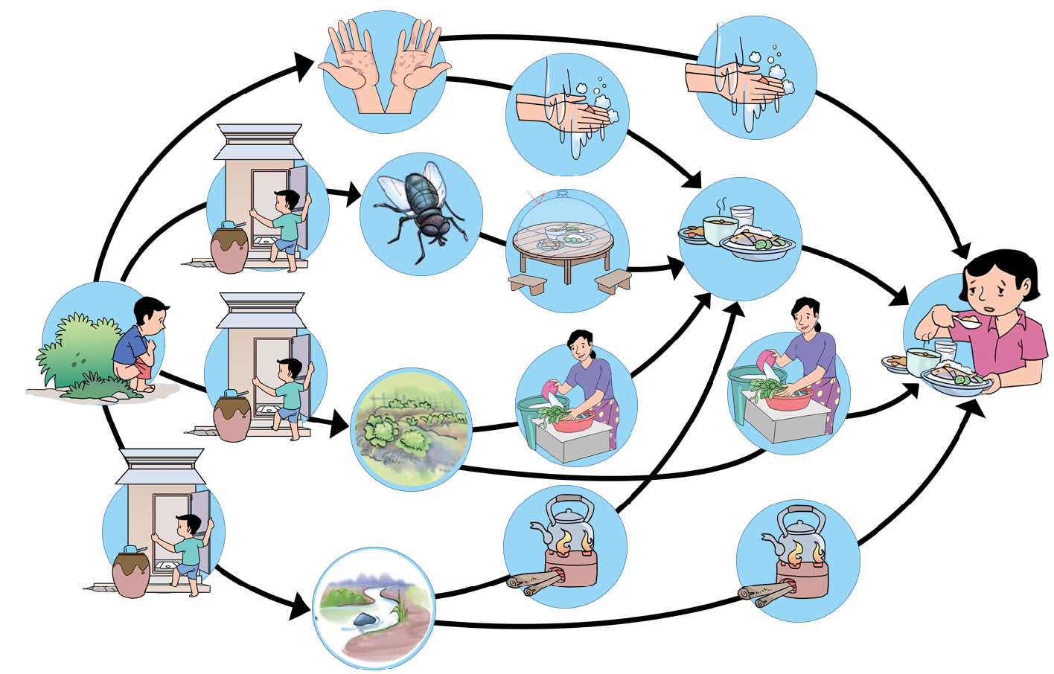

Faecal-oral routes of transmission and preventive measures (F-diagram)