STANDARDISED BATHING FACILITIES

Produced by : WASH Cluster
Specific Support : Solidarities International
Type organization : INGOs
Subject : Sanitation- Bathing Facilities
Created : 2013
Updated : March 2014
Resource : http://www.themimu.info/emergencies/wash-cluster
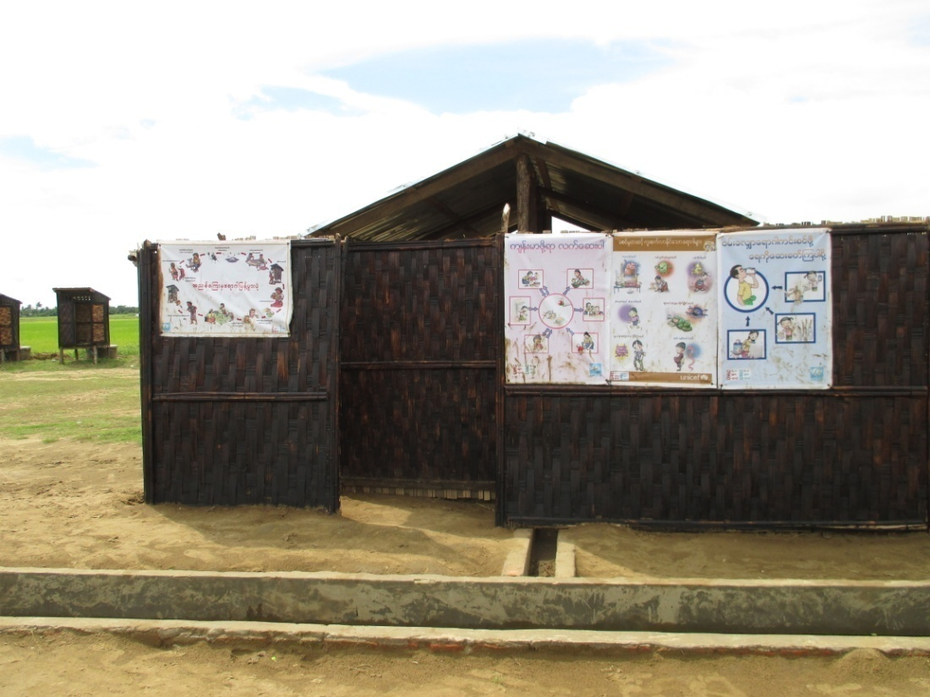

  - Background
The purpose of this document is to formalize the design of bathing facilities provided during the Rakhine and Kachin emergency. As it is hard to standardise the design of the bathing facilities due to the availability of the space, the location of the camp and the preferences of the affected communities, there are differences in the design and the number of cubicles included in one bathing facilities. However, the general features of all bathing facilities documented are conceptually similar. Thus, this document keeps the design which has been commonly discussed among the WASH cluster members in order for easy reference.
  - Particulars of the Design
Ideally, bathing facilities are usually provided for both men and women. After consulting with the communities (mainly for Rakhine), men usually do not use the bathing facilities and women prefer individual bathroom. However, it was agreed with the communities that the individual cubicles will be included in the design.
No. | Particular of the design | Specifications for design | Remark
1. | Floor | The flooring for the bathing area (20ft x 16ft) will be constructed using two types of flooring; a central concrete slab (14ft x 10ft) and a surrounding gravel interior walkway 3ft wide.
2. | Main Bathing Area | The main bathing area will be a concrete slab of 3" thickness laid on a bed of compacted course sand (5"). The dimensions of the concrete slab will be 14ft x 10ft. | The slab will be laid ensuring a 2% drainage slope towards this drainage channel.
3. | Gravel pathway surrounding the main bathing area | A gravel pathway of 3.5ft wide will be constructed around the central concrete slab. The outer edge of the pathway will be retaining wall where 3" of gravel or small stones will be laid on a 5" bed of compacted sand.
4. | Drainage Channel | The length of the drainage channel will be site specific. Drainage channels must effectively remove wastewater and grey water from the site, reduce the risk of ponding and vector breeding areas. | It is estimated that the average length of the drainage channel will be 10m.
5. | Outer Walling | To provide privacy and security to women while bathing. The bathing areas will have two entrances, one at either end each 4ft wide.  Bamboo matting will cover both sides of the wall to ensure privacy to users. | These entrances should not point in the direction of onlookers from the shelters. The bamboo matting will be painted with earth oil (dress oil) to provide a degree of waterproof and to prolong the life of the structure.
6 | Interior Walling | Internal partitions creating individual bathing cubicles. The two walls in front of the entrances (7ft high) will be double lined with bamboo matting (the same as the outer walling) while the interior walls (3ft) will have a single bamboo lining. | All the bamboo matting will be painted with earth oil (dress oil) to provide a degree of waterproof and to prolong the life of the structure.
7. | Roofing (optional) | Roofed bathing structure to protect them from direct sunshine while bathing and to increase the sense of privacy. | The CGI sheets will only cover 4ft out of the 5ft span in order for rainwater from the roof to drain onto the concrete floor rather than onto the gravel walkway.
8. | lt is estimated that for each unit of 5 shelters (8 household per 1 shelter unit) there will be approximately 100 women requiring access to bathing facilities i.e. two, 8-cubicle bathing facilities.

  - Perspective of the design
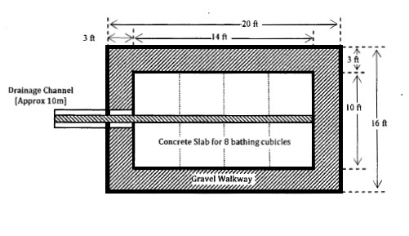
Figure 1 Floor (Plan View)

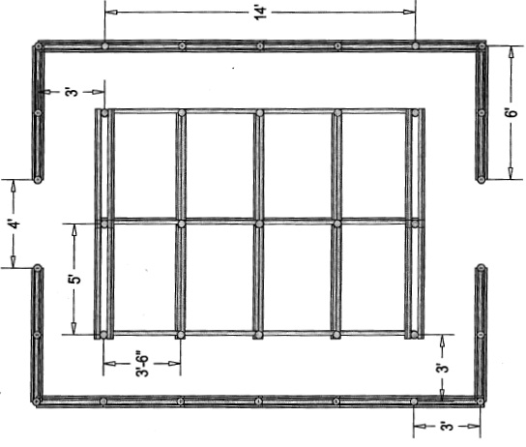
Figure 2 Poles for Interior and Exterior Walling (Plan View)
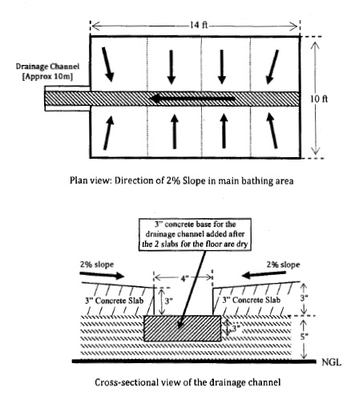
Figure 3 Slope of the floor and its direction (Plan and Side View)

  - 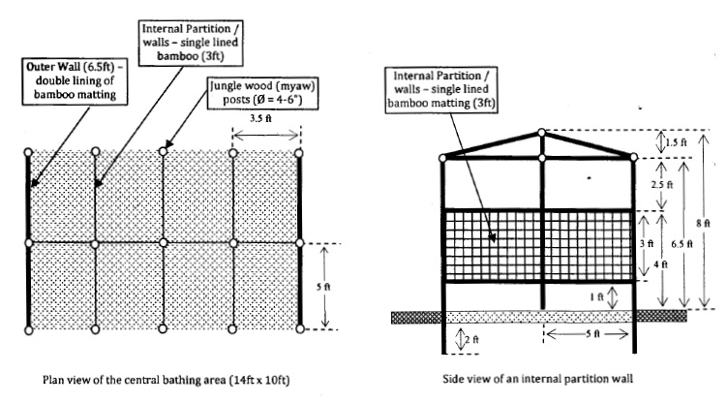
Figure 4 Bathroom (Plan & Side View)
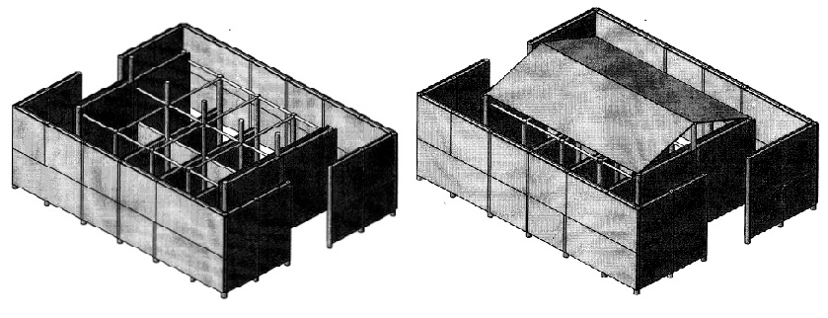
Figure 5 Bathroom (Isometric Views)
  - Guidance notes:
There is no minimum sphere standard for bathing facilities. However, WASH agencies generally agreed the following facts to be adhered. Bathing facilities should be constructed in consultation with the communities to decide the number, location, design, safety, appropriateness and convenience of facilities.
- At least 1 bathing facilities ( average 6 women can take bath at one time) per 50 women
- Bathing facilities should be easily accessible and as close as possible from dwelling
- Bathing facilities should be in well-lit areas with good visibility of the surrounding area to ensure the safety of users
- Water should be made available near to the bathing facilities and proper drainage pathway should be constructed to minimise the stagnant water
- Bathing facilities should be clearly labelled both with written language and picture.
  - Cost and BOQ of Bathroom
The minimum calculated cost of 1 bathroom is around 884 USD. The Bills of Quantity for the bathroom is developed by Solidarites International are as follow:
Table 1 Bill of Quantity of Bathroom
Sr. | Particulars | Unit | Quantity | Rate (MMK) | Amount (USD)
1 | Myaw Post (4 inches diameter) | No | 38 | 2,500 | 100
2 | Myaw Post (2 inches diameter) | No | 11 | 1,500 | 17
3 | Bamboo Mat | Sft | 1570 | 170 | 281
4 | Wire Nails | Viss | 7 | 2,500 | 18
5 | 30G CG I Sheets | No | 12 | 5,500 | 69
6 | Roofing Nails | Viss | 1 | 2,500 | 3
7 | Local hard wood | Ton | 0.15 | 450,000 | 71
8 | Bamboo | No | 30 | 300 | 9
9 | Sand | Sud | 2 | 15,000 | 32
10 | Gravel | Sud | 1 | 60,000 | 63
11 | Bricks | No | 240 | 63 | 16
12 | Cement | Bag | 5 | 7,000 | 37
13 | Skilled Workers | M/D | 19 | 4,500 | 90
14 | Workers | M/D | 11 | 3,000 | 35
Sub-total |  |  |  |  | 842
Contingency 5% |  |  |  |  | 42
Total (1USD= 950 MMK) |  |  |  |  | 884

  - Main Findings & Lesson Learned
Before the development of the design, the participatory approach with women has been applied. The findings from the consultation with women were incorporated in the finalisation of the design. It was learned that these bathing facilities would only be used by women and that the men and young children would prefer to take bathe in the open air at the handpump.
When consulting with the women, they initially stated a preference for individual bathing facilities attached to their shelter. However, it was explained that there are various limitations (space, cost, labour forces etc.) to provide the individual bathing facilities and thus, only communal bathing facilities could be possible during the period. As a consequence, the bathing facilities were designed with individual cubicles rather than the open space.
Further discussion revealed that the primary reason for wanting internal partitions was to provide individual space for bathing rather than privacy and that bathing was a time that women liked to talk to one another and socialize. It was therefore agreed that internal partitions would be low enough for women to see each others’ heads but would provide personal space for bathing.
After being used the bathing facilities for 6 months, the following important findings have been traced. The bathing facilities have open entrances which is difficult to prevent children and men entering into these facilities (even the clear labelling is in place). Sometimes, people misuse the bathing areas for other purposes such as urinals and even defecation. It is also indicated that the bathing facilities can be a potential target for violence since some inimical people can take advantage of the privacy (walls, lock from inside etc.). Moreover, there are strong cultural reasons for women to take bath inside the house especially in the strict conservative man–dominant environment. More commonly, women reported that it is extremely uncomfortable for them to fetch the water outside in the middle of bathing (when they run out of water from the small bucket). The dimension of the individual cubicles is also commented to be narrow when they take bath with the bucket and hang the clothes at the wall. Thus, some women find it hard to use the bathing facilities.
In addition, it is commonly reported that elderly women and disable persons find it very difficult to take bath without another person’s help as they cannot carry water container from the water points to the bathing area.
Based on the findings related to the communal bathing facilities, some WASH agencies started to provide individual bathing facilities integrated to the shelters as a pilot phase.
  - Recommendations
- Selection of the site should be made in consultation with the women and girls.
- Adequate drainage system should be included to minimise the stagnant water and mosquitoes breeding area.
- The sensitivity of the communities for the proposed design should be explored before the construction of the bathing facilities. For example, the communities regard the iron bars in the proposed design as a potential weapon and prohibited to be used.
- One water point should be available inside the bathing facilities (to avoid fetching water in the middle of the bath).
- The individual cubicles should be larger as the current width of 3ft cubicle is found to be narrow to take bath inside (with bucket, cloth etc.)
- The review on the individual integrated bathing room versus communal bathing facilities should be undertaken. (will be reviewed in July 2014)

Report on Gender Analysis on WASH emergency response in Rakhine, by Simona Seliškar in October 2013

