STANDARDISED EMERGENCY ADULT LATRINE

Produced by: WASH Cluster
Subject: Emergency Sanitation- Adult Latrine
Created: 2014
Updated: March 2014
Resource: http://www.themimu.info/emergencies/wash-cluster
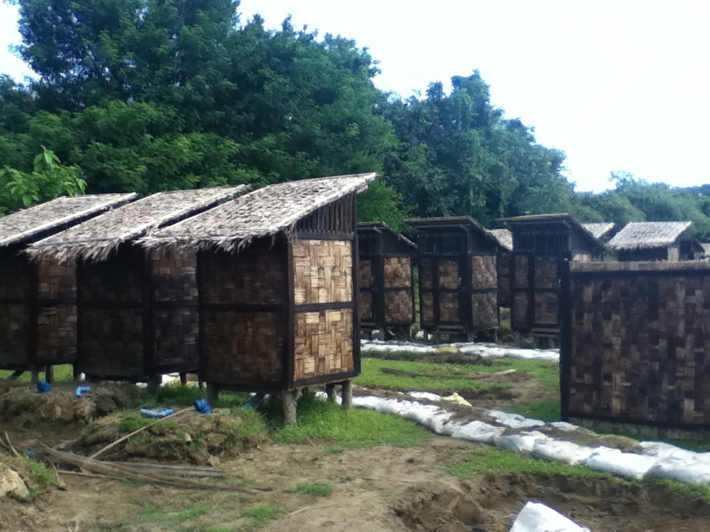

  - Background
This document is to use as guidance for the construction of the latrine during an emergency situation in Myanmar. Agencies should comply with the minimum standard of the following guidance note. The document should be reviewed regularly and modified as needed based on field lesson learn or specific context
  - Particulars of the Design
During the emergency context, the implementing agencies should target to meet the Sphere standard of 1 latrine per 50 people (gender segregated). Aim to complete the construction work within 2 weeks after the emergency situation provided that the situation is under control or stable.
The primary purpose of the emergency latrine is to minimize the risk of water and sanitation related disease transmissions among the affected population and to enhance the hygienic behavior by providing the enabling environment in the affected population. In addition, the resilience and coping mechanism of the affected population should be considered in the construction process of the emergency latrine since the beginning of the emergency situationin order to strengthen the recovery of the affected population.
Being intended to use in Myanmar, WASH cluster aims to produce the emergency latrine design based on the following parameters such as previous emergency situations, the cost effectiveness, the availability of the resources and technology (both personnel and materials) locally and the acceptance of the majority of the communities in Myanmar.
In addition, WASH cluster has defined the appropriate type of latrine with regard to the context of the emergency and its environment. The life-span of the latrine pits is primarily aimed from a minimum of 3 to a maximum of 6 months. The emergency latrines should be replaced with a more durable type where the emergency situation is expected to last longer than 6 months.
Table 1 Design of Latrine
No. | Structure | Specifications of Materials | Remark
1. | Cabin | Individual vs Block/Set  Up to 4 latrines per 1 block/set  (4 feet in width, 4 ft in length and 6 ft in height per latrine) | The following conditions need to be considered before the construction of the superstructure of the latrines.  - Weather  - Land Space  - Soil type  - Camp size  - Aquafier Level  - Available Materials  - Impact on environment  - Community’s preference  - User Interface
2. | Walling | Bamboo/Prefabricated/Tarpaulin Sheet  Not easily penetrable, Safety and privacy
3. | Door | Lockable Inside, Safety and Privacy
4. | Roof | 30 Degree Slope , can withstand the wind speed of 40 mph
5. | Steps | Not slippery, strong and can bear weight with or without hand rails.
6. | Pit | Single bamboo or wooden lined pit and the level of the pit should be raised 0.5 metre above the ground level to minimise the flood where the flooding is a risk.  The cover of the latrine pit should be sealed properly.
7. | Vent pipe | Black Colour wide diameter vent pipe and the height should be 6 inches higher than the superstructure. Or short vent pipe can be used as an alternative during the emergency.
  - Perspective of the design of latrine
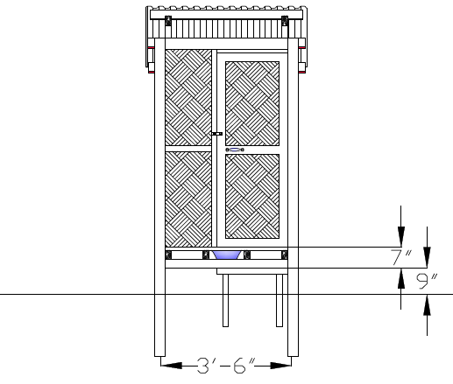
Figure 1Emergency Latrine with Bamboo Sheet (Front View), Not to Scale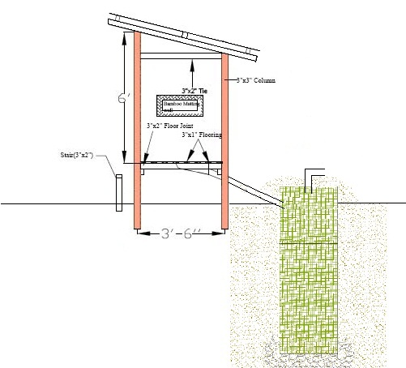
Figure 2Emergency Latrine with Bamboo lined pit (Top View), Not to Scale

  - Guidance notes:
All adult latrines should meet the recommended standards from Sanitation Minimum Sphere Standard Package. All emergency latrines should be constructed in consultation with the communities to decide the number, location, design, safety, appropriateness and convenience of facilities.
Gender separated latrines are available: 1 for 50 people in first emergency (going to 1 for 20 people once situation is stabilized).
Latrine should be attributed by gender or families after discussion with affected population.
Latrine and latrine pit are elevated from ground level in flood-prone area (recommended height is 50cm).
Latrines have access steps, and are lockable from inside.
Latrines are used, and open defecation is kept minimum (less than 3 evidences of open defecation during a transect walk across the camp).
All full latrines are either emptied safely, or decommissioned according to standard procedure.
An initial kit was provided for cleaning and maintaining the public latrine. The minimum kit contents are 1 soap net or box, 1 plastic bucket (15 Litre), 1 cup, 1 brush with handle, 6 pcs of 125 g soap bars, 1 jerry can 20 litres.
Each block of latrine should have a hand washing container (filled 2 times per day), with soap attached (replaced when finished)
Latrine should be as close as possible from the dwellings (recommended distance is 50m), while staying at 30m from water point.
Access path to latrine and light at night should be made available where possible.
Latrine maintenance:
  - For each 10 latrines there is one person responsible for the maintenance (hourly cleaning, water and soap for hand washing point). In the emergency phase, this person will be paid 3000 kyat/day, working every day. During the early recovery phase, other option involving community participation will have to be chosen. These workers should be rotated frequently (every week or every month).
At least 10°% of the male latrine and 10% of the female latrine are disabled-friendly.
Disabledand child -friendly latrine Should include the following:
    - Include a seat (chair frame with a hole in the middle)
  - include a bar on the wall near the door, to help person sitting
  - make the latrine door larger, for people with crouches, and make sure door open towards the outside
  - make the access step larger horizontally, for easy use with crutches

  - Cost and BOQ of Emergency Latrine
The BOQ and cost of the adult latrines can vary depending on the situation. However, the minimum calculated cost of 1adult latrine (tarpaulin sheet and bamboo lined single pit type) is around 100 USD.The items listed in the following table are only for guidance. The Bills of Quantity for the emergency latrine are as follow:
Table 2Bill of Quantity of Emergency Latrine
Sr | Particular | Unit | Qty | Rate | Amount | Remark
1 | Myaw Posts (4 inches) | poles | 4 | 2500 | 10000
2 | 3"x2" Jungle wood | ft | 30 | 250 | 7500
3 | 6"x1" Jungle wood | ft | 32 | 250 | 8000
4 | 3"x1" Jungle wood | ft | 18 | 125 | 2250
5 | 2"x 1/2" Jungle wood | ft | 94 | 50 | 4700
6 | Nail | viss | 0.7 | 1500 | 1050
7 | Tarpaulin | yard | 4 | 2000 | 8000
8 | Bamboo mesh | sqft | 72.25 | 500 | 36125
9 | Bamboo (chinwah ) | no | 3 | 300 | 900
10 | Plastic | yard | 4 | 300 | 1200
11 | Da Ni | sheet | 60 | 50 | 3000
12 | Latrine pan & pipe | set | 1 | 4000 | 4000
13 | Latrine Accessories | set | 1 | 4000 | 4000
 | Total |  |  |  | 90,725
 | Contingencies 5% |  |  |  | 4,536
 | Grand Total (1USD= 950MMK) |  |  |  | 95,261 | ~ 100 USD
  - Main Findings, Lessons Learnt
To be documented.
  - Recommendation
This document is a living document and the findings, lessons learnt and recommendation needs to be incorporated to improve the design.

Sanitation Minimum Sphere Standard Package 2012/3 by WASH Cluster, www.themimuinfo/emergencies/wash-cluster

