**Meeting Minutes**

**Rehabilitation and Reconstruction sub-committee**

**Shelter and WASH Clusters**

Date: 19.3.2015

Time: 3:00 pm to 4:30 pm

Venue: Office of RS transport and communication minister U Hla Han

Chair by: U Aung Than, Dy: Director of Department of Rural Development, member of RRSC

Co-chairs: Richard Kevin Tracey, Shelter Cluster Coordinator, Melissa Adoum WASH Cluster coordinator

Participants: RRSC & UNHCR & OCHA, DRD/MRF/UNICEF/CDN/MRCS/SI/ICRC

Objective: To discuss Infrastructure action plan and discuss current issues

|  |  |  |  |
| --- | --- | --- | --- |
| **Repair and Maintenance (R/M) of camps in yr 2015** | | **Action point** | |
| **RRSC**  **WASH Cluster & CDN** | RRSC shared need requests of camps to agencies regarding to shelter and WASH facilities and infrastructures with specific quantities and locations. RRSC will arrange a meeting for detail discussion with agencies to identify need/coverage/gap after this meeting.  RRSC shared (3) road repairing and upgrading of Hmanzi junction to BDP camp, MTN camp access road and asphalt refilling in TKP road. RRSC stated those mentioned works were ongoing recently and as context the (3) small bridges located in TKP road were renovated fully in late 2014.  However RRSC stated some complaint from Sittwe area camps mentioning there was failure to fulfill commitments in R/M of WASH facilities.  WASH Cluster shared with the group the 4W that includes the information of who is working where and how long the funding is available. Within a project, the R&M of WASH facilities is included as committed through the WASH Cluster strategy 2015 (briefing notes on the wash cluster strategy were shared).  WASH Cluster feed back to RRSC about “vandalism“ or and tampering of WASH facilities as well as solar lighting systems and agencies are facing it seriously relating to fund and CDN also reported similar in KDK, OTC camps as well.  CDN urged RRSC to take relevant action to tackle and control it. | RRSC will present outcome in cabinet meetings  RRSC will report to relevant RSG department | |
| **Shelter Cluster** | Shelter Cluster was reviewing and compiling R/M plan with IPs and urged focus on PT camps such as STM and ANYI to be covered by RSG or and agencies. Currently UNHCR DI of R/M in Mye bon and some Sittwe area camps were ongoing. | Shelter Cluster and IPs will share progress of R/M in camps | |
| **Shelter Concept note, Relocation updates and Setting Shelter minimum standard** | | | |
| **RSG-RRSC**  **Shelter Cluster**  **WASH Cluster**  **MRCS**  **MRF** | ***Relocation: Pilot in Parein and Yin the camps of Mrauk Oo***  RRSC shared some draft relocation plan list of IDP locations and Qty of households (see below) . RRSC reminded agencies about relocation plan was carried out by GAD and likely of implement in phase by phase so thus not all IDPs households living in camps will not be affected in Phase 1 stage due to fund and low profile approach. Initial proposal was provision of 1 million kyats to each beneficiary household but it was in conceptual stage.  GAD is assessing and planning for actual implementation and welcome inputs or and funding assistances as well. After finalized plan and modality will share to Shelter and WASH clusters, RRSC and relevant agencies. In generally TA of each respective town will be focal person of plan. RRSC requested both shelter and WASH clusters to participate in current and potential relocation activities such as PT: KNP, NC, MB.  UNHCR stated that HCR will consider and try to coordinate with Donors for relevant and possible assistances. However during field visit to Nget Chaung camp along with ECHO found that IDPs of Nget Chaung requested to reconsider amount and type of assistance offered.  WASH Cluster stated as well that the support of WASH Cluster and partners for the relocation would only be possible if the RSG leads the process and coordinated at all levels with the international community. It cannot be a one agency or one cluster support only.  MRCS stated that after coordination with UNHCR for R/M in PT camps and submit all relevant notes to MRCS HQ and waiting for response from donors.  MRF stated that Prog: Mgr was in Europe for mission and respond will be available after his return. | | RRSC-RSG will facilitate to GAD  RSG-RRSC will continue coordination  UNHCR will update  MRCS will update  MRF will update |
| **Shelter Cluster**  **RRSC-RSG**  **Shelter Cluster**  **RRSC-RSG**  **WASH Cluster** | ***Concept note:***  UNHCR stated that copies of concept note were handed over to RS security minister on 18 March 2015 for reviewing by senior officials of RS.  RRSC stated that welcome the concept and they will make inputs.  ***Setting Minimum standard:***  UNHCR shared copies of proposed shelter material package based on size*(15’x16’x8’) individual type with estimate of ***USD 1800(1.8 million kyat).*** UNHCR recommended it was developed based on both Intl Humanitarian and local shelter standards to meet and reflect-adapted experiences of shelter cluster’s responds in RS crisis and Nargis, GIRI projects as well.\**(details in paper)*  RRSC welcome the concept and will present it in coming cabinet and they will make inputs and share outcomes.  WASH Cluster coordinator shared and explained about conceptual drawing of models of household latrines with estimated cost ***of USD 100 (100,000kyat).*** It suggested combination of shelter and latrine packages will address the accommodation needs of the beneficiaries, simplify the implementation by DRD and interest donors seeing infrastructure as whole. | | ***All concerned parties will coordinate and update***  ***Proposed Min-standard cost became USD1900 with combination of Shelter+Latrine package*** |

AOB:

* RRSC said the closet RS Cabinet meeting will due in either Monday or Tuesday of next week.
* Next Shelter-WASH cluster meeting will be inform in due time.

**IDP relocation plan of Rakhine state in March 2015 – shared by RRSC**

* 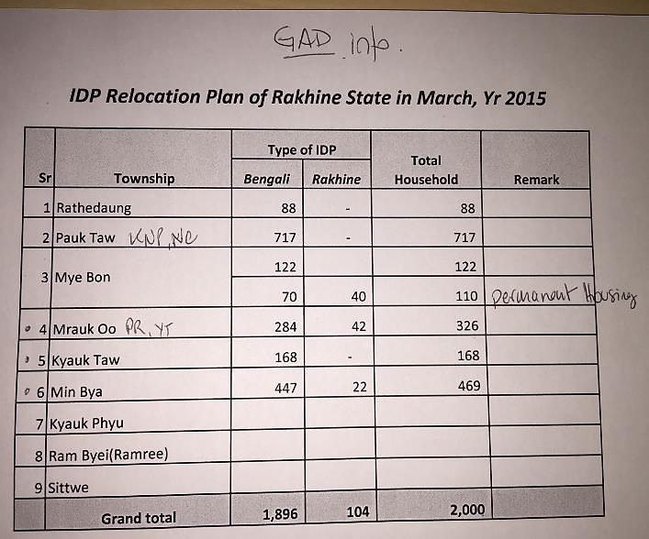

**Participants list**

