Meeting minute
WASH Coordination meeting – Magway Region, Myanmar
Date: Friday, 21st August 2015; Venue: SCI office, Magway
Time: 10:00 h – 12h00; Duration: 2:00 hours
No. of participants – 21
Number of Organizations: 13
Participants:

Org. | Name | Phone
MoE | U Aye Thaung | 09-400061456
Partners’ Myanmar | Daw Thu Thu Sein | 09-2220460
UNICEF | Kaung Myat Than | 09-8610086 | kmthan@unicef.org
UNICEF | Mra Thuzar | 09-8650313,  09-5042627 | mthuzar@unicef.org
MRCS | Nyi Nyi Zay | 09-401582156 | Magwayso.mrcs
Social Care Volunteer Group | Aung Lin Kyi | 09-440225420 | aunglinnkyi@gmail.com
Thirst Aid | Thin New Soe | 09-5006064 | tnswe@thirstaidmyanmar.org  thinnwesoe.sher@gmail.com
Pact Myanmar | Bo Bo Han | 09-401558683 | bbohan@pactworld.org
KMSS | Vincent Than Min Htun | 09-254399354 | vincentthanminhtun@gmail.com
KMSS | Khaing Min Soe | 09-256420817 | khaingminsoe2012@gmail.com
DRD | Daw Waing yu Maw | 09-796896303 | Waingyumaw2013@gmail.com
DRD | Daw Nilar Winn | 09-33698883
World Vision | Saw Marlar | 09-5337549 | Saw.marlar@wvi.org
DRD | Daw Lin Let Thein | 09-401555080 | Linletthein2014@gmail.com
DRD | U Kyaw Soe | 09-49202082 | Drd.mgy@gmail.com
SCI | Rosianto | 09-260203754 | r.hamid@savethechildren.org.uk
SCI | Myo Zaw | 09-259330754 | Myo.zaw.mawgyun ???????
SCI | Syn Hwan | 09-788523971 | Syn.hwan@savethechildren.org
UNICEF | Chaw Wint Thu | 09-799859279 | cwthu@unicef.org
WASH cluster | Didier Boissavi | 09-8610099 | dboissavi@unicef.org
NAG | Si Thu Htun | 09-31452227 | Sithuhtun06a@gmail.com

Agenda:
Time | Item | Organization
10h00-10h10 | Introduction | All attendants
10h10-11h10 | Update on WASH situation and local authorities’ response in Magway region | DRD, Education
11h10-11h240 | 3W tool and coordination mechanism | All attendants
11h40-12h00 | Gap and Needs identified | All attendants

Topic 1: Update on WASH situation and local authorities’ response in Magway region
Summary of discussions | The WASH sub-cluster coordinator provides an update of the humanitarian situation and response in Pwint Phyu and Sidoktaya Townshisp in Magway.  Response has been a combination of efforts from civil society, religious institutions, governmental authorities, private sector, NGOs and communities themselves.  Participants agreed with the identified needs during the presentation.  DRD regional Director mentioned that funding was required to address to the identified needs  SCI told they have been impressed by the community coping mechanism and the local authorities response and efforts  DRD explained they provided bottled drinking water to flood affected people, provide water purification tablets and cleaned the wells by pumping out the water  DRD provided membrane filtered water purification unit to schools and health centers that were severely affected  To date, no increase of diarrhea was found following flooding  DRD requested IEC for hygiene promotion to be displayed in public places  SCI mentioned that due to stagnant water, malaria occurrence need to be closely monitored and that preventives measures should be undertaken  SCI plans to provide Cash For Work to support DRD’s recovery activities
Action points | - The wash sub cluster to share power point presentation to the participants

Topic 2: 3W tool and WASH cluster approach
Summary of discussions | The concept on cluster activation on emergency response has been reminded to participants  DRD welcomed all agencies for cooperation for the response  The wash cluster coordinator introduced 3W tool to ensure the mapping of WASH actors and activities and urged the participants to fill in this 3W asap and to share it with the WASH cluster  Data management to be emphasized for quality response and rationalization of intervention  SCI requested support from WASH cluster for data management in Magway  SCI suggested to map the main past and future activities of WASH participants in the different geographical areas at the end of the meeting in order to have a first update of the situation
Action points | - 3W information to be filled in by WASH agencies  - The WASH actors to discuss the relevance to develop a practical tool to monitor the WASH activities in each village /schools and ECCD  - Consensus between agencies for a coordination meeting to be held at SCI’s office weekly, every Friday 10 am - Coordination to be led by DRD and supported by SCI  - For overlapping matter, bilateral discussions to be made between agencies,  - Key person of Magway DRD to be identified for WASH coordination  - The WASH cluster to explore possibility to provide data management support in Magway  - Gap analysis and key priority needs should be in agenda and discuss in next WASH Cluster meeting

Topic 3: Gap and Needs identified
Summary of discussions | MRCS asked for clarification on beneficiaries figure as there’s data discrepancy  DRD responded to take last updated data  Participants have been asked about the future needs for HKs distribution. No clear needs could be identified for the time being and previous distribution of HKs have been already carried out by WASH actors in miscellaneous locations. Some overlapping of HKs distribution have been mentioned and needs to be addressed.
Action point | - WASH NFI, HK plan of agencies to be shared to SCI,  - WASH plan of agencies to be shared once confirmed

Annex I : Aactvities of agencies and geographical areas

Thirst AID / Metta
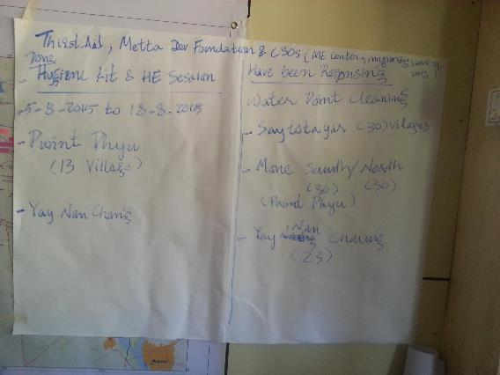

KMSS
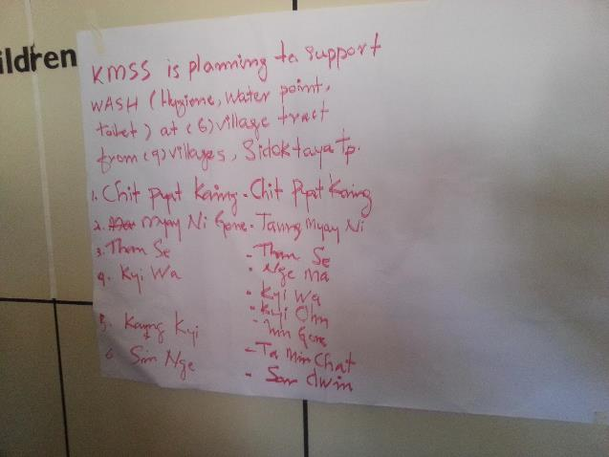

MRCS
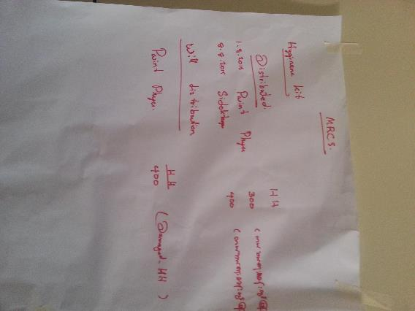

NAG
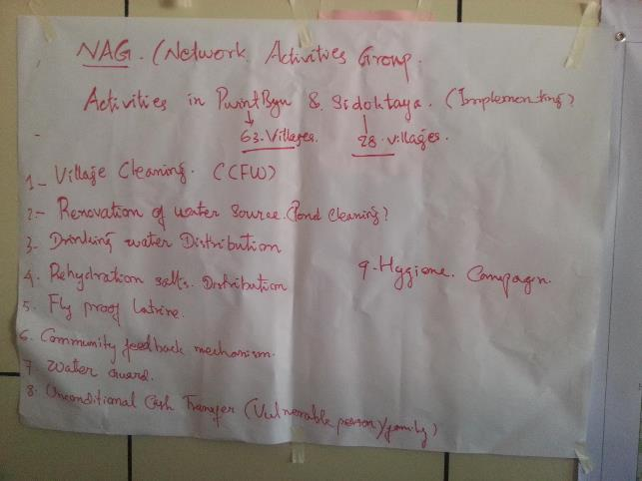

SCI
