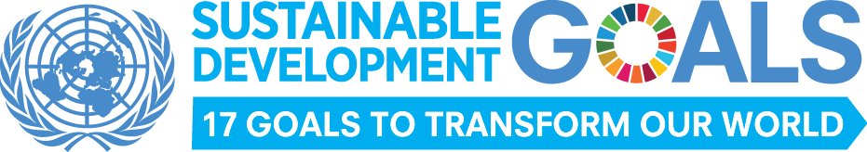

Launch of new sustainable development agenda to guide
development actions for the next 15 years

Landmark decision by 193 countries to transform the world for people and planet
officially goes into force

New York, 1 January 2016 – The new year ushers in the official launch of the bold and transformative 2030 Agenda for Sustainable Development adopted by world leaders last September at the United Nations. The new Agenda calls on countries to begin efforts to achieve 17 Sustainable Development Goals (SDGs) over the next 15 years.

“The seventeen Sustainable Development Goals are our shared vision of humanity and a social contract between the world's leaders and the people,” said UN Secretary-General Ban Ki-moon. “They are a to-do list for people and planet, and a blueprint for success.”

The SDGs, unanimously adopted by the UN’s 193 Member States at an historic summit in September 2015, address the needs of people in both developed and developing countries, emphasising that no one should be left behind. Broad and ambitious in scope, the Agenda addresses the three dimensions of sustainable development: social, economic and environmental, as well as important aspects related to peace, justice and effective institutions.

The mobilization of means of implementation, including financial resources, technology development and transfer and capacity-building, as well as the role of partnerships, are also acknowledged as critical.

The Paris Conference on climate change is seen by many as the first test of political will to implement the Agenda. “The Paris Agreement is a triumph for people, the planet, and for multilateralism. For the first time, every country in the world has pledged to curb their emissions, strengthen resilience and act internationally and domestically to address climate change. By addressing climate change we are advancing the 2030 Agenda for Sustainable Development,” said the UN Secretary-General.

Turning this vision into reality is primarily the responsibility of countries, but it will also require new partnerships and international solidarity. Everyone has a stake and everyone has a contribution to make. Reviews of progress will need to be undertaken regularly in each country, involving civil society, business and representatives of various interest groups. At the regional level, countries will share experiences and tackle common issues, while on an annual basis at the United Nations, the High-Level Political Forum on Sustainable Development (HLPF), will take stock of progress at the global level, identifying gaps and emerging issues, and recommending corrective action.

The 17 Sustainable Development Goals and 169 targets of the new agenda will be monitored and reviewed using a set of global indicators. These will be compiled into an Annual SDG Progress Report.

For more information, visit www.un.org/sustainabledevelopment

Media contacts
UN Department of Public Information
Francyne Harrigan, T: +1 (917) 367-5414 | E: fharrigan@un.org
Ken Matsueda,T: +1 (917) 367-5418 | E: matsueda@un.org
Sharon Birch, T: +1 (212) 963-0564 | E: birchs@un.org

For more information, please visit the Sustainable Development website: www.un.org/sustainabledevelopment or follow us on Twitter at @GlobalGoalsUN and on Facebook at www.facebook.com/globalgoalsUN.

