Knowledge Attitudes and Practices
Survey of Hygiene Behaviours in
Sittwe Township, Rakhine State

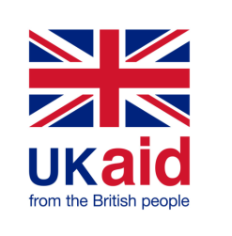
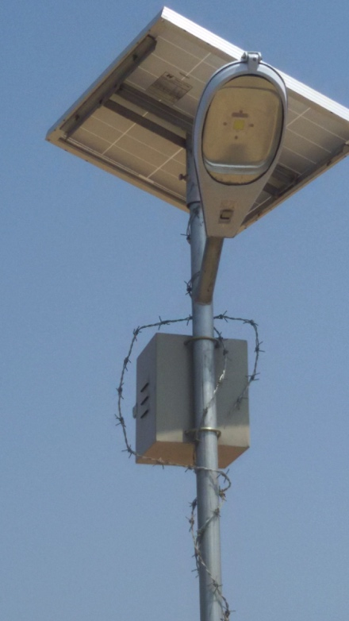
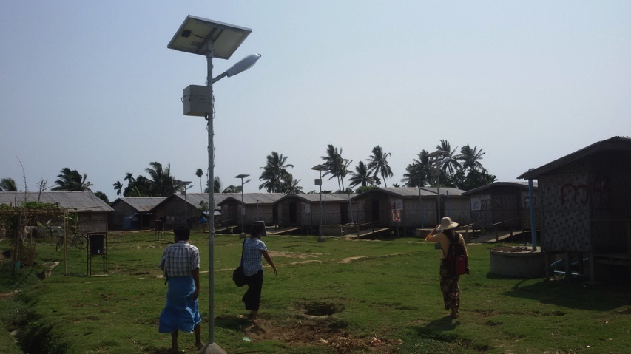
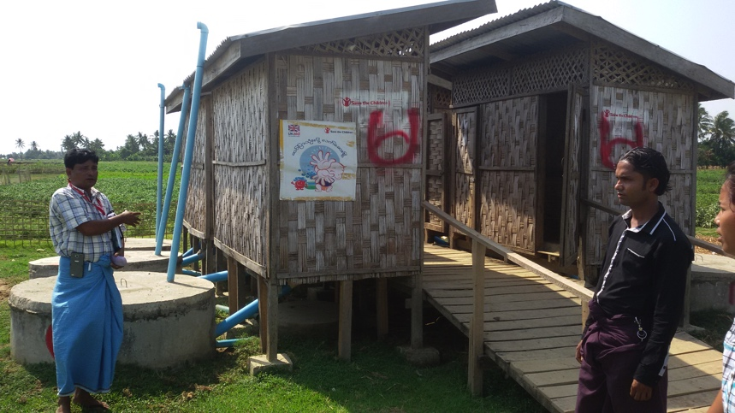
DfID Consortium Partners
May 2015
Solar lighting for gender-segregated latrines assigned to specific temporary shelters
BaSaRa IDP Camp, Sittwe

Table of Contents

Table of Contents 2
01 Introduction 3
02 Objectives of the KAP Survey 3
03 Methodology 4
Sampling Methodology 4
Survey Design 6
Training of Enumerators 7
Data Collection 7
Data Input 7
04 Limitations and Constraints 8
05 Results and Findings 9
DEMOGRAPHICS 9
WATER ACCESS AND DIARRHOEA 10
CERAMIC WATER FILTERS 15
HANDWASHING BEHAVIOURS 18
FOOD HYGIENE 20
SANITATION PRACTICES 21
SOLID WASTE DISPOSAL 24
BATHING AREAS 25
MENSTRUAL HYGIENE 26
HOUSEHOLD SANITARY SURVEY 28
06 Conclusion 29

Annexes
Annex 01: Survey Sampling by Location, Ethnicity of Respondent and WASH Focal Agency 32
Annex 02: Daily Work Plan for Enumerators 33

Introduction

Two waves of inter-communal violence across Rakhine State in June and October 2012 resulted in the displacement of over 93,000 IDPs within Sittwe Township. The violence of June 2012 led to the displacement of approximately 64,000 Muslim IDPs to camps in rural Sittwe and a further 5,000 Rakhine IDPs within Sittwe downtown. The second wave of violence in October 2012 resulted in 15,000 IDPs relocated to rural Sittwe from other affected Townships and in September 2013, an additional 15-20,000 IDPs relocated to the IDP camps from villages on the outskirts of Sittwe town. By the beginning of the 2013 rainy season, 1,800 temporary 8-unit shelters had been constructed for all ‘eligible’ IDPs in Sittwe Township and areas allocated for the construction of WASH facilities.
DfID consortium partners have implemented 3 phases of WASH projects in Sittwe Township since the beginning of the crisis. This report will assess the current situation regarding the Knowledge Attitude and Practices (KAP) regarding hygiene behaviours in the target area to support project indicators for the end of phase 3 and support establishing baseline indicators for phase 4.

Objectives of the KAP Survey
The terms of reference (ToR) for this study outlined the following two objectives:
- Conduct a KAP survey of hygiene behaviours in IDP camps and villages, both those in close proximity to the IDP camps and those in more remote areas to the north of Sittwe Township.
- Monitor DfID project indicators of hygiene behaviour for end of project evaluation of the current project and to establish baseline indicators for the forth round of DfID funding.

In order to achieve these objectives, key accountabilities of the consultant included:
- Design the survey methodology, and develop comprehensive tools for data collection according to WASH best practice and SCI previous surveys
- Review program logframe, proposal, past KAP surveys and other key documents and develop questionnaires accordingly
- Training of data collectors
- Coordination of the survey teams in the field
- Presentation of preliminary findings to at the district and national level stakeholders, if required.
- Data analysis and compilation of a comprehensive survey report
- Prepare and submit final survey reports and data sets to SCI in soft and hard copy.

03 Methodology

The four DfID consortium partners, Save the Children International (SCI), Oxfam GB, Action Contre la Faim and Solidarites International provide WASH services to over 122,000 people in 29 locations of Sittwe Township. This KAP survey used a stratified random household sample of all direct beneficiaries of the project ensuring a 95% confidence interval. Consideration was given to ensure a representative random sample from both ethnicity and the three categories of locations; IDP camps, villages near IDPs and villages in more remote locations north of the IDP camps.

Sampling Methodology
DfID consortium partners provide coverage of WASH services to over 122,000 people (22,250 HH) in 29 locations of Sittwe Township; 12 IDP camps (70,000 people) and 17 villages (52,000 people). The map below illustrates their relative locations. IDP camps are denoted with a white symbol while villages near to IDP camps are in pink and villages in remote areas denoted with a green symbol. The six locations with Rakhine peoples of concern are also highlighted.
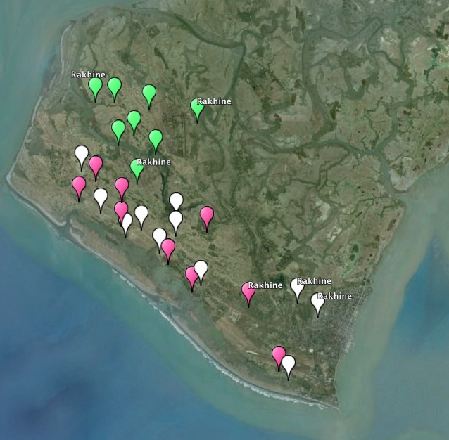
Target Area: 29 IDP Camps and Villages
in Sittwe Township
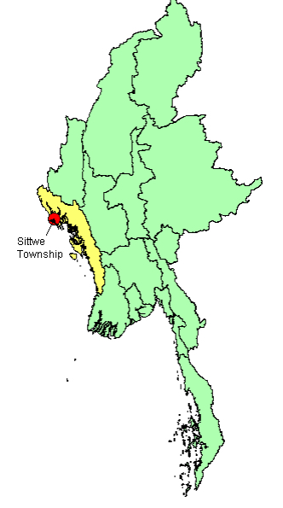

Sittwe Township within Rakhine State and Myanmar
IDP Camps
Villages near camps
Remote villages

In accordance with the methodology used for the baseline KAP survey (March 2014), the formula presented below, identified the need to conduct 428 household interviews to ensure a 95% confidence interval.
Where:
n: Sample size,
Z: Value corresponding to a given confidence level
(1.96 for a confidence level of 95%-value commonly used),
p: Percentage of the primary indicator, expressed as a decimal
c: Selected precision, expressed as a decimal (0.05),
a: Factor to take into account the rate of non responding interviewees and ensure the minimum number

$$n=\frac{Z^{2}p(1-p)}{c^{2}a}$$

To ensure the sample was representative, beneficiary households were stratified by type of location, ethnicity of respondent and the WASH Focal Point Agency (DfID partner). For sampling in villages, each household was assigned a number, a random number generator used to identify the starting point for sampling and an interval of 52 households used to select the number of surveys to be conducted in each location. Of the 428 KAP surveys, 245 were conducted in 11 IDP camps (57%), 152 surveys in 8 villages near to IDP camps (36%) and 31 surveys in 7 villages in remote areas (7%). The process was repeated in IDP camps using temporary 8-unit shelter numbers and then randomly selecting the household.
The table and figures below present a summary of the sampling by location type, ethnicity of respondent and by implementing agency. A detailed breakdown by location is presented in Annex 01.

Type of  Location | TARGET POPULATION |  |  | KAP SURVEYS
 | Location | Pop. | HH | Location | HH
IDP Camps | 12 | 70,088 | 12,744 | 11 | 245
Villages near IDP Camps | 9 | 43,613 | 7,929 | 8 | 152
Villages in Remote Area | 8 | 8,687 | 1,578 | 7 | 31
 | 29 | 122,388 | 22,251 | 26 | 428

Ethnicity | TARGET POPULATION |  |  | KAP SURVEYS
 | Location | Pop. | HH | Location | HH
Rakhine / Maramargyi | 8 | 7,031 | 1,279 | 6 | 25
Muslim | 21 | 115,357 | 20,972 | 20 | 403
 | 29 | 122,388 | 22,251 | 26 | 428

Implementing Agency | TARGET POPULATION |  |  | KAP SURVEYS
 | Location | Pop. | HH | Location | HH
Save the Children | 6 | 39,902 | 7,255 | 6 | 138
Oxfam GB | 7 | 21,666 | 3,939 | 5 | 74
Action Contre la Faim | 8 | 8,687 | 1,578 | 7 | 31
Solidarites International | 8 | 54,488 | 9,907 | 8 | 193
 | 29 | 122,388 | 22,251 | 26 | 428

Survey Design
Initial briefings and project orientation were provided by SCI whilst the project managers from other consortium partners provided additional information, concerns and advice on areas where the KAP survey should focus. Background reading included the third quarter report to DfID, two logical framework matrices; the current DfID funded project (2014-15) and a proposed project for the forth round of funding (2015-16), as well as the two KAP baseline surveys; one for IDPs living in temporary camps, the other for beneficiaries living in houses in nearby or remote villages of Sittwe Township. The minutes of WASH Sub-Cluster coordination meetings also provided insight into some of the challenges faced during this project cycle.
Following discussions with the program managers, a draft survey was compiled which included the inputs of all consortium partners. This draft was edited to a questionnaire of 76 questions and approved by the program managers of the four DfID implementing partners. The table below presents a summary of the questions included in the KAP survey questionnaire.

Topic / Subject | KAP Questions
DEMOGRAPHICS | Consent / Age / Gender / Household composition
DIARRHOEA  (Prevention & Treatment) | Peak periods for diarrhoea / Causes of diarrhoea / Whether people can prevent diarrhoea / Things that can be done at home to reduce likelihood of diarrhoea / Prevalence of diarrhoea in children / Seriousness of diarrhoea / Monthly medical bills
WATER ACCESS AND BEHAVIOUR | Drinking water sources / Changing sources / Whether water can cause illness / illness causes by water / Household water treatment (HWT) / Changes in HWT behaviour
For users of CERAMIC WATER FILTERS | Good aspects of CWF / Problems with CWF / Use / Refilling filters / Quantity provided / Behaviour when no filtered water / Replacement of a filter bowl / Willingness to pay
OBSERVATION | Drinking water container / Behaviour when preparing a glass of water
HANDWASHING BEHAVIOURS | Observation of behaviour / Availability of soap / Most important times / Reasons / Single hand handwashing
For MOTHERS & CARE GIVERS TO CHILDREN | Age of infant / Special times for handwashing when caring for children / Times when children are reminded to wash their hands / Children's use of soap for handwashing after defecation / Frequency of soap use
FOOD HYGIENE | Number of food covers / frequency of using food covers
DEFECATION | Access to a functioning latrine / Where neighbours defecate / Reasons for using a latrine / Reasons for open defecation / Disposal of infant faeces / Changes in behaviour at night / Main difficulty for constructing latrines / emptying latrine pits
SOLID WASTE DISPOSAL | Disposal points / Whether solid waste is a community problem / problems caused by solid waste
BATHING AREAS | Location of facilities / Reasons for constructing a private bathing area / reasons for not having a private bathing area
MENSTRUAL HYGIENE | Sanitary materials used before conflict and now / Reasons for changes in sanitary behaviour / Drying traditional cloths / Whether HH receives sanitary products / Replacement behaviour / personal preference / disposal of napkins

Training of Enumerators
The four DfID implementing partners provided 20 enumerators [19 Muslim and 1 Rakhine; 6 female & 14 female] for data collection selected from project staff that had been actively participated in providing hygiene promotion activities to the target communities. Training was conducted on Thursday 30th April and Saturday 2nd May and Monday 4th May 2015 at the Save the Children sub-office in Tet Kael Pyin village. Although there were 4 or 5 experienced enumerators amongst the group, 12 of them had never conducted a survey before. The table below summarizes the 2 and-a-half day training.

Day | Activity | Remark
Day 1 | - Introduction to the main concepts behind KAP surveys  - Discussion of the successful and less successful components of the DfID WASH project | - 12 enumerators without any survey experience  - 6 female enumerators  - 1 Rakhine enumerator
Day 2 | Muslim translator used to support the Myanmar speaking facilitator  - Introduction to the KAP survey questionnaire  - Checking a common understanding of each question and its response options | - Minor edits made to KAP survey
Day 3 | - Field Test in Tet Kael Pyin village; one survey per enumerator  - Feedback on field test experience and clarifications | - Survey Time: 45 – 60 mins  - Minor edits made to KAP survey

Data Collection
Household interviews were conducted between 5th and 13th May 2014. As only one Rakhine enumerator was initially trained a second, female enumerator was recruited. This two-person team conducted all the surveys in the Rakhine communities. The remaining 19 Muslim enumerators worked exclusively with Muslim communities. As the team was not gender balanced, it was reorganized that female enumerators could support their male colleagues by asking the questions relating to sanitary protection.

Data Input
Two data input specialists were provided by Save the Children International (SCI), whilst a third was recruited by SCI in the second week of data collection. Data was entered into a MS Excel spreadsheet developed by the consultant with validation boxes providing instructions for input staff on each input cell. Data entry occurred between 6th to the 15th May 2015

Limitations and Constraints

Although knowledge, attitudes and practices (KAP) surveys are regarded as a standard tool for monitoring behaviour change in WASH programs, they are subject to limitations with bias being introduced by a wide range of factors. This was compounded by the use of 4 languages in the training: English, Myanmar, Rakhine and the local Muslim Bengali dialect.

The questionnaire was translated from English to Myanmar language. However, it was clear that not all the enumerators were comfortable with this language. When the survey questions were reviewed in the training sessions, a translator specializing in English, Myanmar and the local language supported, to put enumerators at easy. However, as many questions required considerable discussion, it was clear that not all enumerators were confortable with how the questions were written in Myanmar and some concepts were difficult to grasp. The multiple languages increased the likelihood of misinterpretation which was evident once the survey data had been entered into the excel spreadsheet and the resulting raw data required considerably more ‘cleaning’ that would normally be expected.

Person-to-person surveys always carry the risk of skewed responses by inherent pressures respondents might feel to respond in a certain way. Enumerators were trained to be objective and were specially trained in techniques to probe for multiple responses. However, pressures to conduct a certain number of surveys in a given day can always limit the quality of these responses. As the enumerators were also the same people who have been providing hygiene messages to the target community as part of project implementation, it is highly likely that bias was introduced.

The design of a questionnaire will influence the results received. There was evidence in a number of open questions such as the question relating to what respondents do in the home to keep their water ‘safe’ where the leading question received far less responses than when the question used prompting techniques to ascertain levels of knowledge. This prompting may well have skewed the overall findings. Those questions which specifically used this technique did so for a purpose. However, it is uncertain whether enumerator used the same technique for other questions where ‘probing’ was supposed to be the technique to draw out multiple responses.

The gender and age of the respondents, with 85% being women, may also have affected the quality of results. As culturally, the vast majority of women and girls in the target communities remain at home while men are expected to be the bread winners, there may have been less confidence to offer personal responses from a fear that their husbands or fathers would not approve. This may be a factor in why respondents chose not to answer many of the questions posed.

In conclusion, the findings from this survey should be taken as a guide rather than taken at face value. There may have been a tendency for female respondents in the highly conservative Muslim communities not to speak their mind for fear of disapproval from their spouses.

05 Results and Findings

DEMOGRAPHICS
This KAP survey interviewed respondents in 428 households of the target area. The ethnic breakdown of respondents reflected the overall breakdown of the affected population. However, with only 6% of respondents being Rakhine, the relevance of presenting any data by ethnic group was very limited and thus not used in this survey.

The average size of respondent households was 6.2 members which is fractionally higher than the average used by the CCCM Cluster for the camp list (5.5 members). Within households the gender divide is equal with 50.1% men and 49.9% women with no significant differences between villages and the IDP camps. Children under 18-years-old account for 53% of the target population while children under 5 years-old account for 20%. The majority of respondents were women (85% and half of the respondents were aged between 30 and 60 years old.

WATER ACCESS AND DIARRHOEA

The majority of respondents in the target area extract water from boreholes for all household uses. In the IDP camps, where there are less options for alternative water sources, 95% of respondents reported using boreholes for both drinking water and other domestic uses whilst in the target villages of the Township, almost a third of respondents extract water from open wells (30%).

The majority of water sources in the township were reported to be perennial. However, a third of all respondents (29%) reported a need to change water sources during the year. In the IDP camps, the change was reported as mainly due to the breakdown of handpumps whereas in the villages, where shallow open wells are popular, changes in water quality particularly affecting taste as well as low recharge rates in the peak dry season were cited as the primary reasons for changing water sources.

Knowledge of water related illnesses is rather limited across the target area with little difference between those living in IDP camps and those in villages. Whilst 45% of respondents could name one water related illness, mainly diarrhoea, only 31% could name 2 illnesses and 14% named 3 water-related illnesses. Respondents have a clear understanding that diarrhoea can be caused by water (83% of all respondents). However, few respondents demonstrated an understanding that skin and eye infections can be caused by water; 12% and 6% respectively.

When questioned about the causes of diarrhoea, almost all respondents were able to identify one cause. However, less than half of all respondents could identify 2 causes (43%) and only 13% could identify 3 or more.

Surprisingly, more respondents associated dirty food as a cause of diarrhoea (55%) than ‘unclean or unsafe water’ (46%). As the questionnaire addressed the subject of diarrhoea prevention and treatment at the outset of the survey, respondents were not influenced by the water and sanitation related questions which followed. It was also interesting to note that 6% of respondents also mentioned leaving food uncovered and 8% vector transmission. Transmission from dirty hands was reported by almost a third of respondents (28%).

As children are more susceptible to diarrhoea than adults, questions for health seeking behaviour for severe diarrhoea focused on children. Respondents reported a clear understanding of the importance of treating severe diarrhoea with oral rehydration salts (ORS) with 70% reporting treating their children with sachets of ORS which is available across the target area. Although, WASH agencies are not actively promoting the use of home-made ORS for fear beneficiaries will not be prepare it correctly, 21% respondent households reported using this method and a further 3% administering coconut water.

When questioned about whether diarrhoea could be prevented, 53% of respondents reported that it could whilst 39% believed diarrhoea to be inevitable. Respondents appeared to associate this to the season with the hot season (60%) and the change from the hot season to the rainy season (35%) being cited as the times of highest diarrhoea prevalence. When asked what respondents could do to prevent diarrhoea in the home, ‘drinking safe water’ was the most popular response (35% of respondents) whereas ‘eating safe food’ was the second most popular (24%). The difference between respondents’ answers for the causes of diarrhoea where ‘dirty food’ was the most popular response against methods to prevent diarrhoea in the home is likely to be due to the fact that the respondent had been asked a series of water-related questions and would therefore be more likely to be aware that the survey was connected to WASH activities. Handwashing with soap and using a latrine, the other two of the ‘4-cleans’ were reported less; 17% and 2% respectively. It is interesting to note that at this point in the questionnaire, when latrine usage had not been mentioned that few respondents mentioned an association with diarrhoea and latrine usage

To follow-up on questions relating to diarrhoea prevention in the home, respondents were asked whether they thought their children were likely to suffer from severe diarrhoea in the next month; the period corresponding with the highest prevalence of diarrhoea. One in four respondents (26%) believed their children would suffer severe diarrhoea in this period with half of these respondents attributing the diarrhoea to dirty hands (13%).

Water Use Behaviour
Almost all respondents (95%) reported that they do something in the home to keep their drinking water safe. When asked what they do, only 61% of respondents answered that they filter their water with either a muslin cloth or a ceramic water filter. However, further questioning which specifically asked about the two types of filters revealed that 94% of respondents use these methods with 56% claiming to use a ceramic filter and 38% a traditional cloth. The difference in the two answers illustrates that a third of respondents do not associate filtration with making water ‘safe’. This confirm findings from a water quality survey conducted by CDN in Sittwe Township in January 2014 where during informal interviews, beneficiaries said they use the filters because they were told to do so by WASH agencies without being aware of the reason for using them.
In addition to filtration, one in six households also reported the importance of keeping the drinking water container clean and covered; 15% and 16% respectively.

Respondents reported significant changes in household water treatment (HWT) behaviour when compared to before the 2012 conflict with 80% of respondents in IDP camps and 52% in villages reporting behaviour changes. 42% of respondents attributed these changes to the work of WASH agencies while 22% reported that the changes were a result of the efforts of community hygiene promoters through home visits. Very few respondents attributed the changes to either efforts by Government health staff or from radio or TV messages.

CERAMIC WATER FILTERS
Throughout the emergency response, the WASH Cluster in Rakhine State has actively promoted the use of household water treatment (HWT) through ceramic water filters (CWF). In the near future, the Cluster will soon conduct an independent assessment of the effectiveness and usage of ceramic water filters. However, this KAP survey revealed usage to be reasonably high with 58% of respondents claiming to use the filters. Observations conducted by a household sanitary survey confirmed usage to be high with 50% of respondent households using their filters on the day of the survey. Usage was significantly higher in the IDP camps with 70% claiming to use a filter and 61% using it on the day of the survey whereas in the villages usage was a lot lower with 45% claiming to use them and 37% observed.

When questioned about the things respondents liked about their filters, the two most popular responses were that they are good for the health of their family (31%) and that they provide safe clean water. Given that the technology has limitations and that other studies such as the Water Quality Assessment in Sittwe Township conducted in January 2014 revealed a series of complaints from users regarding the slow filtration time and the burden of refilling filters, it was surprising that none of the respondents reported anything negative about the ceramic water filters. Hopefully, the upcoming WASH Cluster study will be able to learn more about this issue.

The hemispherical shape of the ceramic water filters means that the flow rate reduces over time. A study conducted for Unicef in 2009 revealed that for a full filter bowl, the second hour flow rate is 54% of the first hour and the third hour, 38%. This implies that for an average family, filters need to be regularly refilled in order to produce sufficient safe water for all household needs. The study concluded that the filter needs to be filled a minimum of 3 times a day; once at night, first thing in the morning and then 2 or 3 hours later in order to cover the drinking water needs of a 5-member family.

A total of 85% of respondents using ceramic water filters reported that the filter produces sufficient ‘safe’ water to cover the needs of their household with 88% of respondents claiming to refill their filter 2 or 3 times a day. With limited supply, filtered water is mainly used for drinking. However, in the IDP camps a third of CWF users also claim to use filtered water for cooking.

Generally speaking, there appears to be a reasonable level of user satisfaction with ceramic water filters. However, as mentioned previously, the proposed WASH Cluster assessment of ceramic water filters will explore this issue in detail during the 2015 rainy season.

Although the ceramic filter bowls are currently unavailable in the markets of the target area, respondents were asked whether they would like to replace their filter bowl if it was broken. All 248 users replied that they would like to do so and subsequently were asked what they would be willing to pay. As the question was hypothetical, there was some confusion regarding this question as a third of respondents did not answer. However, almost half of filter users (47%) suggested a price in line with what the market would be likely to sell the filters for (NB: the manufacturing cost of ceramic filter bowls is approximately $3 whist the food grade plastic receptacles are more expensive and increase the price of the filter unit considerably).

HANDWASHING BEHAVIOURS
Prior to being asked questions relating to handwashing, enumerators asked the respondent to provide materials so that the enumerator could wash their hands. Soap was provided by only 64% of households (73% in IDP camps and 54% in villages). In households where soap was unavailable, 60% (20% of all respondents) claimed they could not afford it or that their household had more pressing priorities to spend their limited domestic income. Given the regular distributions of soap by WASH agencies and the availability of soap throughout the target area at a ‘reasonable’ price, this was surprising.

When questioned about the most important times to wash hands, only 53% of respondents were able to name two or more critical times and only one in five households could name 3 (21%). No significant differences were observed between respondents in IDP camps and those in villages, nor between the genders of respondents.

Further questioning regarding the reasons for handwashing did not reveal a strong connection between handwashing and reducing the risk of illnesses. Only 28% of respondents mentioned this for this question and only 27% for the question connected to the causes of diarrhoea.

Observations in the field revealed that it is not uncommon for people in the target area to only wash one hand before eating meals. However, when questioned directly on the subject, only 8 respondents admitted to practicing this. Whilst beneficiaries do not touch food with their left hand, there is clearly an issue for transmission as the left hand touches numerous surfaces during meals.

Previous surveys conducted by the nutrition sector have been unable to determine whether handwashing messages provided to mothers and care givers on the importance of handwashing before feeding children have been successful or not. Subsequently, questions relating specifically to this target group were asked during this survey where 95% of respondents fell into this target group.

Although 78% of respondent mothers and care givers mentioned the importance of handwashing before feeding children indicating a high level of knowledge, practices appear lower with only 33% of the 55 respondents caring for children under 6-months-old reporting handwashing before breastfeeding and only 26% of the 147 respondents caring for infants aged 6-24 months, reporting handwashing before supplementary feeding. The findings presented in the chart below (right) include the response of all respondents and subsequently percentages differ slightly from those stated in this paragraph.

Mothers and care givers reported that they regularly remind their children to wash their hands. The three most popular responses for handwashing reminders were before eating (55%), after waking up (48%) and after defecation (45%). In addition, two thirds of respondents (61%) claimed that their children wash their hands with soap almost all of the time. As soap was only available in 64% of respondent households, this would imply that the children in all these households use soap most of the time, which is highly unlikely.

FOOD HYGIENE
Although 55% of respondents identified unclean food as a major cause of diarrhoea, there appears to be little understanding that vectors are a transmission route for diarrhoea. Observations in respondent households during the household sanitary survey revealed uncovered cooked food in 69% of households with only 17% of respondents owning a food cover. It is highly likely that unclean food is one of the most serious hygiene risks in the target area and future hygiene promotion sessions should stress the important of covering food to prevent transmission by vectors.

SANITATION PRACTICES

As the survey questions relating to sanitation practices were asked in the later half of the survey and given the sensitivity of the subject, respondents were asked about the defecation practices of their neighbours rather than that of their own household in order to obtain a general understanding of the prevalence of open defecation. The percentages presented below indicate trends in defecation habits of different beneficiary groups. This data is not appropriate for measuring project indicators.

Respondents reported that although approximately 70% of adults generally use latrines, a large percentage of children do not, preferring open defecation. 46% of respondents reported open defecation by most of the young boys in their neighbourhood whilst 33% reported that young girls practice open defecation rather than use a latrine. It was also reported by 14% of households that the elderly tend to defecate within the home rather than use latrines.

Respondents reported that open defecation practices are more prevalent in the villages than in the IDP camps. With lower latrine coverage, open defecation in the villages is also widely practiced by adults (men 32%; women 24%), whereas in the IDP camps, 85% of respondents claim that adults generally use latrines.
When questioned as to whether respondent households had access to a functioning latrine at the time of the survey, 67% of respondents stated that they had. However, latrine access was significantly higher in IDP camps (78%) than in the villages (55%). Villagers stated the main reason for the low coverage of latrines is that they are unable to afford them (67%). However, this is unlikely to be their only reasons and may well be connected to habitual practices and not recognizing the health risks associated with open defecation.

Given the fact that despite having access to latrines, there remains a high prevalence of open defecation as confirmed by field observations, respondents were asked why people continue to practice open defecation. In the IDP camps, respondents were less willing to comment with 37% choosing not to answer the question. Those that did, claimed the main reason to be damaged or non-functioning latrines (40%) whilst 29% indicated that people prefer open defecation stating that it was either their habitual practice or that latrine use was not in their culture. Very few respondents commented about latrines being claustrophobic, smelling bad or of being full of flies and mosquitos.

Defecation practices differ at night for 39% of respondent households, particularly for the elderly as reported by 13% and for adult women (15%). Two thirds of respondents reporting changes, mentioned defecation within the household by either using a child’s potty, a bedpan or by night soil (collection in a plastic bag) while a further 23% change to use a latrine at night.

The primary reason for these changes according to focus group discussions is fear; fear of meeting someone, fear of attack or a fear of ghosts. In the IDP camps, 34% said they did not feel safe whilst 25% complained of the dark and 23% reported difficulties in access. In the villages, the fear of meeting other people was the most popular reason (33%) as well as a general feeling in insecurity (24%).
To improve security, increase convenience and promote night-time latrine use, pilot projects to install solar lighting have recently been implemented in 3 IDP camps in the target area. During the assessment, field visits were made to two of these locations: BaSaRa IDP camps which is a relatively small camp of 52 temporary shelters relatively isolated from the main population near to Sittwe airport and Ohn Taw Gyi North, one of the largest IDPs in the area. As the solar lighting was only installed 4 or 5 weeks prior to the KAP survey, systems are still functioning effectively with no reports of battery theft or vandalism as was the case in 2013, when the Consortium of Dutch NGOs (CDN), a partner of the DfID consortium in an earlier phase of the DfID funded response, installed solar lighting in Ohn Taw Gyi North.
Feedback from informal interviews and focus group discussions in both camps revealed a high level of user satisfaction with the project. However, the lighting has caused some jealousy from households that do not benefit from lighting close to their temporary shelter.

Informal interviews and focus group discussions revealed respondents are not aware of the dangers posed by infant faeces. Respondents and hygiene promoters were of the opinion, that as young children are often breastfed or eat simple foods, that their faeces are relatively safer than adults when in actual fact they pose considerably higher health risks. Soft infant faeces are usually rinsed through the gaps in the floor with water only. Soap is generally not considered necessary.

For the disposal of solid infant faeces, 39% of the 174 respondents with infants reported throwing them into the fields. However, close to half of the respondents with infants claimed to dispose of infant faeces in a hygienic manner (45%) by either disposing of them a latrine (28%), burying them (13%) or throwing them into waste bins for collection and disposal (4%).

SOLID WASTE DISPOSAL
Solid waste management behaviours differ considerably between the IDP camps and the villages. Systems established by WASH agencies in the IDP camps appear to be functioning reasonably well with 71% of IDP respondents claiming that they regularly use either the waste collection points established in the camps (58%) or that waste is collected from the household by community workers and disposed of in the collection points (13%).

Although observation revealed otherwise, 48% of all respondents do not believe solid waste to be in a problem in their community and a further 18% declined to answer the question.

BATHING AREAS
At the beginning of the emergency response in 2012, the Shelter Cluster included communal bathing areas for women in the site planning for the first IDP camps constructed by UNHCR. However, despite using participatory design techniques, these bathing areas proved a failure. Reports from this KAP survey reveal that 56% of women and girls bathe in home whereas men and boys use the water point.
Although some of the bathing areas inside shelters have been supported by WASH agencies, many were constructed by the beneficiaries themselves. Observations within households revealed that 35% of respondent households have a specific area for women bathing within their shelters although almost double that number reported that women are bathing within shelters.

When asked why these bathing areas were constructed, most respondents replied that women require privacy and that communal bathing areas are inappropriate. The demand for private bathing spaces is great. However, the main reason for not constructing them is a lack of income.

MENSTRUAL HYGIENE
Given the sensitive nature of the subject matter, the survey questions relating to menstrual hygiene were phrased to ask the respondent about the general habits of women in the neighbourhood rather than asking them about their personal habits. Although the question was phrased in this way to deflect embarrassment, it is most likely that women answered it from their personal perspective.
Women reported significant changes in menstrual hygiene habits since the conflict with 51% of respondents reporting that they are now using a different form of sanitary protection to what they used before the conflict. The regular use of sanitary napkins has increased by 51% across the target area; from 18% before the conflict to 69% of women today. The greatest change was reported in the IDP camps where sanitary napkin usage has increased by 70%; from 21% to 91%. However, significant changes were also reported in the villages where usage has increase by 32%; from 13% to 45%.

Changes in Women’s use of Sanitary Protection Materials
13%
22%

Many respondents attributed these changes to the work of NGOs through the efforts of village/camp hygiene promoters and through distributions of sanitary protection materials. However, although almost all households in the IDP camps receive regular supplies of sanitary protection materials only half of the respondents in villages have ever received any (51%) which may explain why greater behaviour change was reported in the IDP camps than villages.

When questioned about their preference for sanitary protection, there was a sight difference between the IDP camps and the villages. However, both forms of protection are relevant to the context and should agencies consider distributions in the future, the choice of both types should be provided. This has already been recognised by WASH Cluster partners as future distributions of consumables will most probably be provided through a voucher system ensuring beneficiaries have a choice.
When questioned about women’s behaviour when sanitary protection consumables are exhausted, it was interesting to learn that over a third of women purchase more. This group of women display a clear preference for sanitary napkins rather than the traditional cloths.

Regarding the disposal of used napkins, those women who answered the question provided a safe answer. Although as it is likely that the napkins are first put in a plastic bag, the fact that a quarter of women throw them in the latrine adds complications to desludging.

HOUSEHOLD SANITARY SURVEY

A household sanitary survey, which looked at 14 sanitary risks, was conducted in each of the 428 respondent households to triangulate information reported from the survey questionnaire, focus group discussions and informal interviews. The sanitary risks were not weighted and therefore it should be noted that the severity of the hygiene risks are not equal.

Little differences were observed between respondents in IDP camps and those living in villages although slightly more hygiene risks per household were observed in the villages. In particular, the availability of soap and the use of ceramic water filters were less in the villages.

For the next phase of project implementation (Phase 4), output indicator 4.1 assesses the percentage of beneficiaries that practice safe water management in the home. To set the baseline indicator, 4 sanitary risks from the household sanitary survey were used; Use of a ceramic water filter, covering drinking water containers, whether a separate container is used for drinking water and whether it is possible to extract drinking water safely (shown in ‘orange’ in the chart presenting sanitary risks. If a sanitary risk was observed for any of these 4 risks, the household was judged NOT to be practicing safe water use behaviours. The household sanitary survey therefore determined that only 45% of respondents are currently practicing safe water use behaviours in the household.

Of serious concern is respondents’ behaviour relating to food hygiene (shown in ‘blue’ on the chart above presenting sanitary risks). As previously stated, food covers were only observed in 17% of households. The household sanitary survey confirmed this and also noted that during the survey that uncovered cooked food was observed in 69% of households. Future hygiene promotion sessions and home visits should give greater emphasis to food hygiene in the next phase of implementation.

06 Conclusion

Although WASH agencies have been actively promoting improved hygiene behaviours in the target area for almost 3 years, using a limited range of messaging, both knowledge and subsequently safe hygiene practices remains very low when compared to similar WASH projects conducted in other parts of Myanmar in both emergency and development settings. A workshop entitled ‘behaviour Change in the Rakhine Context’ facilitated by Oxfam GB in late 2011, attended by field staff from 12 UN/NGO agencies (mainly hygiene promoters) working in central Rakhine on post-Giri cyclone projects and in northern Rakhine State (nRS) on the chronic emergency situation there, revealed that field staff believed the Muslims living in these parts of Rakhine State to be an extremely difficult group to achieve behaviour change with. KAP surveys conducted in this period tended to show higher levels of knowledge to this survey but similar low-levels of practices.

This particular target group are extremely conservative and resist any change from ‘outsiders’. Efforts to work together with Mullahs and other religious figures as agents of change in the past have also met with limited success. It is therefore believed that the greatest long-term changes in hygiene behaviours will most likely come from the younger generation. Consequently, it is recommended that WASH agencies in the target area invest in the youth of the target area as well as working with adult for immediate results.

Whilst considerable efforts have been made by WASH agencies to diversify strategies and develop a wide range of tools for the dissemination of information concerning improved hygiene behaviours, greater efforts are required to convince beneficiaries of the need for change as revealed by the low levels of understanding of the causes of diarrhoea and other WASH related illnesses. Until beneficiaries truly understand the reasons for change, it is unlikely that behaviours will significantly improve.

In phase 4 of the DfID WASH program, partners will continue to move away from generic WASH strategies and tailor hygiene promotion activities to the needs of individual households or those requiring greatest attention. The use of community based hygiene promoters is clearly the way forward as it is highly unlikely Muslim beneficiaries will be influenced by ‘Myanmar’ outsiders. Whilst these community hygiene promoters are highly motivated, it should be remembered than many have a very low level of basic education. The key to success of future stages of the program will rest on these staff and consequently, WASH partners should invest significantly in improving the facilitation skills of these staff. As can be seen from the ‘4-cleans’ approach of the Myanmar government over the past 30 years, whilst the vase majority can recite them, behaviour change in adopting improved practices falls far behind knowledge.

It must be remembered that there are major limitations in the findings of KAP surveys. Beneficiaries have been exposed to these types of questions on numerous occasions and very often, usually for reasons of embarrassment, manipulate their answers to tailor them to what is expected rather than to the reality of the situation. In the case of questions where multiple responses are expected, often responses reflect the skill of the enumerator to extract as many answers as possible and if hurried, findings of the true levels of knowledge and the attitudes that are a barrier to change become limited.

Findings from this KAP report will be used to establish baseline indicators for phase 4 of the DfID funded WASH program of the consortium. The table below presents the baseline indicators that this survey was able to achieve.

OUTPUT INDICATOR – DfID Phase 4 | BASELINE

Output indicator 2.3 | HH Sanitary Survey | % of households using and maintaining ceramic water filters | 51% | Camps & Villages
 |  |  | 61% | IDP camps
 |  |  | 37% | Villages near Camps
 |  |  | 40% | Remote villages
Output indicator 3.1 | KAP Questionnaire | % of people with access to functioning latrines | 67% | Camps & Villages
 |  |  | 78% | IDP camps
 |  |  | 54% | Villages near Camps
 |  |  | 69% | Remote villages
Output indicator 4.1 | KAP Questionnaire | % of targeted beneficiaries with knowledge of handwashing with soap at minimum of 3 of 5 critical times | 21% | Camps & Villages
 |  |  | 21% | IDP camps
 |  |  | 23% | Villages near Camps
 |  |  | 19% | Remote villages
Output indicator 4.2 | KAP Questionnaire | % of caregivers reporting they dispose of child faeces in a hygienic manner. | 44% | Camps & Villages
 |  |  | 55% | IDP camps
 |  |  | 35% | Villages near Camps
 |  |  | 27% | Remote villages
Output indicator 4.3 | HH Sanitary Survey | % of targeted beneficiaries practicing safe water management in the home | 31% | Camps & Villages
 |  |  | 36% | IDP camps
 |  |  | 25% | Villages near Camps
 |  |  | 31% | Remote villages
Note: For output indicator 4.3, safe management in the home was determined by observations during the household sanitary survey. Respondent households were required to comply with the following criteria:

- Use of a separate drinking water container
- Drinking water container is covered
- Drinking water can be extracted safely with risk of contamination

WASH Cluster KAP Indicators

In early 2015, the WASH Cluster in Rakhine State established key KAP indicators. The table below presents the findings from this KAP survey relating to these indicators.

Source of Verification | WASH Cluster KAP Indicator | May 2015
KAP Questionnaire | % men, women and children (>7yrs) have basic knowledge of diarrheal disease transmission  – at least two transmission routes (F-diagram) | 38% | Camps & Villages
 |  | 38% | IDP camps
 |  | 40% | Villages near Camps
 |  | 35% | Remote villages
KAP Questionnaire | % men, women and children (>5yrs) know and practice hand-washing at key moments – at least two moments (after handling faeces, before handling food) | 52% | Camps & Villages
 |  | 57% | IDP camps
 |  | 54% | Villages near Camps
 |  | 35% | Remote villages
KAP Questionnaire | % households collect water from protected source | 84% | Camps & Villages
 |  | 98% | IDP camps
 |  | 73% | Villages near Camps
 |  | 38% | Remote villages
HH Sanitary Survey | % households practice treatment of water to reduce contamination | 51% | Camps & Villages
 |  | 61% | IDP camps
 |  | 37% | Villages near Camps
 |  | 40% | Remote villages
HH Sanitary Survey | % men, women and children (>7yrs) practice safe handling of treated and stored water to prevent re-contamination | 23% | Camps & Villages
 |  | 28% | IDP camps
 |  | 17% | Villages near Camps
 |  | 19% | Remote villages
 | % men, women and children (>7yrs) use exclusively latrines | Not possible to determine
 | % children (<7yrs) use exclusively latrines | Not possible to determine

Annex 01: Survey Sampling by Location, Ethnicity of Respondent and WASH Focal Agency

 | Location . | Acronym | Typology | Main Ethnic Group | WASH Focal Point Agency | Target Population |  | Number of  KAP Surveys
 |  |  |  |  |  | Total | HH
1 | Dar Paing | DP | IDP Camps | Muslim | SI | 10,663 | 1,939 | 38 | 245
2 | Teh Chaung | TC |  | Muslim | SI | 5,446 | 990 | 19
3 | Baw Du Pha | BDP |  | Muslim | SI | 10,827 | 1,969 | 40
4 | Hmansi | HMZ |  | Muslim | SI | 1,982 | 360 | 7
5 | Ohn Taw Gyi (N) | OTG (N) |  | Muslim | SCI | 14,216 | 2,585 | 48
6 | Thet Kel Pyin | TKP |  | Muslim | SCI | 6,255 | 1,137 | 22
7 | Maw Ti Ngar | MTN |  | Muslim | SCI | 3,457 | 629 | 12
8 | Basara | BSR |  | Muslim | SCI | 1,980 | 360 | 7
9 | Say Tha Mar Gyi | STMG |  | Muslim | OGB | 12,064 | 2,193 | 43
10 | Set Yone Su 1 | SYS 1 |  | Maramargyi | OGB | 435 | 79
11 | Set Yoe Kya 2 | SYK 2 |  | Rakhine | OGB | 1,984 | 361 | 7
12 | Set Yone Su 3 | SYS 3 |  | Rakhine | OGB | 779 | 142 | 2
13 | Thet Kael Pyin village | TKP (v) | Villages near IDP Camps | Muslim | SCI | 13,367 | 2,430 | 47 | 152
14 | Basara Village | BSR (v) |  | Muslim | SCI | 627 | 114 | 2
15 | Ohn Taw Gyi Village | OTG (v) |  | Muslim | OGB | 2,355 | 428 | 8
16 | Say Tha Mar Chay Village | STMC (v) |  | Muslim | OGB | 480 | 87
17 | Say Tha Mar Gyi Village | STMG (v) |  | Muslim | OGB | 1,214 | 221 | 6
18 | Teh Chaung Village | TC (v) |  | Muslim | SI | 13,774 | 2,504 | 48
19 | Dar Paing Village | DP (v) |  | Muslim | SI | 10,703 | 1,946 | 37
20 | Baw Du Pha Village | BDP (v) |  | Muslim | SI | 377 | 69 | 2
21 | Teh Chaung Village | TC (v) |  | Rakhine | SI | 716 | 130 | 2
22 | Ah Lar Than Village | ALT | Villages in Remote Areas | Muslim | ACF | 1,286 | 234 | 4 | 31
23 | Me La Zi Kone Village | MLZK |  | Muslim | ACF | 1,091 | 196 | 4
24 | Nga/ Pun Ywar Gyi Village | N/PNG |  | Muslim | ACF | 1,418 | 258 | 5
25 | Nga/ Pun Ywar Chay Village | N/PYC |  | Muslim | ACF | 1,340 | 244 | 4
26 | Thin Pone Tan Village | TPT |  | Rakhine | ACF | 1,231 | 224 | 5
27 | Aung Daing Village | AD |  | Rakhine | ACF | 1,867 | 339 | 7
28 | Daung Pyauk Kay Village | DPK |  | Rakhine | ACF | 91 | 17
29 | Zaw Pu Gyar Village | ZPG |  | Rakhine | ACF | 363 | 66 | 2
 |  |  |  |  |  | 122,388 | 22,251 | 428 surveys

Annex 02: Daily Work Plan for Enumerators

Typology of  Beneficiaries | LOCATION | Date: May | 5 | 6 | 7 | 8 | 9 | 10 | 11 | 12 | 13 | 14
 |  | Number of Surveys | Tue | Wed | Thur | Fri | Sat | Sun | Mon | Tue | Wed | Thu
Camp with IDPs | Thet Kael Pyin | 22 | 22
Village near camps | Thet Kael Pyin Village | 47 |  | 36 | 11
Camp with IDPs | Maw Ti Ngar (TKP west) | 12 | 12
Camp with IDPs | Dar Paing | 38 |  |  | 38
Village near camps | Dar Paing Village | 37 |  |  |  |  | 37
Camp with IDPs | Teh Chaung | 19 |  | 19
Village near camps | Teh Chaung Village | 48 |  |  |  |  |  |  |  | 36 |  | 12
Village near camps | Teh Chaung Village (Rakhine) | 2 |  |  | 2
Camp with IDPs | Baw Du Pha | 40 |  |  |  |  |  |  |  |  |  | 40
Village near camps | Baw Du Pha Village | 2 |  |  | 2
Camp with IDPs | Hmansi | 7 |  |  |  |  | 7
Camp with IDPs | Say Tha Mar Gyi | 43 |  |  |  |  |  |  | 43
Village near camps | Say Tha Mar Gyi village | 6 |  |  |  |  |  |  | 6
Camp with IDPs | Basara | 7 |  |  |  |  | 7
Village near camps | Basara village | 2 |  |  |  |  | 2
Camp with IDPs | Ohn Taw Gyi North | 48 |  |  |  |  |  |  |  |  | 48
Village near camps | Ohn Taw Gyi village | 8 |  |  |  |  |  |  |  |  | 8
Camp with IDPs | Sat Roe Kya 2 (Rakhine) | 7 |  |  |  | 7
Camp with IDPs | Set Yone Su 3 (Rakhine) | 2 |  |  | 2
 |  | 397 | 34 | 55 | 55 | 7 | 53 |  | 49 | 36 | 56 | 52
More remote villages | Ah Lar Than | 4 |  |  |  |  |  |  |  | 4
More remote villages | Me la zi Kone | 4 |  |  |  |  |  |  |  | 4
More remote villages | Nga/ Pun Ywar Gyi | 5 |  |  |  |  |  |  |  | 5
More remote villages | Nga/ Pun Ywar Chay | 4 |  |  |  |  |  |  |  | 4
More remote villages | Aung Daing (Rakhine) | 7 |  |  |  |  |  |  |  | 7
More remote villages | Thin Pone Tan (Rakhine) | 5 |  |  |  |  |  |  | 5
More remote villages | Zaw Pu Gyar (Rakhine) | 2 |  |  |  |  |  |  |  |  | 2
 |  | 31 |  |  |  |  |  |  | 5 | 24 | 2
 | TOTAL Number of Surveys | 428 | 34 | 55 | 55 | 7 | 53 |  | 54 | 60 | 58 | 52
 | Cumulative Number of Surveys |  | 34 | 89 | 144 | 151 | 204 | 204 | 258 | 318 | 376 | 428

Source: Camp Coordination and Camp Management (CCCM) Cluster, Camp List (Feb 2015)
A registration process for IDP status was suspended in September 2012. IDPs relocating to the camps of Rural Sittwe shortly after the completion of the temporary shelters in September 2013 were never formally recognized by the RSG. However, these IDPs from villages to the north of Sittwe downtown are included on the CCCM Camp List.
IDPs living in a tented community near to the port in Teh Chaung village were offered temporary shelter by the RSG in July 2013 but refused to relocate away from the port. Although RSG security concerns forbids the construction of shelters, the mostly Kaman community have permission from the Security Minister to temporarily occupy the land.
In the first two phases of implementation, the consortium included the Dutch Consortium of NGOs (CDN). However, for phase 3, CDN were replaced by Oxfam GB
Surveys were not conducted in 3 of the smallest target locations: Set Yone Su 1 IDP camp (Maramargyi), Set Tha Mar Chay village (Muslim) and Daung Pauk Kay village (Rakhine)
The ‘4-Cleans’ are the 4 most important ways to prevent diarrhea in the home which have been actively promoted in Myanmar for the past 30 years through the Central Health Education Bureau (CHEB), a department of the Ministry of Health
The mechanics of Ceramic Water Filters in Myanmar, Unicef / Safe Water Systems (2009)

