CHIN STATE
JULY / AUGUST 2015 LANDSLIDE
SITUATION REPORT 19TH NOVEMBER

Produced by: WASH cluster
Organization: UNICEF
Location: Chin – Hakha
Month: November 2015
Resources: http://www.themimu.info/emergencies/wash-cluster

Background

- The all 9 townships of Chin state have been affected by landslide. 4 townships from Mindat district in Southern Chin state and 5 townships from Hakha and Falam district in Northern Chin state.
- Totally, 5 people died. Some Cows and Buffalos also died and missed. 55 schools, 28 religious buildings, 38 others buildings, 2 small dam, 303 bridges and 6039 acres of farming lands have been damaged around Chin state.
- Heavy rain occurred continuously nearly 3 weeks in Chin state and the whole Myanmar since beginning of end of July to beginning of August 2015. Water was saturated at the upper part of Chin Mountain and it allowed easily occurring landslide at every part of Chin state.
- Most of townships in Chin state were located on the top of mountains. A landslide was damaged most of the main road of Chin state, villages, water sources and downtown area.
- After 3 months period occurring landslide, there have 3 kinds of affected people in chin as below:
- People who living in temporary relocation sites.
- People who living with their relative house or their compound and living rental house
- People who return to their original house (the house was partially damage and government allow living in dry season)
- Floods/ Landsides affected population 5265 persons have been still living in 19 temporary relocation sites of 3 Townships in Chin State according by 11 November 2015 OCHA report.
- Landslide was happened regularly in Chin state but this time affected was very huge. Local old aged people said, normally 20 year per 1 time the landslide was occurred but this time affected he didn’t saw in the past.

- Agencies Response
- General
Still open 5 temporary relocation sites in Hakha, 2 relocation sites in Tedim and 2 relocated villages in Tonzang Townships. KMSS- Hakha has temporary shelter program in Hakha and already built a sample for 2 different families’ size but they didn’t implement to construct temporary shelter because of they have still waiting approval to construct from State Government. Hakha Recuse Committees has invited shelter experts to advice for winterization program of temporary relocation shelters. Food distribution has been done by World Food Program and working with KMSS-Hakha. They have provided not only who living in the relocation sites but also displaces persons who living with their relative houses and rental houses. Government mobile clinic has been operating in relocation sites. In Hakha and Tedim Townships, State Government has been starting to construct individual houses for displace persons in new permanent relocation sites.
- Water Supply
The existing relocation sites in Hakha 5 pipe water supply systems have been still functioning and the population coverage of water supply was more than 100%. But 2 water sources were not accessible to get water in dry season. SCI provided 5 pipe water supply systems in 5 affected villages of Hakha Township.
KMSS Hakha offices has supported water supply system for 5 affected villages in Hakha,2 affected villages in Falam and one affected village in Thantlang Townships.
Tedim two relocation sites have been access water from Town Municipal pipe line. The government constructing relocation site still gap water supply system. World Vision has provided pipe water system to two affected villages. KMSS-Kalay has renovated or rehabilitated village’s water supply system in 15 affected villages of Tedim Township and 3affected villages of Tonzang Township.
Tonzang Township, 6 village’s water sources renovation have been done by PKN and 3 village’s water sources renovation also done by Ar Yone Oo.
State DRD implementing affected village’s water supply condition

The table below is DRD implementing renovation and or rehabilitation of gravity flow water supply for floods/landslides affected villages in Chin State.

NO | Township | Affected villages | HH | Population | Remark
1 | Thantlang | 2 | 121 | 344 | Implementation ongoing
2 | Hakha | 1 | 22 | 157 | Implementation ongoing
3 | Falam | 22 | 1561 | 8002 | Implementation ongoing
4 | Tedim | 4 | 313 | 1445 | Implementation ongoing
5 | Matupi | 3 | 105 | 583 | Implementation ongoing
6 | Kanpetlet | 2 | 45 | 307 | Implementation ongoing
7 | Paletwa | 9 | 585 | 3604 | Implementation ongoing
 | 7 Townships | 43 villages | 2752 | 14442

State DRD estimated renovation and rehabilitation cost for damage lists of village water systems and Unicef provided budget for those 43 village’s water supply rehabilitation and renovation.

- Sanitation
82 semi-permanent latrines with hand washing points constructed by SCI in 5 relocation sites of Hakha. The existing emergency latrines decommission process not yet started in the camp. 8 public bathing spaces of 32 rooms have available in 5 relocations sites in Hakha. 75 latrine sanitary kits have been already distributed by SCI in Hakha camps. SCI have already procured communal refuse bin for 5 relocation sites.
In Tedim, 8 emergency latrines have been still using in current relocation site of indoor stadium but not cover the population. Some house hold already moved to near the government constructing relocation area and 4 temporary latrines only accessible. The government housing package excluded in household latrine and needed to support household latrines in that relocation sites.
- Hygiene
In Hakha 5 relocation sites, SCI has already form WASH committees and starting to conduct hygiene education session.
KMSS- Kalay distributed 741hygiene kits to 15 affected villages in Tedim and 3 affected villages in Tonzang. SCI has distributed 34 hygiene kits for Natzang village in Tonzang Township.

- Recommendation
- To identify physical disable persons and consider to support appropriate WASH facilities for them.
- To consider protection mainstreaming in WASH intervention. (example: lighting for pathway of latrines, inside lockable latrine)
- Hygiene promotion activities need to improve not only camps but also affected villages.
- Downtown area relocation sites, Solid Waste management and water supply operation system needed to collaborate with Town Municipal Department.
- Public latrines in relocation sites also needed to separate gender.
- Some water sources were not spring water sources and its might be dry up in dry season. We have to find yearly available water sources for displace persons.

- Challenges;
- A few number of agencies have implement in Chin and they haven’t technical persons
- Yearly available gravity flow water sources were far from downtown area and villages
- Open defecation still found in the camps
- Due to hardly road access materials cost have been higher than the others area and also delay implementation
- Hard wood, Bamboo are very difficult to buy in Hakha
- Protection and others social support have still gaps
- Other observation
- Shelter winterization program was urgent need in temporary relocation sites.
- Cooking fuel, cloths and Blankets has been the basic needed for displace persons of temporary relocation sites.
- Child friendly spaces have not function in Hakha relocation sites.
- Hakha Recuse Committees organized student night study in Hakha relocation sites have been functioning.
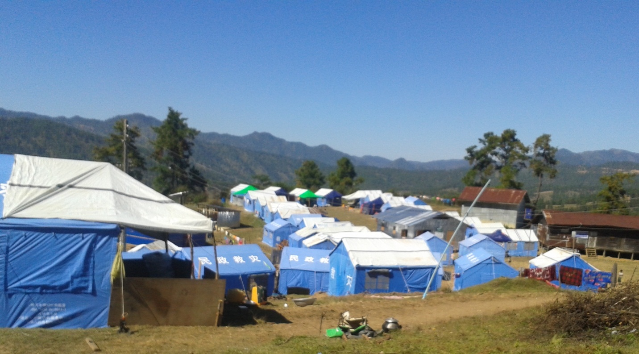
Figure 1: Agriculture compound camp (moved from Bethel Church)

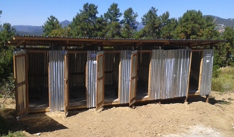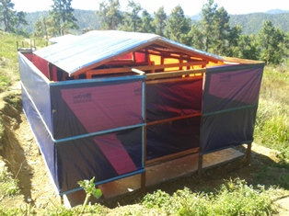
Figure 2: Public latrines in CCU relocation site. Figure 3: Public bathing spaces in CCU relocation site.

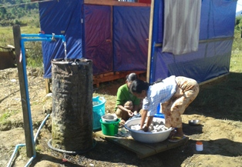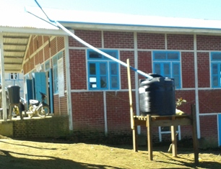
Figure 4: Public washing places in the camp. Figure 5: Gutter system to collect rain water

