Sagaing Region
July / august 2015 floods
Situation report 15th October

Produced by: WASH cluster
Organization: UNICEF
Location: Kale District
Month: September 2015
Resources: http://www.themimu.info/emergencies/wash-cluster

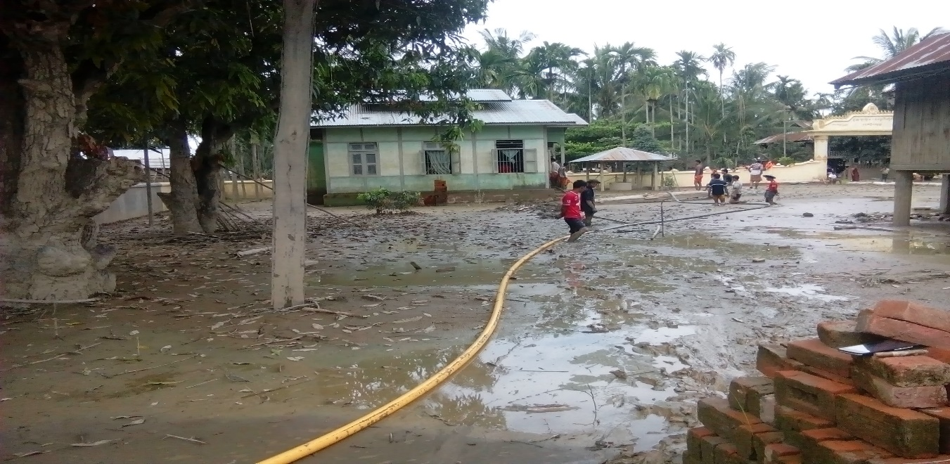
Well renovation and cleaning on Monastery of Ye Le Oo Village of Kale Township

Background at Sagaing region level
According to the heavily raining during July and August 2015, there was flooding in many parts of Myanmar including Sagaing Region. 499024 population of 96957 households from 37 townships was affected by this flooding. Kale District is included in the severely affected areas and most of the organizations and government in line departments intended to focus the emergency response and recovery activities in this district. Demographic and basic data such as affected villages, households, population have been specified as below. And WASH cluster member agencies will use these data in the future planning and implementation as a baseline data. These data was profiled by District Department of Rural Development.

2. Prioritization for WASH response
WASH cluster and DRD is now negotiating to implement WASH projects by WASH partner agencies in the 3 priority field. In WASH coordination meeting, DRD suggested to all WASH organizations to implement WASH projects base on 3 priority areas: 1) Relocation villages 2) Still camp opening villages and 3) Severity category. Severity category just still need to have for Tamu and Min Kin townships. The prioritization area and villages can be seen in the following charts:

The table below provides the categorization of impact that has been set up by the regional disaster committee led by RRD at Kale.
Possible suggested response in terms of WASH response is also give for each category.

Level of flood impact
Category | Impact | Suggested WASH humanitarian response
A | Affected but no damages | No need for WASH intervention, Households can cope by themselves to clean flooded facilities
B | Partially affected by floods, minor damages and partial loss of assets | Most of villagers living within the riverbeds are familiar with regular floods and it can be assumed that they are resilient enough to cope with the situation
C | Drastic damages but possibility to rebuilt from damaged facilities | Give priority to the most vulnerable people for the reconstruction / rehabilitation of WASH facilities. Distribution of pan & pipes, hygiene kits distribution, Hygiene promotion, support to water points and latrines cleaning
D | Villages totally or partially washed away with critical damages to habitat and facilities. | Some villagers being part of this category have been displaced and are living in temporary locations within different settings (religious or governmental buildings, along the roads, Host families,..).  WASH actors should ensure that these people have access to basic WASH facilities with minimum WASH standards during their displacement.  Depending on governmental plan and communities willing, it may take up to three months before these people came back to their dwelling.

3. Camp Opening situation on Kale District
At 10th Sep 2015, there was 23 number of camp opened villages (according to the data filling exercises shared from WASH implementing organizations). Then, the peoples gradually returned back to their own villages based on the weather conditions. So, at the end of September, the opened camp only have 19 camps. The last updated camp opened villages number is 13 shared information at 2nd Oct 2015 WASH coordination meeting. Today, there was only 12 camps in Kale and 4 camps in Tamu Townships. Ye Le Oo and Pauk Khon camps were final closed camps and all of them returned back to their homes. Among these existing 12 camps of Kale township, 8 camps has a plan to settle on the relocation villages, 2 camps is still waiting to the decreasing of water level of their village and 2 villages are living as relocation type in new place (but government offices has not confirmed yet that relocation site currently they stayed is officially agreed or not). Most of the people of these camps already go back to their original home. Only some people of washed off their homes by flooding still live in the camps. They are waiting to the completing time of reconstruction of their homes by DRD and other implementing organizations.
4. WASH implementing organizations in Kale
There are 8 implementing WASH partners (ADRA, KPN-Metta, HHO, IsraAID, NAG, MRCS, MSF-Swiss, AYO) in Kale flooding response in 46 villages among Kale District. Although NGOs are intervening in 105 villages, there are2 or 3 agencies in the same villages with different activities. Until now, there was not reported issues for the overlapped activities in the same villages. 2 Agencies (World Vision and Save the Children) have a plan to response in Kale district. World Vision has already confirmed to set up the office during 2nd week of Oct 2015 but not yet for Save the Children.

5. WASH situation Kale District
5.1 Water Supply
Water point cleaning and chlorination process on the flooded wells and ponds has been finished 80% of Kale District by cooperation of NGOs, DRD and private sectors. Other 20% are the totally damaged households and having a plan to move to the relocation villages. Now, implementing organizations are working for water point renovation and new water point installation activities in these flooding villages to cover their water quantity and quality needs. DRD also has a plan to set up the all needed deep tube wells in 15 relocation sites.
Water supply in the camps is mainly managed by DRD and hosted village leaders. DRD is now distributing the water to these camps by 2 trucks every day. The hosted villager leaders such as religious leaders and village governors supported the water by sharing from their existing water point and then pumped up the water for their daily usage. Fuel for pumping water was donated by private individual donors and some NGOs.
5. 2 Sanitation
NAG, KPN and ADRA are now conducting the Environment, houses and road cleaning activities by cash for work and unconditional cash transfer process. NAG and ADRA covered to implement these activities in 30 villages. Other left villages did their village environmental cleanliness by themselves. So, most of the camp living villagers already come back to their original home (only left the villagers having a plan to settle in the relocation villages).
ADRA organization will renovate the damaged latrines in the targeted 25 villages of Kale Township. NAG implemented 10-20 latrines in 21 villages. NAG selected the targeted households to build up the latrines for the vulnerable people households. Metta foundation focus their latrines construction activities on the actual needed villages after filling by other agencies. Kale Peace Network cooperating with Metta Foundation are now conducting the required needed latrines construction on the relocation villages and also in flooding refugee camps. Department of Health are planning to support the latrine pan and pipe for all affected households. They estimated 4000-5000 pan and pipe to provide on all damaged and flooded households of Kale District. MRCS will build up the needed latrines in the 12 relocation villages. MRCS hope to start latrines construction project only when December 2015.
5.3 Hygiene Promotion
Hygiene Promotion sessions in the flooding townships are mainly done by ADRA, NAG, KPN-Metta and Ar Yone Oo organizations. Most of the people of the flooded villages have the latrines using practices. There is no open defecation on their original villages. So, most of the organization focus on the hygiene promotion education on the hand washing practices and regular cleanliness of the latrines subjects. And they also give the personal hygiene education portions on these hygiene promotion sessions nail clipping, regular bathing, environmental cleaning etc.
ADRA conducted the hygiene promotion session through the village volunteers. They trained to the village volunteers and these volunteers arranged the hygiene promotion sessions once a month regularly. NAG supported the hygiene promotion session by direct conducting from project staffs. During the hygiene promotion sessions, they provided hygiene items to the attendances by questioning the hygiene related knowledge.
5. WASH Coordination Meetings
WASH coordination meetings have been hold in Kale Township 4 times. 1st time is in 25th August 2015 at Central Emergency Response Office Kale. 2nd, 3rd and 4th time are in 11th Sep 2015, 18th Sep 2015 at District DRD Office and 2nd Oct 2015. The minutes of these WASH coordination meeting have been shared to all WASH implementing organizations and government offices. In every meetings, DRD take the leading role and facilitated the meetings since 2nd time of the WASH coordination meeting. DRD distributed the meeting minutes of these WASH coordination meeting with Myanmar versions to the related government departments. And WASH cluster focal person assisted to DRD while inviting the meeting participants of NGOs, writing the meeting minutes and sending to the NGOs offices through email.
6. Information Management
According to the discussion points of 1st WASH coordination Meeting hold in Central Emergency Response Office, WASH Cluster agreed to support the information management training to the WASH implementing organizations of Kale. And Information management officer arrived to Kale Township last week and met with District DRD Officer and then arranged to support the Information management training to WASH agencies.
Information management training conducted in 21st Sep 2015 from 9:00Am to 4:00PM at Shin Hong Hotel Meeting Room of Kale Township. 17 participants of 9 organizations involved in this training. Participated Organizations are as followed:
- DRD (2 participant)
- UNICEF (2 participants- IM Officer and Me)
- MSF (1 participant)
- ADRA (3 participant)
- Metta (1 participant)
- NAG (2 participant)
- KPN (1 participant)
- AYO (2 participant)
- HHO (3 participant)
7. Conclusion
Most of the organizations focus their WASH activities only in Kale and Tamu townships. It is still need on WASH activities on rest 2 townships Kalewa and Min Kin townships. It is also need on the WASH assessment on these 2 townships. Kalewa Township is situated on the risk place and has a very big chance to happen for flooding because most of the villages are living alongside of the stream and rivers.
Although most of the organizations set up the new water points on the original villages, there was no conducting for water quality testing. It is still weak on water quality testing activities on WASH recovery projects not only on relocation villages but also primary villages. DRD would like to request the water quality test kits and also techniques for the Water safety plan for the recovery plan.
WASH implementing organizations and government departments supported the latrines by different way of providing. There is no standardization on latrine structure and also providing way. Some organization provide pan and pipe only, some organization build up the latrines with solid structure, some organizations constructed the semi-permanent latrines, etc. And most of the latrines design are not based on the flooding resistant structure. So, in the future, WASH cluster should discuss about the appropriate latrine design for these flooding areas for the flooding resistant latrine design. It is also still lack on the data for the damaged WASH facilities on health and school. As a results, WASH projects on school and health centre are in gaps.

