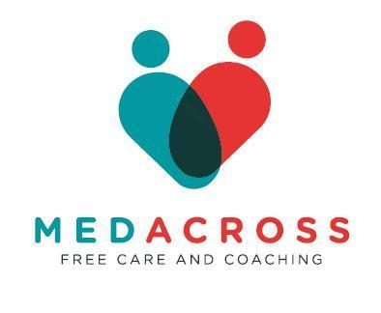

**VACANCY ANNOUNCEMENT**

**COMMUNICATION OFFICER - MANDALAY**

MEDACROSS ONLUS Office in Mandalay seeks applications for “Communication Officer” position (Burmese Nationals only).

Expected Duration of Assignment: 11 months with the possibility of extension

Type of contract: part-time (2 days per week)

Starting date: asap

Language required: English and Burmese

Duty station: Mandalay (City and Township)

Salary: according to experience

**Background Information**

MedAcross is a non-profit organisation, established in 2016 by a group of doctors with the aim of treating people who do not have access to the right to health and prevention in the World. MedAcross currently operates in Myanmar, Thailand, Sri Lanka, Rwanda and Somaliland with a horizontal approach, not focusing solely on a health and emergency response, but promoting multi-sectoral development for communities.

The cooperation model applied by MedAcross is strongly focused on constant dialogue with the stakeholders and local communities with whom the projects are implemented, integrating health needs with synergetic development objectives (e.g. health and nutrition, health and livelihoods, health and labour rights).

From the 30th of March, MedAcross activated an emergency response to the earthquake to support vulnerable populations in Mandalay region with medical and humanitarian support.

**Short summary of the post:** We are seeking a motivated and skilled **Communication Officer** to implement our external communication strategies, especially producing social media contents.. The successful candidate will work closely with program team on the field, HQ communication office, and stakeholders to ensure consistent, impactful messaging aligned with our values and goals.

.

**Detailed List of expected tasks:**

1. Manage content creation (articles, press releases, newsletters, social media, etc.).
2. Ensure branding and messaging are consistent across all platforms and materials.
3. Support documentation of project activities, success stories, and lessons learned.
4. Perform any other tasks as assigned by the line manager.

**Essential requirements**

1. Minimum of 3 years of relevant professional experience.
2. Strong writing, editing, and storytelling skills in English.
3. Proficiency in digital tools and platforms (Photoshop, Canva, Adobe Creative Suite).
4. Familiarity with humanitarian aid is an asset.
5. English fluency required.
6. Possess a valid driving license.
7. Possess photographic equipment
8. Be familiar with the local context.

**Lines of authority:**

- Works under the HQ Communication Office

- Work with: All the other national and international staff

**Terms and Conditions**

1. 4 days off in case of death of a close relative
2. Sick leave according to official medical prescription
3. 15 days leaves per year + national holidays according to MedAcross calendar
4. Meals for working days, yearly bonus

Applications can be made either in person or by email within 13th July 2025.

Applications can be made by email as soon as possible sending your CV to BOTH [media@medacross.org](mailto:media@medacross.org) and p.coordinator@medacross.org.

Applicant profiles will be immediately evaluated after reception of the application and the vacancy closed once a suitable candidate will be selected.

MEDACROSS operates on national and international level, in keeping with the general guidelines of the laws on cooperation with developing countries, and aims to contribute to the objective 3 of the Sustainable Development Goals (SDGs) , which aspires to ensure health and wellbeing for all, through a courageous commitment to end the AIDS epidemic, tuberculosis, malaria and other communicable diseases and to achieve universal health coverage, by 2030, that ensures access to drugs and vaccines for all.

MEDACROSS does not tolerate sexual exploitation and abuse, any kind of harassment, including sexual harassment, and discrimination. All selected candidates will, therefore, undergo rigorous reference and background checks.