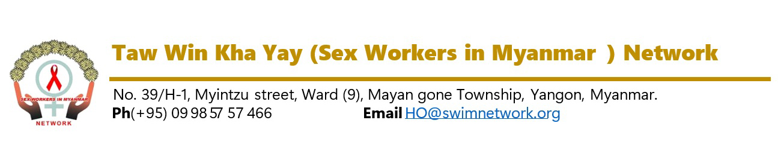
Vacancy Announcement
(22/2026)

Date – 16 October 2026

Required Position | Network and Partnership Support Manager
Required Person | (1) Person
Report to | Senior Program Manager
Contract Type | Full Time Staff
Duty Station | Yangon
Duration of Contract | December 2026 (high potential extension)

Network Background

Taw Win Kha Yay (SWiM) Network is a local community-led, non-government organization, founded by six pioneer female sex workers (FSW) living with HIV in Myanmar since 2009. SWiM Network envisions to create an enabling social environment that is free from discrimination against and harassment of FSW, that ensures equal opportunity and that does not stigmatize HIV infection or HIV by promoting the access to information knowledge, capacity, rights and to participate actively through advocacy at every stage of the HIV/AIDS programme and activities to reduce discrimination.
With more than thirteen years of representation and services for the sex worker community in Myanmar, SWiM Network now has implemented core advocacy activities and humanitarian projects with about fifty national staff and volunteers at thirty townships across different States and Regions in Myanmar through the funding supports of various local and international donors as well as UN agencies.
Taw Win Kha Yay (SWiM) Network is now looking for a suitable passionate national candidate for Network and Partnership Support Manager position based in Yangon.
Job Purpose
The Network and Partnership Support Manager is responsible for strengthening organizational partnerships, supporting network coordination, and enhancing collaboration with stakeholders, including community-based organizations (CBOs), government agencies, international NGOs, donors, and private sector partners. The role ensures effective partnership management, networking, and capacity building to achieve program goals and strategic objectives.
Key Responsibilities
1. Partnership Development and Management
- Identify, establish, and maintain strategic partnerships with local, national, and international organizations.
- Serve as the primary focal point for partner organizations and ensure timely communication and collaboration.
- Negotiate, draft, and monitor partnership agreements and Memoranda of Understanding (MoUs).
- Monitor partner performance and ensure compliance with organizational and donor requirements.
2. Network Strengthening and Coordination
- Support the coordination of existing networks, coalitions, and working groups related to (health, humanitarian response).
- Facilitate information sharing, joint planning, and advocacy among network members.
- Organize and participate in coordination meetings, workshops, and conferences to represent the organization.
3. Capacity Building and Technical Support
- Assess the capacity needs of partners and network members and develop tailored capacity-strengthening plans.
- Provide technical guidance, training, and mentorship to enhance partners’ organizational and programmatic capacity.
- Provide qualitative proposal writing towards the potential donors.
4. Communication and Advocacy
- Develop and maintain a strong communication flow with partners and networks, including newsletters, updates, and resource sharing.
- Support advocacy initiatives by coordinating joint actions, preparing position papers, and facilitating stakeholder engagement.
5. Supporting the Senior Program Manager in Partner Projects
- Assist the Senior Program Manager in planning, executing, and monitoring partner-led projects to ensure deliverables and timelines are met effectively.
- Serve as a key focal point between external partners and internal teams, maintaining active communication and facilitating regular progress updates.
- Help oversee project budgets, resource allocation, and grant compliance across partner initiatives in collaboration with senior leadership.
- Help identify operational risks or bottlenecks in partner projects early on, assisting in the development and implementation of mitigation strategies.
Key Qualifications and Experience
- Bachelor’s degree in Social Sciences, Development Studies, International Relations, or a related field (Master’s degree preferred).
- Minimum 5 years of experience in partnership management, networking, or program coordination in NGOs, UN agencies, or development organizations.
- Proven experience in building and maintaining strategic partnerships and networks.
- Strong understanding of (public health, humanitarian aid, gender equality).
- Excellent communication, negotiation, and relationship-building skills.
- Strong organizational and analytical skills, with experience in report writing and documentation.
- Proficiency in MS Office and familiarity with partnership or grants management tools.
- Fluency in English.
Key Competencies
- Strategic thinking and problem-solving.
- Ability to work collaboratively with diverse stakeholders.
- Strong interpersonal and facilitation skills.
- Commitment to organizational values and principles, including gender equality and inclusion.
Application process:
Interested and qualified candidates are invited to apply with Application Letter and Curriculum Vitae with two referees (one referee much be current Supervisor) through mail to HR@swimnetwork.org or the following address; No. 39/H-1, Myintzu Street, (9) Ward, Mayangone Township, Yangon, Myanmar.
The deadline for applications is 5:00 PM (MMT), 23 October 2026. Only short-listed candidates will be invited for relevant tests and/or personal interviews.

Taw Win Kha Yay (SWiM) Network is the key population led organization providing right based services to Female Sex Workers and other community. The candidate must demonstrate positive attitude towards key populations and relevant community. People of all ethnicities, religions, genders, ages, individuals living with HIV, and those with disabilities are encouraged to apply.

