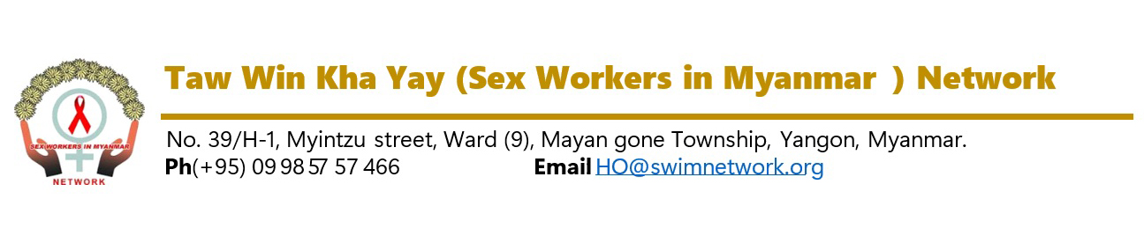
Vacancy Announcement
(21/2026)

Date – 16 October 2026

Required Position | Project Officer (L’initiative Project)
Required Person | (1) Person
Report to | Senior Program Manager
Contract Type | Full Time Staff
Duty Station | Yangon
Duration of Contract | December 2026 (high potential extension)

Network Background

Taw Win Kha Yay (SWiM) Network is a local community-led, non-government organization, founded by six pioneer female sex workers (FSW) living with HIV in Myanmar since 2009. SWiM Network envisions to create an enabling social environment that is free from discrimination against and harassment of FSW, that ensures equal opportunity and that does not stigmatize HIV infection or HIV by promoting the access to information knowledge, capacity, rights and to participate actively through advocacy at every stage of the HIV/AIDS programme and activities to reduce discrimination.

With more than thirteen years of representation and services for the sex worker community in Myanmar, SWiM Network now has implemented core advocacy activities and humanitarian projects with about fifty national staff and volunteers at thirty townships across different States and Regions in Myanmar through the funding supports of various local and international donors as well as UN agencies.
Taw Win Kha Yay (SWiM) Network is now looking for a suitable passionate national candidate for Project Officer position based in Yangon.

Responsibilities
Under the supervision of the Senior Program Manager, the incumbent will be responsible for:

- Ensuring the project reaches its target.
- Coordinating budget and operational processes.
- Submitting timely project reports to the management committee and donors.
- Systematically maintaining records and information.
- Managing the areas covered by the project.
- Requesting and reporting operational expenses to the management committee monthly.
- Traveling as needed to ensure timely completion of project activities.
- Timely managing and approving project expenses.
- Collaborating and coordinating with project staff.
- Leading and managing in organizing special events.
- Actively leading and participating in regular meetings.
- Assigning and delegating daily tasks to project staff.
- Conducting monitoring visits to project areas as necessary.
- Addressing project challenges in coordination with the senior management committee.
- Collaborating with other organizations and networks to ensure project success.
- Performing other tasks assigned by the supervisor according to the project’s needs.

Requirements

- Bachelor’s degree in a relevant field University or related field
- At least 2 years or equivalent proven experiences, including INGO or NGO with HIV/AIDS project.
- Be able good communicate and cooperate with organization and travel to project areas.
- Must be able to coordinate with Donors.
- Ability to efficiently communicate in verbal and written English;
- Ability to work under stressful conditions, Result Orientated, Analytical Thinking;
- Strong Negotiation Skills, Relationship Building, Leadership Skills, Team spirits;
- Ability to work in multi-cultural environment with High level of integrity with in depth knowledge of vulnerable community particularly PLHIV and HIV affected communities.

Application process:

Interested and qualified candidates are invited to apply with Application Letter and Curriculum Vitae with two referees (one referee much be current Supervisor) through mail to HR@swimnetwork.org or the following address; No. 39/H-1, Myintzu Street, (9) Ward, Mayangone Township, Yangon, Myanmar.

The deadline for applications is 5:00 PM (MMT), 23 October 2026. Only short-listed candidates will be invited for relevant tests and/or personal interviews.

Taw Win Kha Yay (SWiM) Network is the key population led organization providing right based services to Female Sex Workers and other community. The candidate must demonstrate positive attitude towards key populations and relevant community. People of all ethnicities, religions, genders, ages, individuals living with HIV, and those with disabilities are encouraged to apply.

