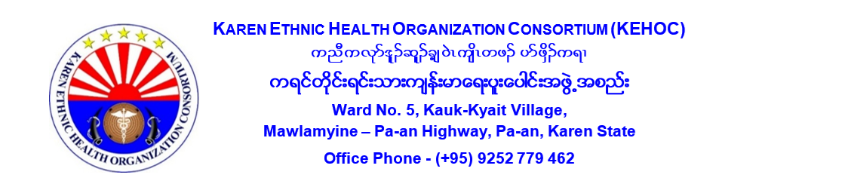

**VACANCY ANNOUNCEMENT (Reannouncement)**

**1. JOB DETAILS:**

**Position : Medical Logistics Officer**

**Number of Position : 1 Post**

**Reports Directly to : Logistics Manager**

**Supervisee : None**

**Duty Station : Pa-an, Karen State**

**2. PRIMARY PURPOSE OF THE POSITION**

**Position Summary:** The Medical Logistics Officer is responsible for overseeing the procurement, distribution, and inventory management of medical supplies and commodities across health projects. This includes ensuring compliance with regulatory standards and supporting inventory control in remote, resource-limited areas. The officer will also contribute to the ongoing digitalization of logistics processes.

**3. KEY RESPONSIBILITIES:**

* Support the procurement, storage, and distribution of medical supplies and pharmaceuticals.
* Provide technical assistance in setting up and maintaining medical warehouses, both centrally and at fixed clinics.
* Ensure accurate tracking of inventory and facilitate timely restocking of supplies.
* Monitor stock levels, and expiration dates, and maintain regulatory compliance across all medical goods.
* Collaborate closely with health teams, project leads, and suppliers to ensure timely and efficient delivery of medical supplies.
* Consolidate and analyze stock reports from various projects and fixed PHC clinics.
* Actively contribute to the upgrade and digitalization of the medical logistics management system.
* Ensure the accuracy of digital records and assist in system improvements.
* Prepare regular reports on medical logistics and inventory performance.
* Perform additional tasks as assigned by the Senior Executive Officer.

**4. EDUCATIONAL BACKGROUND AND QUALIFICATIONS:**

* Educational background in pharmacy or a related field.
* Knowledge of inventory control systems, especially in resource-limited settings.
* Experience with digital logistics management systems is highly desirable.
* Strong communication, organizational, and analytical skills.
* Good understanding of the context, including health service provision in the assign area.
* Proficiency in Karen ethnic languages is preferred.
* Respecting and Promoting Individual and cultural differences.
* A good team player and good personal skill (honest, trust worthy, flexible and respectful) to coworkers and organizations.

**Application Process:**

Interested candidates should address the application to **Admin and HR Coordinator**, Ward No.5, Kauk-Kyait Village, Mawlamyine – Pa-an Highway, Pa-an or **hr.kehoc@gmail.com** with his/her complete **curriculum vitae (CV)**, **two recommendation letters**, a photo taken within last three months, **NRC copy**, copy of certificate(s) and additional training attended.

**Deadline of Application**

The all-complete application should arrive by **22nd April 2025**.

**Only short-listed candidates will be contacted for interview.**

The Karen Ethnic Health Organization Consortium has a zero-tolerance for the Prevention of Sexual Exploitation, Abuse, and Harassment of beneficiaries. Protection from Sexual Exploitation, Abuse, and Harassment (PSEAH) is everyone’s responsibility, and all employees are required to adhere to the Code of Conduct, which enshrines the principles of PSEAH, at all times (both during work hours and outside work hours). The Karen Ethnic Health Organization Consortium is also committed to safeguarding children and has a zero-tolerance policy for any form of child Exploitation, Violation, Abuse, and Neglect (EVAN). Familiarization with and adherence to the Code of Conduct is an essential requirement of all staff.