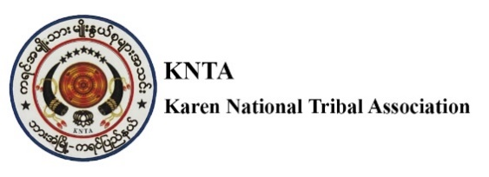

**Vacancy Announcement**

**Title : Human Resource Officer**

**No. of positions : 1**

**Department/section : Education Project**

**Reporting to : HR Coordinator/Director**

**Supervises :**

**Location : Hpa-an Township, Kayin State**

**Contract duration : 10 Months contract with chance of extension**

# BACKGROUND

Karen National Tribal Association is a local CSO composed of major seven language and culture organizations based in Hpa An, Kayin State. KNTA includes seven ethnic groups (Pwo, Sagaw, Mopwar, Pagu, Karenphyu, Bwe, Gebah ) from seven townships (Hpa-an, Hlaingbwe, Kawkareik, Kyarinnseikgyi, Myawaddy, Thandaunggyi and Pon) supporting Karen Literature and Culture activities at the sub- national , township and community level . While preserving local language and culture, KNTA works together with other NGO/INGOs to support language development and equity in education including Early Childhood Care and Development, Basic Education, NFE, and NFPE activities reaching to the marginalized children taking the opportunity of KNTA volunteers’ presence in the communities across the region.

With the presence of KNTA’s volunteers at all townships in Kayin and Mon State, KNTA maintains the strong network and good access to the affected areas keeping a good relationship with local, township and state level authorities - state and non- state under the flag of Local Ethnic Language and Culture Preservation. KNTA is committed to working together in partnership with any organizations to advocate the right of children, especially marginalized regardless of color, race and religion in South East Areas of Myanmar.

**Key Responsibilities:**

**1. Recruitment & Onboarding:**

* Assist in the recruitment process (posting job ads, screening resumes, scheduling interviews) according to KNTA’s HR Manual.
* Coordinate new employee onboarding (preparing contracts, conducting orientations, ensuring compliance).

**2. Employee Records & Compliance:**

* Maintain accurate HR records (personal data, attendance, performance reviews).
* Ensure compliance with labor laws and company policies.
* Handle tax and statutory requirements (if applicable).

**3. Payroll & Benefits Administration:**

* Assist in payroll processing (leave management, deductions, bonuses).
* Administer employee benefits (health insurance, pensions, allowances).

**4. Performance Management:**

* Support performance appraisal processes.
* Track employee progress and assist in training & development programs.

**5. Employee Relations & Engagement:**

* Act as a point of contact for employee queries.
* Address grievances and mediate conflicts.
* Organize employee engagement activities (team-building, surveys, recognition programs).

**6. Training & Development:**

* Identify training needs of the staff and coordinate workshops/seminars.
* Track employee training progress and certifications.

**7. Policy Implementation & HR Projects:**

* Assist in developing and updating HR policies.
* Participate in HR projects (diversity initiatives, wellness programs, digital transformation).

**Skills & Qualifications:**

* Education: Bachelor’s degree in HR, Business Administration, or related field.
* Experience: 2+ years in HR (generalist or specialist roles) with INGO, NGO or CSO.
* Knowledge: Labor laws, HR best practices, payroll systems (e.g., SAP, Workday).
* Soft Skills: Communication, problem-solving, confidentiality, teamwork.
* Certifications (Preferred): PHR, SHRM-CP, or equivalent.
* Ability to multi-task, follow procedures and meet deadlines
* Ability to work both independently and in a flexible manner
* Proven knowledge and respect of key humanitarian principles
* Ability to listen, communicate positively, and resolve conflicts that may arise desired.
* Fluency in Burmese and in English required, local language is a plus.

If you are interested in these positions to apply, please send Application Letter, Curriculum Vitae, Copies of Education Certificate, National ID Copy and three referees including your last employer to as per follow Email address (kntahpaan2020@gmail.com) not later than 25th June 2025.