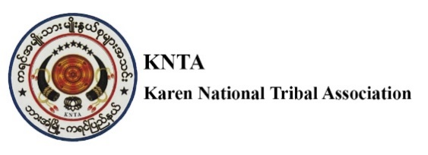

**Vacancy Announcement**

**Title : MEAL Officer**

**No. of positions : 1**

**Department/section : Education Project**

**Reporting to : Project Manager**

**Supervises : Field Focals**

**Location : Hpa-an Township, Kayin State**

**Contract duration : 10 Months contract**

# BACKGROUND

Karen National Tribal Association is a local CSO composed of major seven language and culture organizations based in Hpa An, Kayin State. KNTA includes seven ethnic groups (Pwo, Sagaw, Mopwar, Pagu, Karenphyu, Bwe, Gebah ) from seven townships (Hpa-an, Hlaingbwe, Kawkareik, Kyarinnseikgyi, Myawaddy, Thandaunggyi and Pon) supporting Karen Literature and Culture activities at the sub- national , township and community level . While preserving local language and culture, KNTA works together with other NGO/INGOs to support language development and equity in education including Early Childhood Care and Development, Basic Education, NFE, and NFPE activities reaching to the marginalized children taking the opportunity of KNTA volunteers’ presence in the communities across the region.

With the presence of KNTA’s volunteers at all townships in Kayin and Mon State, KNTA maintains the strong network and good access to the affected areas keeping a good relationship with local, township and state level authorities - state and non- state under the flag of Local Ethnic Language and Culture Preservation. KNTA is committed to working together in partnership with any organizations to advocate the right of children, especially marginalized regardless of color, race and religion in South East Areas of Myanmar.

**Key Responsibilities:**

* Support the collection of quantitative and qualitative data related to project activities.
* Ensure timely and accurate data entry into databases, tracking tools, or M&E systems.
* Maintain organized and confidential documentation of all program activities.
* Conduct regular monitoring visits to project sites to verify activity implementation and data accuracy.
* Collect feedback from beneficiaries and stakeholders using structured forms or participatory methods.
* Support pre/post assessments, beneficiary verification, focus group discussions (FGDs), and key
* informant interviews (KIIs) where applicable.
* Assist in compiling monthly and quarterly M&E reports for internal use and donor reporting.
* Identify inconsistencies or gaps in data and report findings to the M&E Officer.
* Contribute to visual presentations (dashboards, graphs, charts) that illustrate project progress.
* Support training and orientation of field staff and community facilitators on data collection tools and reporting templates.
* Participate in internal reflection sessions, learning reviews, and assessments.
* Feedback and suggestions from the beneficiaries served by KNTA Organization Must be able to assist in handling complaints.
* Help ensure feedback and complaint mechanisms are functioning and accessible at community level.
* Uphold confidentiality, respect, and ethical standards when handling sensitive information,

. **Qualifications**

* University degree in sociology, statistics, development studies, or a related field
* At least 2 years of proven experience, with an INGO or NGO
* Technical knowledge in MEAL and data management methodologies
* Proven knowledge of qualitative/quantitative research methods
* Demonstrated experience with MS Office and data analysis
* Skilled in the use of Kobo Toolbox, remote monitoring, and surveys
* Excellent organizational skills and attention to details
* Willingness to travel to the field
* Ability to multi-task, follow procedures and meet deadlines
* Ability to work both independently and in a flexible manner
* Proven knowledge and respect of key humanitarian principles
* Ability to listen, communicate positively, and resolve conflicts that may arise desired.
* Fluency in Burmese and in English required, local language is a plus.

If you are interested in these positions to apply, please send Application Letter, Curriculum Vitae, Copies of Education Certificate, National ID Copy and three referees including your last employer to as per follow Email address (kntahpaan2020@gmail.com) not later than 25th June 2025.