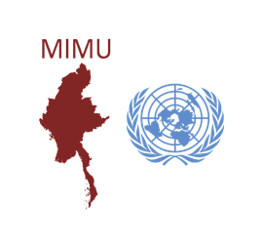
Myanmar Information Management Unit
CUSTOMISED MAP REQUEST FORM
Kindly allow us at least 10 working days to process your request!

Please note that MIMU products are posted on the website unless you inform us otherwise.
Please contact us if you require any further information.
Requester Information
Name: |  |  |  | Email:
Organisation: |  |  |  | Phone:
Title:
Date:
Required date (if applicable):
1. | Content of Map and Purpose
Proposed Map Title:
Purpose of Map:
What should the map show :
Level of Detail: States/Regions Townships Village Tracts Villages
Select the items you would like to include in the map: Road Railway River Land Cover
Settlement (Urban Area, Town point, Village, etc.) Topographic Feature (elevation)
Others _________________________________________________________________ (please specify)
Size : A4 (210 x 297) mm A3 (297 x 420) mm A1 (594 x 841) mm A0 (841 x 1189) mm
Other _________________________________________________________________ (please specify)
Note: MIMU does not produce maps smaller than A4.
2. Before you submit your request, please ensure that.
- You have provided the specific data needed for the maps, preferably in MS Excel Spreadsheet.
- You are sure of the final map size (changing map size may require creation of a new map).
- You have included Pcodes for Township / Village Tract or Village information (MIMU P-Code data is available at http://themimu.info/place-codes or our Office’s Resource Centre). If you cannot find Pcodes matching your data, please provide the detailed administrative structures. E.g., State/Region Name, Township Name, Village Tract Name, Village Name and its GPS Coordinates.
Please note that
- MIMU products are provided free of charge for humanitarian and development purposes thanks to the generosity of our donors.
- The logos of the MIMU and its donors are included on all map headers. No other logos will be included in the map header.

