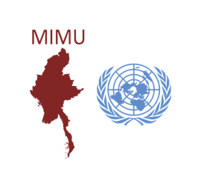
Myanmar Information Management Unit
MAP PRINTING REQUEST FORM
Kindly allow us at least 5 working days to process your request!
Limited to 5 prints per organisation per year.

Please note that the maps are only available for pick up at our office in Yangon.
For other locations, feel free to reach us for printing assistance.
Please contact us for any further information and/or request.

Requester Information
Name: |  | Email:
Organisation: |  | Phone:
Title:
Date:
Required date (if applicable):

You are kindly requested to fill the Map’s Ref No., version and Map’s Title. Please refer to the MIMU Maps page.

Map Ref No. | Map Title | No. of Copies | Size  Other (Specify) |  | Type of Copies
 |  |  | A0 A1 A4 |  | Soft copy  Hard copy
 |  |  | A0 A1 A4 |  | Soft copy  Hard copy
 |  |  | A0 A1 A4 |  | Soft copy  Hard copy
 |  |  | A0 A1 A4 |  | Soft copy  Hard copy
 |  |  | A0 A1 A4 |  | Soft copy  Hard copy
 |  |  | A0 A1 A4 |  | Soft copy  Hard copy

Note:

1. If the maps should be supplied in other sizes, then provide the requested size here. Note that large map formats must be authorized by the MIMU Manager or MIMU GIS Team Focal.
2. If you need many copies, you are advised to request an electronic copy and MIMU can provide contact details of local printing companies.

